Press Release

Flexible options for control cabinet mounting

The ARCA IEC enclosure series from Fibox is designed for flexible handling in any and all on-site conditions. The various wall mounting options are a case in point. The polycarbonate enclosures feature double-walled corners with mounting holes located outside of the IP66 protected installation space. These enable direct wall attachment with screws that cannot be accessed from the outside. Alternatively, Fibox offers stainless steel wall mounting lugs that resist adverse environmental conditions. The threaded lugs can be fastened with a screw from the inside of the enclosure. The wall mounting lugs available in two depths of 10 and 40 mm also enable hidden routing of cables behind the cabinet. In addition, Fibox offers pole mounting sets (100-300 mm diameter) for all 14 cabinet sizes from 200 x 300 x 150 mm to 800 x 600 x 300 mm.

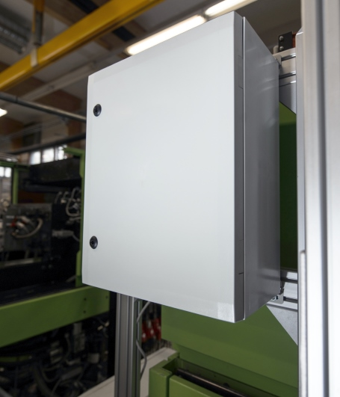
Illustration: Versatile resilient wall mounting options: Fibox has engineered the ARCA IEC series for high utility, durability, and excellent usability

Illustrations: | arca_iec_fibox_production_19 | Char.s: | 840
File name: | 201605026_pm_arca_wmk_stainless_en | Date: | 2016-06-07
About FIBOX
The Finnish company FIBOX Oy Ab is one of the leading international suppliers of plastic enclosures for electric and electronic components used in industrial automation as well as information, communication, and medical technology. The international distribution center is located in Porta Westfalica, Germany. At present, the FIBOX portfolio features more than 1,000 types of standard enclosures manufactured from polycarbonate, the copolymer ABS, glass fiber polyester, and aluminum that provide ingress protection ratings up to IP66/IP67. For several decades, FIBOX has been actively driving the market for enclosure products and the associated tool and production technologies with original designs. As early as 1966, the company introduced injection-molded polycarbonate enclosures, thus marking the start of a new era in control cabinet manufacturing. FIBOX offers a wide range of services, including customization and marking of individual boards or cabinets as well as the planning and delivery of complete automation systems. A broad range of accessories complements the enclosure solutions.

Contact:  Fibox Oy Ab  Keilaranta 19  02150 Espoo  Finland  Tel.: +358 (0)207 785 700  Fax: +358 (0)207 785 702  Email: infofi@fibox.com  WWW: www.fibox.com |  | gii die Presse-Agentur GmbH  Immanuelkirchstr. 12  10405 Berlin  Germany  Tel.: +49 . 30 . 538 965 - 0  Fax: +49 . 30 . 538 965 - 29  E-Mail: info@gii.de  WWW: www.gii.de

