Press Release

Temperature profiling validates reheat furnace, saves fuel

Commissioning a new slab reheat furnace, Danieli Centro Combustion capitalized on application-tailored DATAPAQ Furnace Tracker systems from Fluke Process Instruments. Two systems were used to profile slabs in four different production scenarios, to set up the furnace, and fine-tune energy consumption. This validation proved to the customer, a leading global steel manufacturer at their plant in Poland, that steel slabs are heated to the required temperature of 1280 °C throughout. The DATAPAQ TP3 data loggers go through the furnace with the slabs and collect temperature readings from 20 thermocouples attached at various depths inside the product. Fluke Process Instruments provided a complete solution with engineering advice on how best to set it up. The electronics is protected by a TB4272-type low-height “phased evaporation” insulation system specified to ensure nine hours insulation to be still safe in case of delays in the measurement run. The type K thermocouples were supplied with a Nicrobell sheath which increases their temperature tolerance to above 1300 °C.

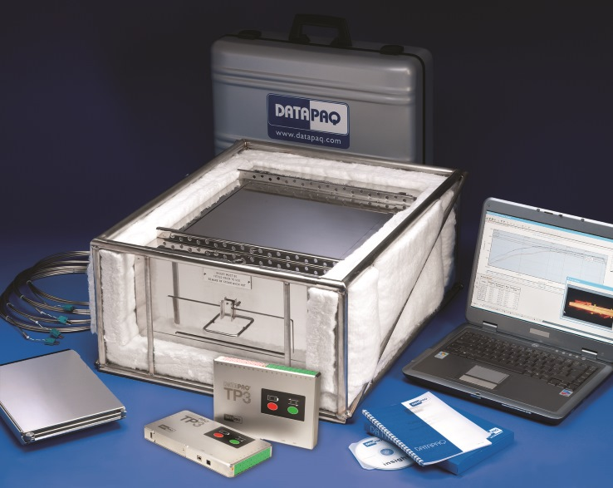
Illustration: The DATAPAQ Furnace Tracker for slab reheat records temperature profiles from inside the six-hour process at 1300 °C

Milan-based Danieli Centro Combustion, one of the world’s leading manufacturers of heating and reheating furnaces, has been using DATAPAQ systems for many years. In the current project, the company made use of the new DATAPAQ Insight Basic software, which comprises all essential visualization, analysis, and reporting functions. Danieli also used radio telemetry of data for the first time ever, an option that is available for most DATAPAQ applications. It enables parameter adjustments while the process is ongoing and prevents loss of data. Danieli used it to optimize fuel efficiency. Adjusting the furnace, Danieli ensured that the slabs reach the target drop-out temperature just before they leave the furnace after six hours. The furnace processes about 200 tons of steel per hour. Fuel costs amount to several 10K EUR per day. Reducing the fuel consumption by just 1 or 2% means that the DATAPAQ system pays for itself within six months.

Illustrations: | furnace_tracker_slab_reheat | Char.s: | 2,025
File name: | 201609004_pm_danieli_furnace_tracker_en | Date: | 2016-10-26
About Fluke Process Instruments
Fluke Process Instruments designs, manufactures, and markets a complete line of infrared temperature measurement and profiling solutions for industrial, maintenance, and quality control applications. Distributed worldwide under the Raytek, Ircon, and Datapaq brands, the products reflect the combined experience of over 125 years in manufacturing the world’s finest temperature measurement tools and devices.
About Fluke
Founded in 1948, Fluke Corporation is the world leader in compact, professional electronic test tools. Fluke customers are technicians, engineers, electricians, and metrologists who install, troubleshoot, and manage industrial, electrical, and electronic equipment and calibration processes.

Contact for Europe, Middle East, Africa:  Fluke Process Instruments  Datapaq Ltd.  Stephan Wilke  Blankenburger Str. 135  13127 Berlin  Germany  Tel.: +49 . 30 . 478 008 - 412  Fax: +49 . 30 . 471 0251  Email: stephan.wilke@fluke.com  WWW: www.flukeprocessinstruments.com  Contact for Americas, Asia-Pacific:  Fluke Process Instruments  Datapaq Inc.  Arlene Lucas-Starrh  Santa Cruz, CA, USA  Tel.: 800 227 8074 (US & Canada)  or +1 831 458 3930  Email: arlene.lucas-starrh@fluke.com |  | gii die Presse-Agentur GmbH  Immanuelkirchstr. 12  10405 Berlin  Germany  Tel.: +49 . 30 . 538 965 - 0  Fax: +49 . 30 . 538 965 - 29  Email: info@gii.de  WWW: www.gii.de

