Press Release

LOXrail catalog available for download from Losyco
New intra-logistics system at a glance

In a new brochure, advanced intra-logistics systems manufacturer Losyco introduces the innovative LOXrail system and provides an overview of all available variants. The easy and cost-efficient installation and operation make this floor rail system ideally suited for machine and tool manufacturers as well as many small and medium-sized companies seeking to introduce continuous flow production. Optimized for transporting heavy and bulky loads, the rail system is available in two sizes with 25 mm or 40 mm rail diameters. The standard length for a piece of track is 3 meters. The hardened and polished guide rails are available in CF 53 or stainless steel grades. A wide selection of wheel sets with one or two wheels moves payloads with up to 100 kN. The wheel sets come with or without a mounting frame and optionally as powered versions. The special profile of the wheels ensures minimal friction, enabling loads weighing several tons to be moved manually. The steel round bar housed in the base profile is finally fixed with only one anchoring clip to prevent axial displacement. This also means that less material and less maintenance is required. Thanks to the floor-level installation, the highly wear-resistant rails never get in the way of employees or pallet jacks. An almost gap-free surface prevents dirt accumulation. Various accessories such as junction elements and end pieces, different kinds of wipers to protect the wheels, mounting gauges, and leveling and absorbing panels complement the program. The new catalog is available for download from the company website www.losyco.com.

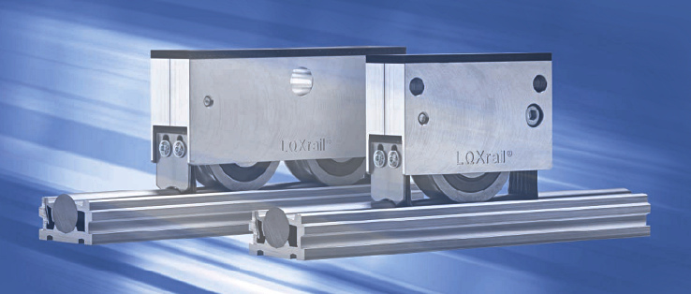
Illustration: The new LOXrail catalog presents the comprehensive portfolio for the heavy-duty rail system

Illustrations: | loxrail_katalogbild | Char.s: | 1,601
File name: | 201609030_pm_katalog2016_en | Date: | 2016-09-21
About Losyco
Based in Bielefeld, Germany, Losyco designs, manufactures, and deploys intra-logistics systems for industrial customers. Founded by experienced engineers in 2016, the company's first core product is LOXrail®: with this novel round bar rail system, loads weighing several tons can be easily moved around, precisely to the desired spot. It can be operated manually or with auxiliary drives. Losyco also supplies conveying and handling equipment such as chain and roller conveyors, material management and storage systems, sound-proof cabins, and machine covers. In addition, Losyco offers support and guidance for customers wishing to transform their production processes to implement lean manufacturing and continuous flow production. Losyco is a member of the DRECKSHAGE Family.

Contact:  LOSYCO GmbH  Member of the DRECKSHAGE Family  Derek P. Clark  Walter-Werning-Str. 7  33699 Bielefeld  Germany  Tel.: +49 . 521 . 945 643-0  Fax: +49 . 521 . 945 643-399  Email: info@losyco.com  Internet: www.losyco.com |  | gii die Presse-Agentur GmbH  Immanuelkirchstr. 12  10405 Berlin  Germany  Tel.: +49 . 30 . 538 965-0  Fax: +49 . 30 . 538 965-29  Email: info@gii.de  Internet: www.gii.de

