Press Release

A lean means of transportation for the heavy-goods industry

Launching the LOXrail program, German manufacturer Losyco provides a round rail system that increases assembly line efficiency for large machine and product manufacturing processes. The new system, characterized by minimal rolling friction, is brought to the market by a team of accomplished intra-logistics industry experts, led by managing director Derek P. Clark. Loads as heavy as several tons can be moved manually or with a small auxiliary drive with much lower energy consumption and much less equipment compared to standard procedures using overhead cranes, SGVs, or pallet trucks. LOXrail is available in two sizes with rail diameters of 25 or 40 mm. Goods loaded on standard or custom-made trolleys are safely transported and accurately positioned. Nominal payloads vary with the number of wheel sets. Even standard trolleys carry payloads of up to 40 tons. In one-piece flow assembly lines, the trolleys serve as mobile workstations. The floor-level rails never get in the way of employees and are no obstacle for rolling racks, working and cleansing machines, etc. The rail products portfolio includes junctions as well as components to change the direction of the trolley.

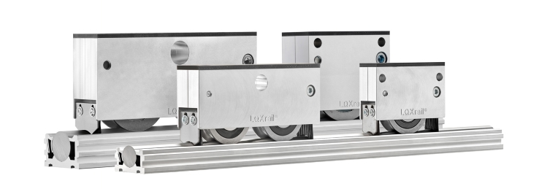
Illustration: Lean in line: LOXrail from Losyco enables one-piece flow assembly of medium-weight and heavy-weight machines and products

Managing director Clark points to the wide range of services available from Losyco: "We offer more than a transport system. LOXrail is the cornerstone of a holistic approach. All of our team members have many years of experience and considerable expertise in production logistics. We provide comprehensive and hands-on support to companies seeking to introduce a production line based on lean manufacturing principles." To this end, Losyco offers additional equipment such as chain and roller conveyors to complement the round bar rails. The company devises and manufactures customized logistics solutions and helps streamline production processes.

Illustrations: | loxrail_0902-003 | Char.s: | 1,833
File name: | 201609042_pm_loxrail_en | Date: | 2016-09-29
About Losyco
Based in Bielefeld, Germany, Losyco designs, manufactures, and deploys intra-logistics systems for industrial customers. Founded by experienced engineers in 2016, the company's first core product is LOXrail®: with this novel round bar rail system, loads weighing several tons can be easily moved around, precisely to the desired spot. It can be operated manually or with auxiliary drives. Losyco also supplies conveying and handling equipment such as chain and roller conveyors, material management and storage systems, sound-proof cabins, and machine covers. In addition, Losyco offers support and guidance for customers wishing to transform their production processes to implement lean manufacturing and continuous flow production. Losyco is a member of the DRECKSHAGE Family.

Contact:  LOSYCO GmbH  Member of the DRECKSHAGE Family  Derek P. Clark  Walter-Werning-Str. 7  33699 Bielefeld  Germany  Tel.: +49 . 521 . 945 643-0  Fax: +49 . 521 . 945 643-399  Email: info@losyco.com  Internet: www.losyco.com |  | gii die Presse-Agentur GmbH  Immanuelkirchstr. 12  10405 Berlin  Germany  Tel.: +49 . 30 . 538 965-0  Fax: +49 . 30 . 538 965-29  Email: info@gii.de  Internet: www.gii.de

