Press Release

Monitor the mini wave

Fluke Process Instruments announces the smallest thermal profiling system designed specifically for miniature wave selective soldering processes. The DATAPAQ SelectivePaq uses four thermocouples to take measurements from the electronic assembly as it passes through the preheating and dip soldering phases. Sample intervals can be adjusted to up to 20 times per second. The detailed temperature profiles enable electronics manufacturers to adjust their operations for optimum efficiency, validate the consistent quality of PCBs to customers, and prove adherence to both solder and component temperature constraints. The profiling system combines a new four-channel DATAPAQ Q18 micro data logger with the latest micro-miniature thermocouple plugs and a low-mass thermal shield merely 20 mm high and 40 mm wide. It is therefore optimally suited to monitor the performance of machines that offer very restricted space and for use with holding frames. The complementary DATAPAQ Selective Soldering Process Sensor Array facilitates regular and frequent process stability measurements.

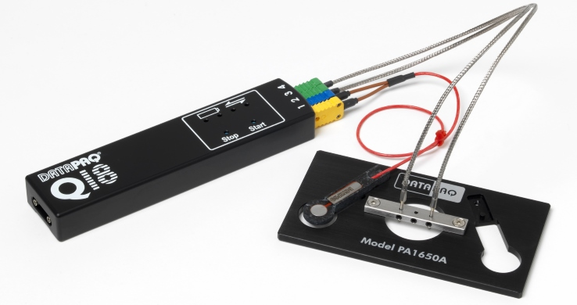
Illustration: The new DATAPAQ SelectivePaq is a complete solution for monitoring the stability and repeatability of miniature wave selective soldering processes

The logger provides a superior accuracy of ±0.5 °C and resolution of 0.1 °C. It connects up to three height-adjustable wave contact thermocouples and up to two preheat thermocouples for monitoring both process phases. The preheat thermocouples contain a top and a bottom sensor and are designed to work with IR and convection preheat technologies. The machined-from-solid aluminum logger case and user-replaceable rechargeable battery pack ensure a long operational life and lowest ownership costs. The system is supplied with the full DATAPAQ Insight Reflow software. Data analysis includes maximum slopes, maximum temperatures, and wave contact times. The software enables data export to other Windows-compatible programs.

Illustrations: | datapaq_selectivepaq_array | Char.s: | 1,803
File name: | 201610009_pm_datapaq_selectivepaq_en | Date: | 2016-12-13
About Fluke Process Instruments
Fluke Process Instruments designs, manufactures, and markets a complete line of infrared temperature measurement and profiling solutions for industrial, maintenance, and quality control applications. Distributed worldwide under the Raytek, Ircon, and Datapaq brands, the products reflect the combined experience of over 125 years in manufacturing the world’s finest temperature measurement tools and devices.
About Fluke
Founded in 1948, Fluke Corporation is the world leader in compact, professional electronic test tools. Fluke customers are technicians, engineers, electricians, and metrologists who install, troubleshoot, and manage industrial, electrical, and electronic equipment and calibration processes.

Contact for Europe, Middle East, Africa:  Fluke Process Instruments  Datapaq Ltd.  Stephan Wilke  Blankenburger Str. 135  13127 Berlin  Germany  Tel.: +49 . 30 . 478 008 - 0  Fax: +49 . 30 . 471 0251  Email: sales-info@datapaq.com  WWW: www.flukeprocessinstruments.com  Contact for Americas, Asia-Pacific:  Fluke Process Instruments  Datapaq Inc.  Arlene Lucas-Starrh  Santa Cruz, CA, USA  Tel.: 800 227 8074 (US & Canada)  or +1 831 458 3930  Email: arlene.lucas-starrh@fluke.com |  | gii die Presse-Agentur GmbH  Immanuelkirchstr. 12  10405 Berlin  Germany  Tel.: +49 30 / 53 89 65 - 0  Fax: +49 30 / 53 89 65 - 29  e-mail: info@gii.de  WWW: www.gii.de

