Press Release

Compact MID-calibrated energy meter from Gossen Metrawatt
Power you can count on

Nuremberg – Measurement specialist Gossen Metrawatt introduces ENERGYMID, a new generation of high-performance, extremely compact power meters. The new devices feature scalable functionality and are available for 2-, 3- or 4-wire networks with a transformer connection (1(6) A) and input voltages ranging from 100 to 500 V. They come pre-calibrated according to the MID standard and provide power consumption and power feed data for differentiated cost accounting. In addition to energy consumption and depending on the specific meter model, up to 33 additional parameters can be measured. These include reactive energy, apparent power, neutral conductor current, power factor, frequency, and energy fed into the network.

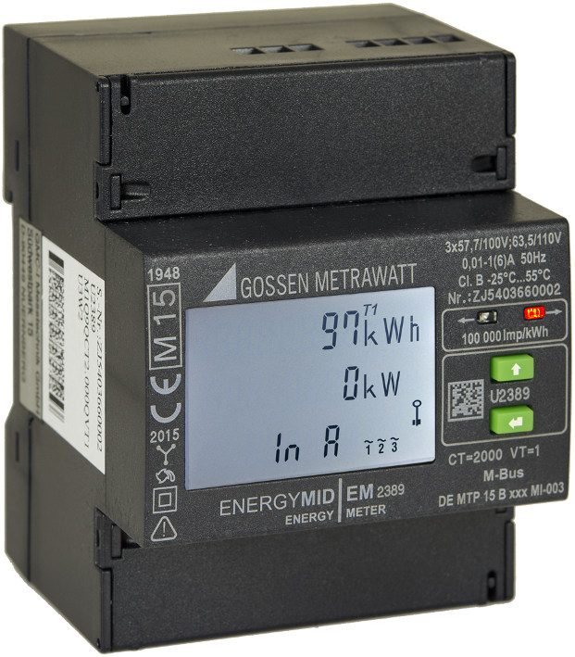
Illustration: The new generation of sustainable energy meters from Gossen Metrawatt come with a MID-compliant calibration for differentiated cost accounting

Network quality is also monitored via THD current and voltage measurement. The ENERGYMID handles up to eight different rates for electricity and is therefore well-equipped for future structural pricing changes. Measured values are transmitted via pulse through standardized or freely programmable S0 interfaces. LON, M-Bus, MODBUS-RTU/-TCP or BACnet interfaces are optionally available as well for data transfer and remote readout. An integrated ring buffer ensures local data backup. The meters feature a high power density and are only four 18 mm module units wide. These extremely compact devices can be mounted on 35 mm DIN rails in any position. A backlit display clearly shows the selected measurement data, facilitates the monitoring of connection parameters and alerts users to installation errors by changing the display color. A parameter lock and sealed cover ensure the devices cannot be tampered with. The new ENERGYMID is available at a competitive price and with a manufacturer's warranty of three years.

Illustrations: | em_kompakt | Char.s: | 1,730
File name: | 201609001_pm_energymid | Date: | 2016-11-17

About Gossen Metrawatt

GMC-I Messtechnik is one of the world's leading suppliers of measurement systems. Under the GOSSEN METRAWATT brand, the company develops and distributes a wide range of high-quality measuring and test devices for the electrical trade, industry, and the medical sector. The scope of products includes measuring and testing equipment for standardized testing of electrical systems and appliances, multimeters, calibrators, network analyzers, power supplies, as well as transducers and power meters for high-voltage and moving-coil measurement. GMC-I Messtechnik also provides a varied offering of training courses for customers and develops energy management concepts. The corporate group runs its own DakkS-certified calibration center that performs DakkS, ISO and factory calibrations for virtually all electrical measured values. GMC-I Messtechnik is part of the GMC Instruments group, which also includes other specialized manufacturers for measurement and testing technology – notably, Camille Bauer Metrawatt, Dranetz, Prosys, Seaward and Rigel, and Kurth Electronic. The group's production sites in Germany, Switzerland, England and the United States are complemented by a global sales network.

Contact:  GMC-I Messtechnik GmbH  Christian Widder  Leiter Marketingkommunikation  Südwestpark 15  90449 Nürnberg  Germany  Phone: +49 911 / 8602 - 572  Fax: +49 911 / 8602 - 4699  E-mail: christian.widder@gossenmetrawatt.com  Web: www.gossenmetrawatt.com | 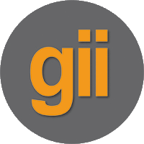 | gii die Presse-Agentur GmbH  Immanuelkirchstr. 12  10405 Berlin  Germany  Phone: +49 30 / 538 965 - 0  Fax: +49 30 / 538 965 - 29  E-mail: info@gii.de  Web: www.gii.de

