Press Release

Compact logger checks cure of coated monoblock containers

Fluke Process Instruments has developed a miniature monitoring solution for monoblock cure processes. The DATAPAQ MonoPaq2 system profiles the metal temperature of coated aluminum bottles, aerosols, and collapsible tubes both in IBO and OBO lines. The thermal barrier measures merely 41 x 48 x 195 mm, making it 43% smaller by volume than the preceding generation. The temperature profiling system can be used in lines with very closely spaced pins (>45 mm) and with various product basket sizes. This engineering success is primarily based on the development of a new data logger with a minimal footprint. The new DATAPAQ Q18 logger connects four thermocouples via micro-miniature sockets and logs up to 32,000 readings per channel with an adjustable interval of 0.05 s or more. Its accuracy of ±0.5 °C puts it squarely in the class of the best available loggers.

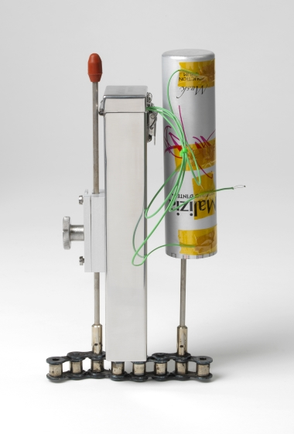
Illustration: The new, highly precise miniature logger records detailed temperature profiles of monoblock processes

Downloaded to a PC or notebook, the thermal profile can be reviewed with the DATAPAQ Insight software, which includes versatile visualization, analysis, and reporting functions. Manufacturers can thereby optimize their oven settings and ensure that every product experiences the specified time at temperature. Regular monitoring is facilitated by the compact size and light weight of the system. Mounting brackets are available in different versions for quick and secure attachment in any line layout.

Illustrations: | datapaq_monopaq_obo | Char.s: | 1,365
File name: | 201611050_pm_datapaq_monopaq2_en | Date: | 2016-12-13
About Fluke Process Instruments
Fluke Process Instruments designs, manufactures, and markets a complete line of infrared temperature measurement and profiling solutions for industrial, maintenance, and quality control applications. Distributed worldwide under the Raytek, Ircon, and Datapaq brands, the products reflect the combined experience of over 125 years in manufacturing the world’s finest temperature measurement tools and devices.
About Fluke
Founded in 1948, Fluke Corporation is the world leader in compact, professional electronic test tools. Fluke customers are technicians, engineers, electricians, and metrologists who install, troubleshoot, and manage industrial, electrical, and electronic equipment and calibration processes.

Contact for Europe, Middle East, Africa:  Fluke Process Instruments  Datapaq Ltd.  Stephan Wilke  Blankenburger Str. 135  13127 Berlin  Germany  Tel.: +49 . 30 . 478 008 - 0  Fax: +49 . 30 . 471 0251  Email: sales-info@datapaq.com  WWW: www.flukeprocessinstruments.com  Contact for Americas, Asia-Pacific:  Fluke Process Instruments  Datapaq Inc.  Arlene Lucas-Starrh  Santa Cruz, CA, USA  Tel.: 800 227 8074 (US & Canada)  or +1 831 458 3930  Email: arlene.lucas-starrh@fluke.com |  | gii die Presse-Agentur GmbH  Immanuelkirchstr. 12  10405 Berlin  Germany  Tel.: +49 . 30 . 538 965 - 0  Fax: +49 . 30 . 538 965 - 29  Email: info@gii.de  WWW: www.gii.de

