Press Release

PROFTEST PRIME from Gossen Metrawatt
State of the art in electrical testing

Nuremberg – The new PROFITEST PRIME for standard-compliant testing of electrical installations is due to be launched by Gossen Metrawatt in spring 2017. This instrument combines state-of-the-art measurement technology with a unique set of features. It is suitable for almost any inspection task in machinery and switchgear construction, industrial and IT networks, wind turbines, photovoltaic systems, and electric charging stations. It is the only product of its kind with a large-scale test range that has been expanded to include 690 V AC and 800 V DC networks. Moreover, it is unique in featuring various newly developed test procedures: for the first time, it is possible to loop test in networks secured with type B RCD protection switches. Other new test procedures include innovative measurement methods to test ISO monitors up to 690 V and AC/DC sensitive RCDs up to 440 V in IT networks. All measurements can be made while leaving the measuring lines in place.

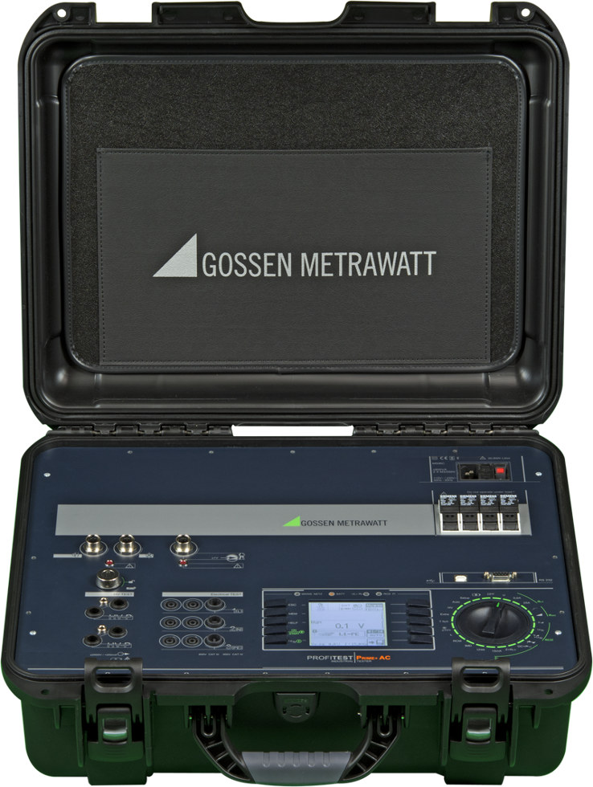
Illustration: PROFITEST PRIME, a new test device with range of functions that are unique on the market, is due to be launched in spring 2017

Test prods and fuses can be changed quickly. Coded connectors prevent handling errors. Modern data management has been implemented to facilitate the creation of plant structures for protocols and other documentation. In addition to predefined automated sequences that enable fast implementation of various measurement tasks, custom test sequences can be programmed. PROFINET PRIME is the only device in its class that can be operated on battery power in case the regular power supply is unavailable. The battery charge is sufficient for up to a thousand measurements, giving users great flexibility. In addition to the standard version for low voltage installations up to 1,000 V AC / 1,500 V DC, the PROFITEST is available in two enhanced versions that additionally include high-voltage tests with 5,000 V DC or 2,500 V AC. The latter also features a function for pulsed continuous measurements to identify defective cable insulation. All models feature Bluetooth and USB interfaces for bi-directional data exchange, e.g. to keep test result logs in a PC software. An RS232 interface is integrated to enable the connection of bar code or RFID scanners and various sensors. Extensive accessories and attractive package solutions are also available.

Illustrations: | profitest-prime-ac | Char.s: | 2,208
File name: | 201611058_pm_profitest_en | Date: | 2016-11-16

About Gossen Metrawatt

GMC-I Messtechnik is one of the world's leading suppliers of measurement systems. Under the GOSSEN METRAWATT brand, the company develops and distributes a wide range of high-quality measuring and test devices for the electrical trade, industry, and the medical sector. The scope of products includes measuring and testing equipment for standardized testing of electrical systems and appliances, multimeters, calibrators, network analyzers, power supplies, as well as transducers and power meters for high-voltage and moving-coil measurement. GMC-I Messtechnik also provides a varied offering of training courses for customers and develops energy management concepts. The corporate group runs its own DakkS-certified calibration center that performs DakkS, ISO and factory calibrations for virtually all electrical measured values. GMC-I Messtechnik is part of the GMC Instruments group, which also includes other specialized manufacturers for measurement and testing technology – notably, Camille Bauer Metrawatt, Dranetz, Prosys, Seaward and Rigel, and Kurth Electronic. The group's production sites in Germany, Switzerland, England and the United States are complemented by a global sales network.

Contact:  GMC-I Messtechnik GmbH  Christian Widder  Leiter Marketingkommunikation  Südwestpark 15  90449 Nürnberg  Germany  Phone: +49 911 / 8602 - 572  Fax: +49 911 / 8602 - 4699  E-mail: christian.widder@gossenmetrawatt.com  Web: www.gossenmetrawatt.com |  | gii die Presse-Agentur GmbH  Immanuelkirchstr. 12  10405 Berlin  Germany  Phone: +49 30 / 538 965 - 0  Fax: +49 30 / 538 965 - 29  E-mail: info@gii.de  Web: www.gii.de

