Press Release

DATAPAQ EasyTrack3: more memory, easy handling

The newest generation DATAPAQ EasyTrack3 system makes profiling oven cure of painted and powder-coated products as easy as never before. Fluke Process Instruments has equipped the data logger with a rugged and light polycarbonate casing that withstands harsh treatment and heat up to 100 °C without distortion and without harm to the electronics. Versions with four or six thermocouple channels are available. Data is stored in a non-volatile memory – the capacity has been tripled to up to 18,000 readings per channel.

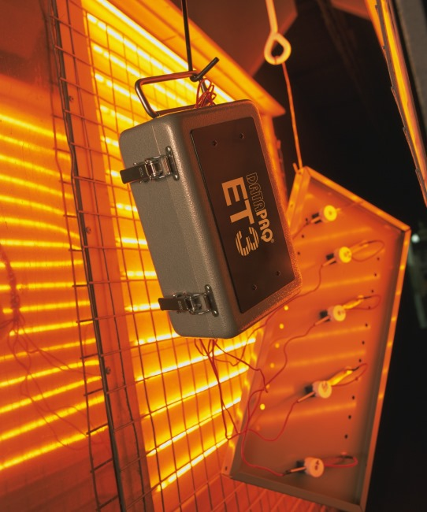
Illustration: Measure IR and convection ovens with more detail and more data security and – with the pro version – up to three consecutive profiling runs

The loggers use replaceable 9 V batteries. An intelligent power management ensures a long battery life for 50 and more profiling runs. Calibration certificates stored aboard the logger can be printed anytime. When the logger is connected to a PC (via USB), the software now starts automatically. Reviewing and analyzing the data, users can dynamically change the language. Logger diagnostics is much facilitated by a quick reference guide and animated tutorials. For remote diagnostics, status data can be emailed to the manufacturer’s tech support. Fluke Process Instruments supplies a versatile range of profiling systems with probes and thermal barriers to suit a variety of applications. The new pro version logger carries out up to three consecutive profiling runs before data download to a PC. It features a traffic light indicator that instantly shows whether process criteria have been met. The DATAPAQ EasyTrack Insight Professional software includes advanced analysis functions such as rise/fall, peak difference, area under curve calculation, marking of up to six oven zones in the temperature graph, a probe map for high repeatability, saved zooms for even more comfortable reviewing and sharing of data, and customized profile reports.

Illustrations: | datapaq_easytrack3_appl2 | Char.s: | 1,767
File name: | 201701004_pm_datapaq_easytrack3_en | Date: | 2017-04-05
About Fluke Process Instruments
Fluke Process Instruments designs, manufactures, and markets a complete line of infrared temperature measurement and profiling solutions for industrial, maintenance, and quality control applications. Distributed worldwide under the Raytek, Ircon, and Datapaq brands, the products reflect the combined experience of over 125 years in manufacturing the world’s finest temperature measurement tools and devices.
About Fluke
Founded in 1948, Fluke Corporation is the world leader in compact, professional electronic test tools. Fluke customers are technicians, engineers, electricians, and metrologists who install, troubleshoot, and manage industrial, electrical, and electronic equipment and calibration processes.

Contact for Europe, Middle East, Africa:  Fluke Process Instruments GmbH  Stephan Wilke  Blankenburger Straße 135  13127 Berlin  Germany |  | gii die Presse-Agentur GmbH  Immanuelkirchstr. 12  10405 Berlin  Germany  Tel.: +49 . 30 . 538 965-0  Fax: +49 . 30 . 538 965-29  Email: info@gii.de  WWW: www.gii.de
Tel.: +49 . 30 . 478 008-0
Fax: +49 . 30 . 471 0251
Email: marcom1.emea@flukeprocessinstruments.de
Internet: www.flukeprocessinstruments.com

Contact for Americas and Australasia:
Arlene Lucas-Starrh
arlene.lucas-starrh@fluke.com

Contact for Asia (except China):
Clothilde Bugnard
clothilde.bugnard@fluke.com

