Press Release

Smallest mini-wave profiler
Fluke Process Instruments at SMT Hybrid Packaging show

Fluke Process Instruments presents a trade show novelty at the 2017 SMT Hybrid Packaging exposition – the world's smallest thermal profiling system designed specifically for miniature-wave selective soldering processes. The DATAPAQ SelectivePaq measuring system consists of a new, smaller data logger and customized thermal barrier. Merely 20 mm high and 40 mm wide, it fits into every wave soldering system and is ideally suited for use with holding frames.

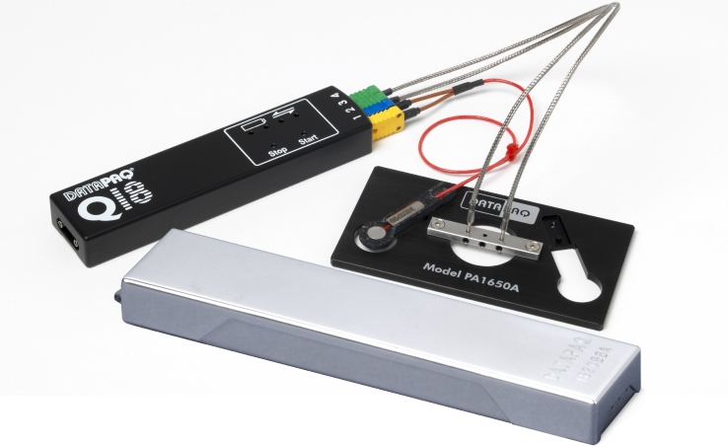
Illustration: DATAPAQ SelectivePaq is an ultra-compact temperature profiling system for monitoring the stability and repeatability of miniature-wave selective soldering processes

Part of the proven DATAPAQ Q18 series, this micro-size data logger provides a superior accuracy of ±0.5 °C and a resolution of 0.1 °C. It uses four thermocouples to take measurements from electronic assemblies as they are preheated in an IR or convection oven and then dip-soldered. Probing intervals can be adjusted to up to 20 samples per second. With a logger case machined from solid aluminum and user-replaceable rechargeable battery packs, these products achieve a very long service life and extra-low operating cost. The profiling systems come with the full-fledged version of the DATAPAQ Insight Reflow software that has data analysis options for maximum slopes, maximum temperatures, and wave contact times. An optional Sensor Array facilitates regular and frequent checks of process stability.

Fluke Process Instruments at SMT Hybrid Packaging
16 – 18 May 2017, Nuremberg, Germany
Hall 4, Stand 437

Illustrations: | datapaq_selectivepaq_array_tb | Char.s: | 1,261
File name: | 201705002_pm_smthybridpackaging_en | Date: | 2017-05-05
About Fluke Process Instruments
Fluke Process Instruments designs, manufactures, and markets a complete line of infrared temperature measurement and profiling solutions for industrial, maintenance, and quality control applications. Distributed worldwide under the Raytek, Ircon, and Datapaq brands, the products reflect the combined experience of over 125 years in manufacturing the world’s finest temperature measurement tools and devices.
About Fluke
Founded in 1948, Fluke Corporation is the world leader in compact, professional electronic test tools. Fluke customers are technicians, engineers, electricians, and metrologists who install, troubleshoot, and manage industrial, electrical, and electronic equipment and calibration processes.

Contact for Europe, Middle East, Africa:  Fluke Process Instruments GmbH  Stephan Wilke  Blankenburger Str. 135  13127 Berlin  Germany |  | gii die Presse-Agentur GmbH  Immanuelkirchstr. 12  10405 Berlin  Germany  Tel.: +49 . 30 . 538 965-0  Fax: +49 . 30 . 538 965-29  Email: info@gii.de  WWW: www.gii.de
Tel.: +49 . 30 . 478 008-0
Fax: +49 . 30 . 471 0251
Email: marcom1.emea@flukeprocessinstruments.de
Internet: www.flukeprocessinstruments.com

Contact for Americas and Australasia:
Arlene Lucas-Starrh
arlene.lucas-starrh@fluke.com

Contact for Asia (except China):
Clothilde Bugnard
clothilde.bugnard@fluke.com

