Press Release

The well-tempered SMT circuit board

Fluke Process Instruments supplies systems solutions for temperature profiling in SMT processes that comprise a data logger, thermocouples, a thermal barrier, and software. DATAPAQ Reflow Trackers monitor reflow, wave, vapor phase, and selective soldering applications. They travel along with the PCBs through every stage of the process including the preheating phase, capturing detailed temperature profiles along the way based on data gathered by up to 12 sensors. Featuring automatic analysis, traffic light signals, and programmable alarms, the loggers instantly show whether the specification for a profile is compromised. Precise temperature control is vital – the solder must be melted without damaging the electrical components. The DATAPAQ Easy Oven Setup software, which is included free-of-charge with any Reflow Tracker system, features a function for automatically determining oven recipes. This saves a lot of valuable time during commissioning and product changeovers. In addition, the software provides comprehensive analysis functions. Downloaded to a computer, the profiles can be shared via the open communications standard OPC for further analysis. The most recent addition to Fluke Process Instruments' profiler range for the electronics industry is the world's smallest temperature monitoring system for selective mini-wave soldering: no more than 20 mm high and 40 mm wide including the thermal barrier, DATAPAQ SelectivePaq enables reliable measurements even in very tight spaces.

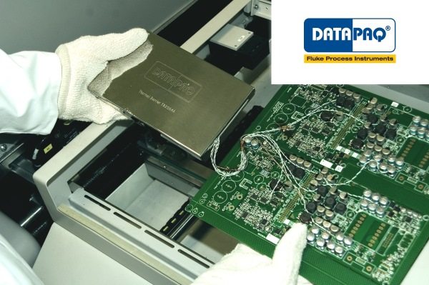
Illustration: Fluke Process Instruments develops and manufactures temperature profiling solutions especially adapted to reflow applications

Illustrations: | pcb_datapaq | Char.s: | 1,504
File name: | 201705003_pm_smt_temp_logger_en | Date: | 2017-05-05
About Fluke Process Instruments
Fluke Process Instruments designs, manufactures, and markets a complete line of infrared temperature measurement and profiling solutions for industrial, maintenance, and quality control applications. Distributed worldwide under the Raytek, Ircon, and Datapaq brands, the products reflect the combined experience of over 125 years in manufacturing the world’s finest temperature measurement tools and devices.
About Fluke
Founded in 1948, Fluke Corporation is the world leader in compact, professional electronic test tools. Fluke customers are technicians, engineers, electricians, and metrologists who install, troubleshoot, and manage industrial, electrical, and electronic equipment and calibration processes.

Contact for Europe, Middle East, Africa:  Fluke Process Instruments GmbH  Stephan Wilke  Blankenburger Str. 135  13127 Berlin  Germany |  | gii die Presse-Agentur GmbH  Immanuelkirchstr. 12  10405 Berlin  Germany  Tel.: +49 . 30 . 538 965-0  Fax: +49 . 30 . 538 965-29  Email: info@gii.de  WWW: www.gii.de
Tel.: +49 . 30 . 478 008-0
Fax: +49 . 30 . 471 0251
Email: marcom1.emea@flukeprocessinstruments.de
Internet: www.flukeprocessinstruments.com

Contact for Americas and Australasia:
Arlene Lucas-Starrh
arlene.lucas-starrh@fluke.com

Contact for Asia (except China):
Clothilde Bugnard
clothilde.bugnard@fluke.com

