Press Release

Heat protection range for temperature profiling in paint operations
Robust results ensured

The new DATAPAQ EasyTrack3 temperature profiling system from Fluke Process Instruments addresses the needs of any paint or powder coating operation. A comprehensive range of thermal barriers protects the data logger with its non-volatile memory in infrared and convection ovens. The light-weight aluminum standard barrier shields the electronics for up to 2 hours at 200 °C. Thermal protection is ensured by high-performance microporous insulation and a heat sink. The DATAPAQ EasyTrack3 Professional System extends protection to 3 hours, allowing users to monitor up to three cure processes consecutively. A thermal barrier for high-temperature PTFE and Dacromet coating withstands 400 °C for up to 90 min. Lastly, the manufacturer has also designed a low-height barrier for profiling typical mesh belt cure lines where oven clearance is significantly restricted. At merely 31 mm high, the barrier provides protection for a full 13 min at 200 °C or for 30 min at 100 °C. The logger operating temperature is 85 °C. It automatically switches off, should it ever heat above that point – for instance due to unscheduled line stops. This prevents faulty data collection. The profiler provides a measurement accuracy of ±1.6 °C (logger and thermocouple accuracy combined) over its entire operating temperature range. The robust, tried-and-tested system ensures successful measurements day after day.

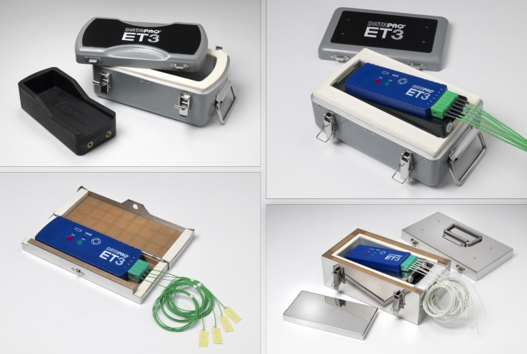
Illustration: The DATAPAQ EasyTrack3 program comprises equipment for temperature profiling in PTFE and Dacromet coating, IR and convection ovens, and low-clearance mesh belt ovens

Illustrations: | datapaq_easytrack3_tb_range | Char.s: | 1,394
File name: | 201706008_pm_easytrack3_barriers_en | Date: | 06-14-2017
About Fluke Process Instruments
Fluke Process Instruments designs, manufactures, and markets a complete line of infrared temperature measurement and profiling solutions for industrial, maintenance, and quality control applications. Distributed worldwide under the Raytek, Ircon, and Datapaq brands, the products reflect the combined experience of over 125 years in manufacturing the world’s finest temperature measurement tools and devices.
About Fluke
Founded in 1948, Fluke Corporation is the world leader in compact, professional electronic test tools. Fluke customers are technicians, engineers, electricians, and metrologists who install, troubleshoot, and manage industrial, electrical, and electronic equipment and calibration processes.

Contact for Europe, Middle East, Africa:  Fluke Process Instruments GmbH  Stephan Wilke  Blankenburger Str. 135  13127 Berlin  Germany |  | gii die Presse-Agentur GmbH  Immanuelkirchstr. 12  10405 Berlin  Germany  Tel.: +49 . 30 . 538 965-0  Fax: +49 . 30 . 538 965-29  Email: info@gii.de  WWW: www.gii.de
Tel.: +49 . 30 . 478 008-0
Fax: +49 . 30 . 471 0251
Email: marcom1.emea@flukeprocessinstruments.de
Internet: www.flukeprocessinstruments.com

Contact for Americas and Australasia:
Arlene Lucas-Starrh
arlene.lucas-starrh@fluke.com

Contact for Asia (except China):
Clothilde Bugnard
clothilde.bugnard@fluke.com

