Press Release

Industrial-strength temp profilers and infrared thermometers

The temperature monitoring experts Fluke Process Instruments will showcase a wide range of sensors for various industry sectors and applications at the 2017 Advanced Engineering exhibition. The latest addition to the noncontact, infrared thermometer portfolio, the Endurance series covers measured temperatures from 50 °C to 3,200 °C. It comprises monochrome and ratio pyrometers with various spectral ranges. The sensors feature a stainless steel IP65 housing, galvanically insulated I/Os, a versatile range of sighting options including a high-resolution onboard video camera, remote monitoring via Industrial Ethernet, and a built-in web server for process troubleshooting and traceability. Applications include the metals, glass, plastics, and semiconductor industries.

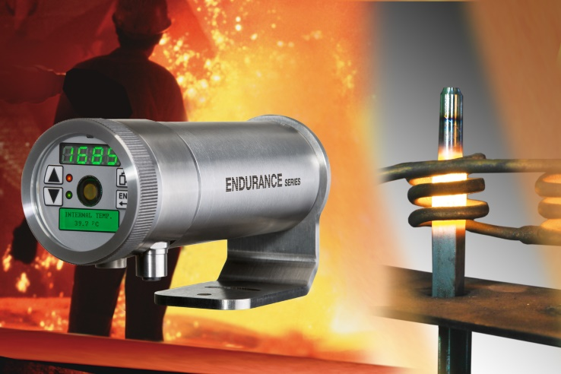
Illustration 1: Rugged infrared thermometers ensure high precision and flexible integration in all kinds of process monitoring setups

Outstanding additions to the manufacturer’s temperature profiling portfolio include the smallest profiler designed specifically for miniature wave selective soldering processes: the DATAPAQ SelectivePaq takes measurements from surface-mount assemblies as they pass through the preheating and dip soldering phases. The system combines a four-channel DATAPAQ Q18 micro data logger with the latest micro-miniature thermocouple plugs, the DATAPAQ Insight Reflow software, and a low-mass thermal shield that is merely 20 mm high and 40 mm wide.
The paint and powder-coating industry will greatly appreciate another profiler premiere at Advanced Engineering: the latest-generation DATAPAQ EasyTrack3 system makes profiling oven cure of painted and powder-coated products as easy as never before. Loggers are now available for up to three consecutive profiling runs before data download to a PC. Upon leaving the oven, a traffic-light indicator on the logger casing shows whether process criteria have been met. The DATAPAQ EasyTrack Insight Professional software includes advanced analysis functions such as rise/fall, peak difference, area under curve calculation, marking of up to six oven zones in the temperature graph, a probe map for high repeatability, saved zooms for even more comfortable reviewing and sharing of data, and customized profile reports.

Fluke Process Instruments at the Advanced Engineering exhibition
Birmingham, UK, 01 – 02 November 2017
Booth J42

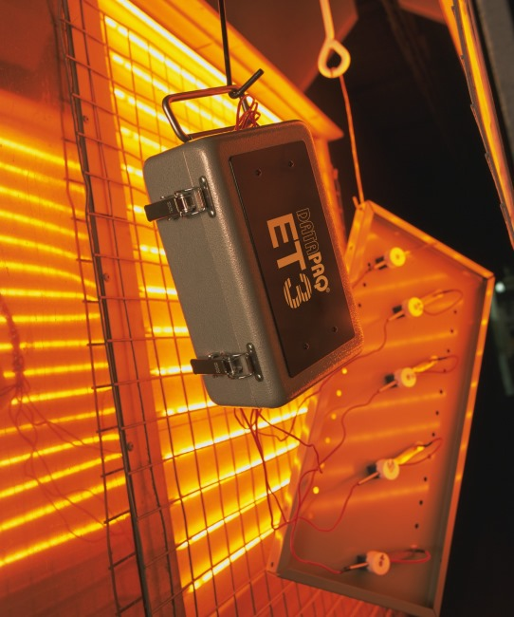
Illustration 2: The profilers for IR and convection ovens provide more detail and more data security; the pro version enables up to three consecutive profiling runs

Illustrations: | endurance_appl  datapaq_easytrack3_appl2 | Char.s: | 2,126
File name: | 201707042_pm_advanced_engineering_en | Date: | 08-30-2017
About Fluke Process Instruments
Fluke Process Instruments designs, manufactures, and markets a complete line of infrared temperature measurement and profiling solutions for industrial, maintenance, and quality control applications. Distributed worldwide under the Raytek, Ircon, and Datapaq brands, the products reflect the combined experience of over 125 years in manufacturing the world’s finest temperature measurement tools and devices.
About Fluke
Founded in 1948, Fluke Corporation is the world leader in compact, professional electronic test tools. Fluke customers are technicians, engineers, electricians, and metrologists who install, troubleshoot, and manage industrial, electrical, and electronic equipment and calibration processes.

Contact for Europe, Middle East, Africa:  Fluke Process Instruments GmbH  Stephan Wilke  Blankenburger Str. 135  13127 Berlin  Germany |  | gii die Presse-Agentur GmbH  Immanuelkirchstr. 12  10405 Berlin  Germany  Tel.: +49 . 30 . 538 965-0  Fax: +49 . 30 . 538 965-29  Email: info@gii.de  WWW: www.gii.de
Tel.: +49 . 30 . 478 008-0
Fax: +49 . 30 . 471 0251
Email: marcom2.emea@flukeprocessinstruments.de
Internet: www.flukeprocessinstruments.com

Contact for Americas and Australasia:
Arlene Lucas-Starrh
arlene.lucas-starrh@fluke.com

Contact for Asia (except China):
Clothilde Bugnard
clothilde.bugnard@fluke.com

