Press Release

Fluke Process Instruments launches new website combining industrial temperature measurement solutions

Fluke Process Instruments has announced the launch of a new website, www.flukeprocessinstruments.com, combining its extensive global capabilities in industrial temperature measurement. The website was designed to reflect the company’s core competencies and mission to provide the most comprehensive infrared temperature measurement and profiling solutions for industrial, maintenance and quality control applications.
Fluke Process Instruments brings together more than 150 years of experience in pioneering new technologies into one integrated company. By joining three recognized brand leaders – Raytek, Ircon and Datapaq – it offers a complete line of infrared sensors, linescanners, thermal imagers and profiling systems for use in today’s most demanding environments.

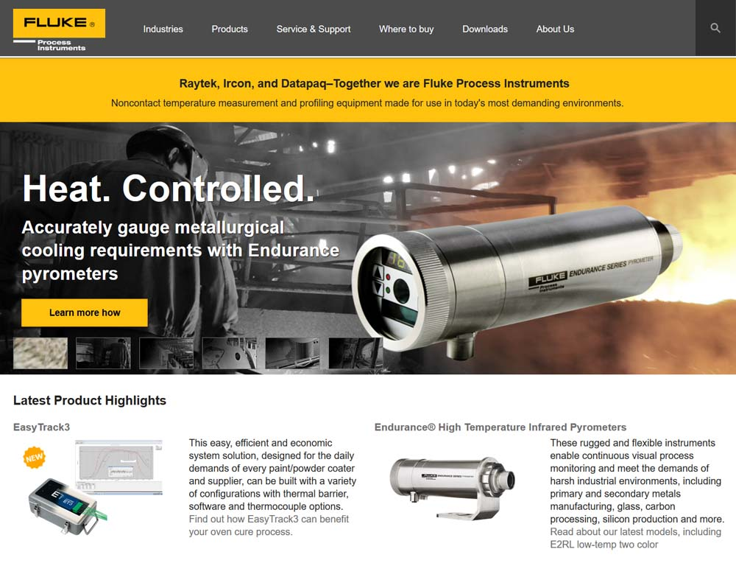
Illustration: The new website integrates the Raytek, Ircon and Datapaq temperature measurement products and provides an easy access to them via specific applications or industries

Fluke Process Instruments has consolidated multiple legacy domains into a single website with a new look and feel. Content and resources on the site are focused on industry and application-specific requirements, with solutions offered by type of technology.
“We wanted a website that projected our fundamental capabilities, including our ability to meet the challenges of industrial temperature measurement through a world-class customer portal,” said Fluke Process Instruments Vice President of Sales and Marketing, Steven Moore. “This site accomplishes these objectives and accurately conveys our dedication to providing process instruments and solutions that assist our customers with making products that help the world function better.”
Key features of the new Fluke Process Instruments website include:
- Integrated Assets and Resources – Provides one-stop shopping with easily recognizable industry application solutions for IR temperature measurement and thermal profiling
- Expanded and/or Refreshed Content – Increases availability of resources across the Fluke Process Instruments line and targets specific needs at each level of the customer journey
- Intuitive Interface – Makes information easier to find, simplifies search functionality and contributes to an improved overall customer experience
- Responsive Design – Simplifies navigation using any device (desktop, tablet and/or mobile) to keep pace with the new generation of industrial worker mobility
- Greater ease-of-use – Includes top-level navigation with dropdown menus to put information at the visitor’s fingertips, and provides links to relevant resources on each product page
- More Focused Sector capability – Helps end-users from various industries quickly and clearly understand solutions tailored to their unique requirements
- Improved Product Descriptions & Details – Offers concise specifications and visual images of the entire portfolio, with applications and products cross-referenced on individual pages
Fluke Process Instruments developed its website based on recognized best practices and extensive voice of the customer (VOC) usability studies. The new site is currently provided in English, but will be updated to include German, French, Spanish and Chinese language versions in the near future. In addition, new Fluke Process Instruments social media sites will be coming soon.
An “Our Shared Purposes” video provides additional information on the company.

Illustrations: | flukeprocessinstruments_com_2017 | Char.s: | 3,212
File name: | 201708018_pm_website_relaunch_en | Date: | 08-23-2017
About Fluke Process Instruments
Fluke Process Instruments designs, manufactures, and markets a complete line of infrared temperature measurement and profiling solutions for industrial, maintenance, and quality control applications. Distributed worldwide under the Raytek, Ircon, and Datapaq brands, the products reflect the combined experience of over 125 years in manufacturing the world’s finest temperature measurement tools and devices.
About Fluke
Founded in 1948, Fluke Corporation is the world leader in compact, professional electronic test tools. Fluke customers are technicians, engineers, electricians, and metrologists who install, troubleshoot, and manage industrial, electrical, and electronic equipment and calibration processes.

Contact for Europe, Middle East, Africa:  Fluke Process Instruments GmbH  Stephan Wilke  Blankenburger Str. 135  13127 Berlin  Germany |  | gii die Presse-Agentur GmbH  Immanuelkirchstr. 12  10405 Berlin  Germany  Tel.: +49 . 30 . 538 965-0  Fax: +49 . 30 . 538 965-29  Email: info@gii.de  WWW: www.gii.de
Tel.: +49 . 30 . 478 008-0
Fax: +49 . 30 . 471 0251
Email: marcom2.emea@flukeprocessinstruments.de
Internet: www.flukeprocessinstruments.com

Contact for Americas and Australasia:
Arlene Lucas-Starrh
arlene.lucas-starrh@fluke.com

Contact for Asia (except China):
Clothilde Bugnard
clothilde.bugnard@fluke.com

