Press Release

Gossen Metrawatt enhances new generation of electric meters
Highly accurate metering devices for direct connection

Nuremberg – Gossen Metrawatt now provide their compact, high-performance ENERGYMID energy meters in two versions designed for direct connection. These models require no external current and voltage transformers, which saves installation space as well as expenses. The recently launched EM 2281 meter measures energy consumption directly in 2-wire AC systems with 230 V voltage. The second model now introduced by the measuring technology experts, the EM 2289 meter has been designed for 4-wire three-phase current with ratings up to 80 A and an input voltage of 400 V. Like all devices in this new generation meter range, the two direct measuring models are pre-calibrated according to MID standards and generate power consumption records and power feed data for differentiated cost accounting. With an extensive range of functions comprising not only energy consumption, but also up to 33 additional parameters depending on the selected model, the EM 2281 and EM 2289 meters are uniquely positioned in their market segment. For instance, they can be used to measure reactive energy, apparent power, neutral conductor current, power factor, frequency and power supply, and will additionally monitor power quality through Total Harmonic Distortion (THD). Users can choose from a range of standard or freely programmable outputs to measure value transmission via pulse. The manufacturer also offers optional interfaces for M-Bus, LON, BACnet, and MODBUS RTU/TCP to facilitate flexible network integration and remote readout. With a width of merely 4 pitch units, the new generation meters are also extremely compact. They can be mounted on 35 mm DIN rails in any orientation in a cabinet. A backlit display clearly shows the selected measurement data, facilitates the monitoring of connection parameters and alerts users to phase failure, overload and installation errors by changing the display color.

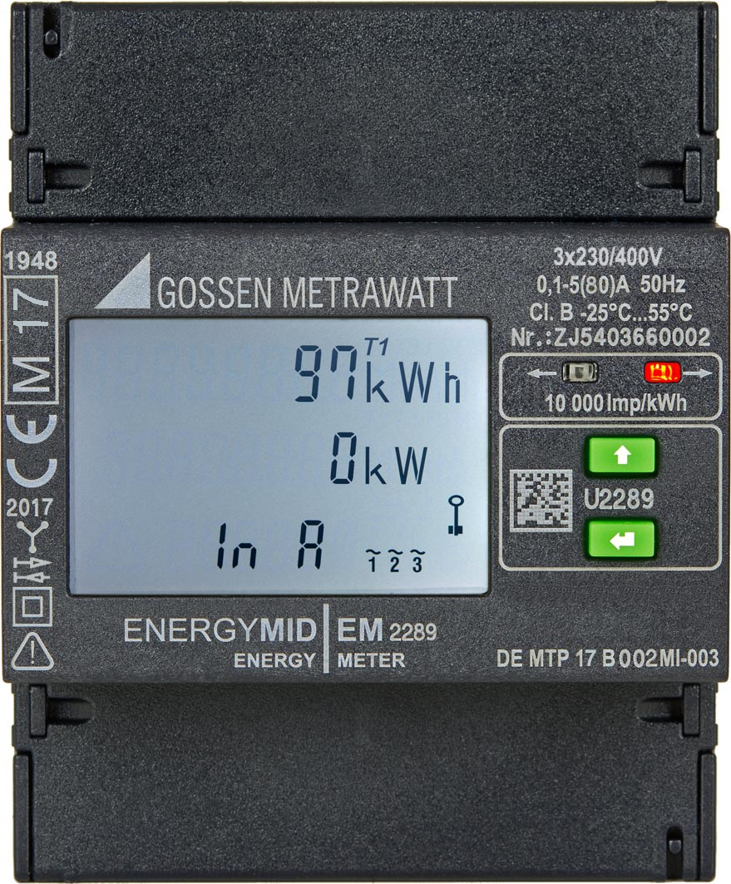
Illustration: The highly compact ENERGYMID from Gossen Metrawatt is now available in two versions for direct measurement, which means without extra current and voltage transformers.

Illustrations: | em2289_front | Char.s: | 1,889
File name: | 201708047_pm_energyMID_2281_89_en | Date: | 09-20-2017

About Gossen Metrawatt

GMC-I Messtechnik is one of the world's leading suppliers of measurement systems. Under the GOSSEN METRAWATT brand, the company develops and distributes a wide range of high-quality measuring and test devices for the electrical trade, industry, and the medical sector. The scope of products includes measuring and testing equipment for standardized testing of electrical systems and appliances, multimeters, calibrators, network analyzers, power supplies, as well as transducers and power meters for high-voltage and moving-coil measurement. GMC-I Messtechnik also provides a varied offering of training courses for customers and develops energy management concepts. The corporate group runs its own DakkS-certified calibration center that performs DakkS, ISO and factory calibrations for virtually all electrical measured values. GMC-I Messtechnik is part of the GMC Instruments group, which also includes other specialized manufacturers for measurement and testing technology – notably, Camille Bauer Metrawatt, Dranetz, Prosys, Seaward and Rigel, and Kurth Electronic. The group's production sites in Germany, Switzerland, England and the United States are complemented by a global sales network.

Contact:  GMC-I Messtechnik GmbH  Christian Widder  Leiter Marketingkommunikation  Südwestpark 15  90449 Nürnberg  Germany  Phone: +49 911 / 8602 - 572  Fax: +49 911 / 8602 - 4699  E-mail: christian.widder@gossenmetrawatt.com  Web: www.gossenmetrawatt.com |  | gii die Presse-Agentur GmbH  Immanuelkirchstr. 12  10405 Berlin  Germany  Phone: +49 30 / 538 965 - 0  Fax: +49 30 / 538 965 - 29  E-mail: info@gii.de  Web: www.gii.de

