Press Release

Anti-microbial multimeter from Gossen Metrawatt
Exact measurements in hygienically demanding environments

Nuremberg – Measuring technology for testing the electrical safety in sterile or hygienically sensitive areas – ranging from hospitals, laboratories, or medical practices to production facilities in the pharmaceutical or food sector – are subject to particularly strict regulations. For such environments, measuring technology expert Gossen Metrawatt has developed SECULIFE HIT AM, a digital TRMS multimeter featuring an anti-microbial design. The ergonomically designed hand-held device enables TRMS AC and AC + DC measurements, irrespective of the signal shape, for voltages and currents up to 20 kHz. 23 multimeter functions provide secure and reliable measurements for all required inspection tasks, including current measurement from 100 mA up to 10 A, voltage, capacitance and resistance measurement, and diode and continuity tests. In addition, a 1 kHz low pass filter can be switched on to measure e.g. the motor voltage at electronic frequency converters. Measurement of 5 V square wave signals is also supported. For enhanced safety, the housing, cables, and measuring probes are made from an anti-microbial material composition that counteracts microbial colonization. The multimeter comes with IP65 ingress protection. It features an illuminated display with digital and analog measurement indicators, which show fixed values as well as dynamic measurement curves with great accuracy. Measured parameters can be adjusted via a rotary switch and a function key. The measuring range automatically adapts to the reading, but can also be manually selected whenever necessary. A single connection port is used for all current measuring ranges, which completely eliminates any potential confusion. Up to 40 values per second can be automatically stored. The total storage capacity is sufficient for more than 15,000 measurements. The device is approved for CAT IV measurements up to 600V and is extremely safe to operate: in addition to a high-voltage sensor that ensures the input signal is safe to touch, the device features automatic socket blocking, which prevents the incorrect connection of cables or selection of the wrong measured parameters.

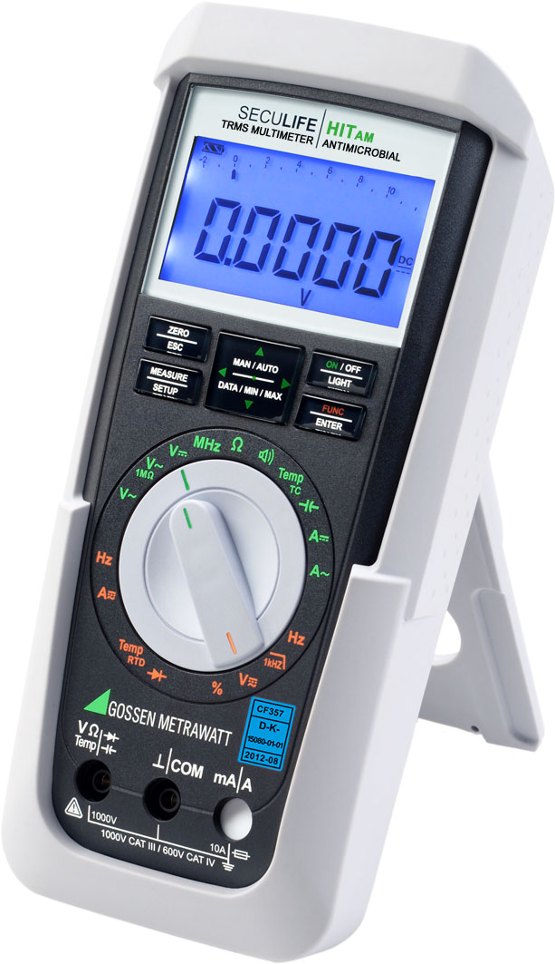

Illustration: Featuring an anti-microbial enclosure, the SECULIFE HIT AM is very ergonomic and provides highly versatile functionality

Illustrations: | seculifehitam_persp | Char.s: | 2.134
File name: | 201708050_pm_seculife_en | Date: | 10-18-2017

About Gossen Metrawatt

GMC-I Messtechnik is one of the world's leading suppliers of measurement systems. Under the GOSSEN METRAWATT brand, the company develops and distributes a wide range of high-quality measuring and test devices for the electrical trade, industry, and the medical sector. The scope of products includes measuring and testing equipment for standardized testing of electrical systems and appliances, multimeters, calibrators, network analyzers, power supplies, as well as transducers and power meters for high-voltage and moving-coil measurement. GMC-I Messtechnik also provides a varied offering of training courses for customers and develops energy management concepts. The corporate group runs its own DakkS-certified calibration center that performs DakkS, ISO and factory calibrations for virtually all electrical measured values. GMC-I Messtechnik is part of the GMC Instruments group, which also includes other specialized manufacturers for measurement and testing technology – notably, Camille Bauer Metrawatt, Dranetz, Prosys, Seaward and Rigel, and Kurth Electronic. The group's production sites in Germany, Switzerland, England and the United States are complemented by a global sales network.

Contact:  GMC-I Messtechnik GmbH  Christian Widder  Leiter Marketingkommunikation  Südwestpark 15  90449 Nürnberg  Germany  Phone: +49 911 / 8602 - 572  Fax: +49 911 / 8602 - 4699  E-mail: christian.widder@gossenmetrawatt.com  Web: www.gossenmetrawatt.com |  | gii die Presse-Agentur GmbH  Immanuelkirchstr. 12  10405 Berlin  Germany  Phone: +49 30 / 538 965 - 0  Fax: +49 30 / 538 965 - 29  E-mail: info@gii.de  Web: www.gii.de

