Press Release

Flexible measuring system for simple retrofitting
Transparent metering with ENERGYSENS

Nuremberg – In order to enhance the energy efficiency of buildings, infrastructure and industrial facilities, getting a transparent record of energy consumption is absolutely vital. However, densely packed equipment and distributed installations often complicate the integration of efficient measurement technology. Measurement specialist Gossen Metrawatt therefore now introduces ENERGYSENS, a new modular sensor system for precise energy consumption metering in accordance with precision class 1 in the DIN EN 60688 or DIN EN 62053-21 standards. The new measuring system comprises the slim ENERGY EScom basic module, which is only 2 HP wide, and up to 10 highly compact ENERGY ES sensor units that are available in four versions with 3 or 12 measuring inputs for current ratings of up to 40 A or 80 A. This allows for a flexible connection of up to 120 measuring points with a connection length up to 5 m to each base module. This very versatile solution is also very suitable for tight installation spaces in existing energy distribution boxes. Mounting the devices is very easy. In 50/60 Hz AC low-voltage systems, they can monitor the actual consumption values for effective power, energy, current, voltage and frequency. Moreover, by monitoring the phase load, ENERGYSENS also contributes to preventive maintenance and keeping downtime to a minimum. The sensors feature an extremely low profile with a very slim 13 mm. They are mounted onto the fuses. Measured values are transmitted to the base module via plug-on ribbon cable. Universal Modbus TCP and MODBUS RTU interfaces ensure fast data transfer in a variety of system environments. For an easy system integration without any programming, Gossen Metrawatt provides a free configuration software that is available for download on the company's website. In addition to the sleek design, ENERGYSENS also excels in term of minimal power consumption, in contrast to much more power-hungry other products on the market.

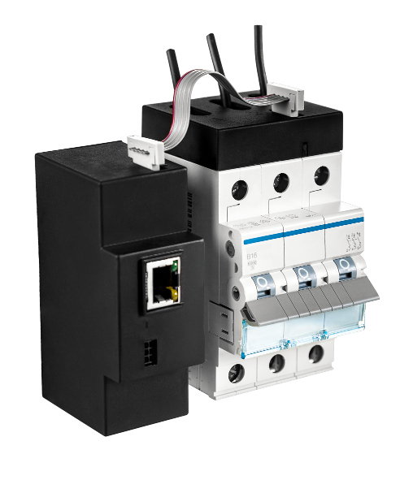

Illustration: ENERGYSENS from Gossen Metrawatt is an economic, space-saving retrofit solution that can be quickly installed to provide state-of-the-art metering technology

Illustrations: | ip_sensor | Char.s: | 1,955
File name: | 201708051_pm_energysens_en | Date: | 11-01-2017

About Gossen Metrawatt

GMC-I Messtechnik is one of the world's leading suppliers of measurement systems. Under the GOSSEN METRAWATT brand, the company develops and distributes a wide range of high-quality measuring and test devices for the electrical trade, industry, and the medical sector. The scope of products includes measuring and testing equipment for standardized testing of electrical systems and appliances, multimeters, calibrators, network analyzers, power supplies, as well as transducers and power meters for high-voltage and moving-coil measurement. GMC-I Messtechnik also provides a varied offering of training courses for customers and develops energy management concepts. The corporate group runs its own DakkS-certified calibration center that performs DakkS, ISO and factory calibrations for virtually all electrical measured values. GMC-I Messtechnik is part of the GMC Instruments group, which also includes other specialized manufacturers for measurement and testing technology – notably, Camille Bauer Metrawatt, Dranetz, Prosys, Seaward and Rigel, and Kurth Electronic. The group's production sites in Germany, Switzerland, England and the United States are complemented by a global sales network.

Contact:  GMC-I Messtechnik GmbH  Christian Widder  Leiter Marketingkommunikation  Südwestpark 15  90449 Nürnberg  Germany  Phone: +49 911 / 8602 - 572  Fax: +49 911 / 8602 - 4699  E-mail: christian.widder@gossenmetrawatt.com  Web: www.gossenmetrawatt.com | 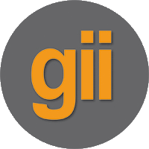 | gii die Presse-Agentur GmbH  Immanuelkirchstr. 12  10405 Berlin  Germany  Phone: +49 30 / 538 965 - 0  Fax: +49 30 / 538 965 - 29  E-mail: info@gii.de  Web: www.gii.de

