Press Release

Space saver in the control cabinet:
Slim energy meter with a wide range of functions

Nuremberg – Because every inch is precious in a control cabinet, Gossen Metrawatt has now launched a new generation of MID calibrated meters built to extremely compact dimensions. In a 4 HP design, which corresponds to an enclosure width of merely 72 mm, the new ENERGYMID provides a unique range of functions in its device class. At the same time, its small size allows the meter to be easily mounted on any 35 mm DIN rail in any position. Installation and commissioning are safe and easy thanks to the integrated connection fault diagnosis function. Its backlit panel, which very clearly displays all selected measurement data, alerts users to any installation errors via a distinctive change of color in the display. Depending on the selected model, the units record not only energy consumption but up to 33 additional parameters for cost accounting according to the standards of the Measuring Instrument Directive 2014/32/EU. These parameters include reactive energy, apparent power, neutral conductor current, power factor, frequency, power supply and more. In addition, the devices monitor power quality through Total Harmonic Distortion (THD). Measured values are transmitted via pulse through standardized or freely programmable S0 interfaces. The meter is available with optional bus interfaces for M-Bus, LON, BACnet, and MODBUS RTU/TCP to facilitate data transmission and remote readout. ENERGYMID meters come with three years manufacturer's warranty from Gossen Metrawatt and are offered at an attractive price. They are suitable for 2-, 3- and 4-wire systems with current transformer connection (1(6) A) and input voltages ranging from 100 to 500 V. They can be supplied as pre-configured standard models or in custom versions with an individually selected range of features and interfaces.

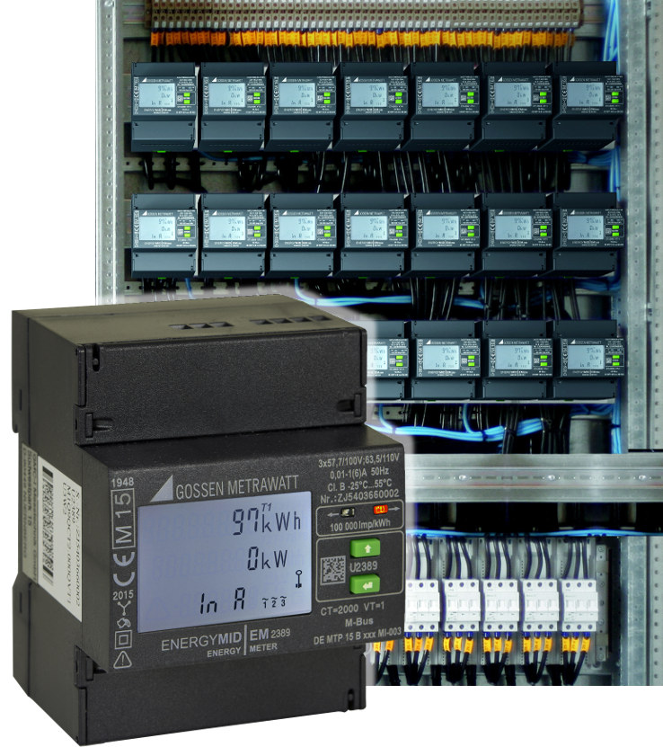

Illustration: Unique functionality in a slim 4 HP device: ENERGYMID energy meter from Gossen Metrawatt

Illustrations: | collage_schaltschrank_zaehler | Char.s: | 1,791
File name: | 201708052_pm_kompakter_energiezaehler_en | Date: | 12-07-2017

About Gossen Metrawatt

GMC-I Messtechnik is one of the world's leading suppliers of measurement systems. Under the GOSSEN METRAWATT brand, the company develops and distributes a wide range of high-quality measuring and test devices for the electrical trade, industry, and the medical sector. The scope of products includes measuring and testing equipment for standardized testing of electrical systems and appliances, multimeters, calibrators, network analyzers, power supplies, as well as transducers and power meters for high-voltage and moving-coil measurement. GMC-I Messtechnik also provides a varied offering of training courses for customers and develops energy management concepts. The corporate group runs its own DakkS-certified calibration center that performs DakkS, ISO and factory calibrations for virtually all electrical measured values. GMC-I Messtechnik is part of the GMC Instruments group, which also includes other specialized manufacturers for measurement and testing technology – notably, Camille Bauer Metrawatt, Dranetz, Prosys, Seaward and Rigel, and Kurth Electronic. The group's production sites in Germany, Switzerland, England and the United States are complemented by a global sales network.

Contact:  GMC-I Messtechnik GmbH  Christian Widder  Leiter Marketingkommunikation  Südwestpark 15  90449 Nürnberg  Germany  Phone: +49 911 / 8602 - 572  Fax: +49 911 / 8602 - 4699  E-mail: christian.widder@gossenmetrawatt.com  Web: www.gossenmetrawatt.com |  | gii die Presse-Agentur GmbH  Immanuelkirchstr. 12  10405 Berlin  Germany  Phone: +49 30 / 538 965 - 0  Fax: +49 30 / 538 965 - 29  E-mail: info@gii.de  Web: www.gii.de

