Press Release

Monitoring of paint and powder cure

Complementing the newly launched DATAPAQ EasyTrack3 temperature data logger for paint and powder cure, Fluke Process Instruments supplies a comprehensive range of precise and reliable thermocouple probes. The type K thermocouples are specified to ANSI MC96.1 for an accuracy of ±1.1 °C or 0.4%. They are supplied with a PTFE-jacketed cable designed to give flexibility but also enhance life expectancy in an industrial environment. These measure temperatures up to 265 °C. In addition, high-temperature glass-fiber thermocouples rated up to 500 °C are also available. Various attachment options accommodate all magnetic and non-magnetic products of all shapes and sizes. Small patch probes have a very short response time and are therefore ideal for monitoring small parts, plastics, and cans. Clamp-on probes measure surface and air temperature and can be used universally for thin parts, including aluminum-extruded products. A range of magnetic probes are available for rapid attachment to ferrous surfaces in moving lines – namely offset magnetic probes for monitoring flat products and air temperature and MicroMag surface probes which easily fit in tight spaces. The range is completed by two-, four-, and six-channel probe clamps for quickly detaching the data logger and probe ID tags.

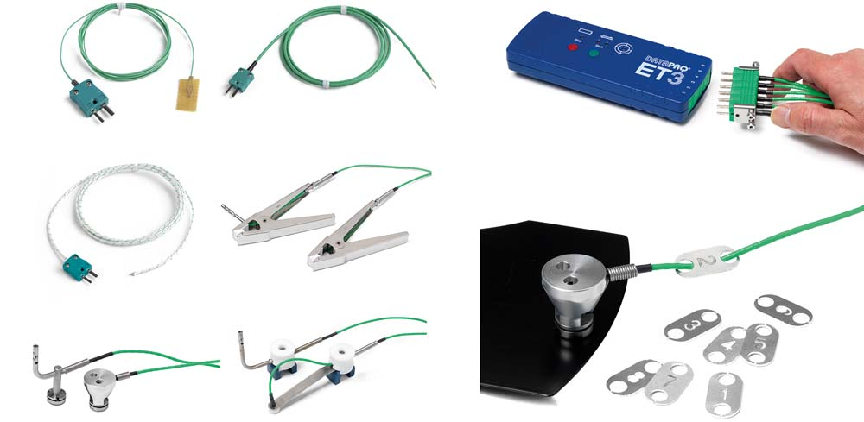
Illustration: The temperature profiling program includes thermocouples for ferrous materials, aluminum, and plastics

Illustrations: | datapaq_easytrack3_thermocouples | Char.s: | 1,293
File name: | 201709001_pm_easytrack3_probes_en_1 | Date: | 09-20-2017
About Fluke Process Instruments
Fluke Process Instruments designs, manufactures, and markets a complete line of infrared temperature measurement and profiling solutions for industrial, maintenance, and quality control applications. Distributed worldwide under the Raytek, Ircon, and Datapaq brands, the products reflect the combined experience of over 125 years in manufacturing the world’s finest temperature measurement tools and devices.
About Fluke
Founded in 1948, Fluke Corporation is the world leader in compact, professional electronic test tools. Fluke customers are technicians, engineers, electricians, and metrologists who install, troubleshoot, and manage industrial, electrical, and electronic equipment and calibration processes.

Contact for Europe, Middle East, Africa:  Fluke Process Instruments GmbH  Stephan Wilke  Blankenburger Str. 135  13127 Berlin  Germany |  | gii die Presse-Agentur GmbH  Immanuelkirchstr. 12  10405 Berlin  Germany  Tel.: +49 . 30 . 538 965-0  Fax: +49 . 30 . 538 965-29  Email: info@gii.de  WWW: www.gii.de
Tel.: +49 . 30 . 478 008-0
Fax: +49 . 30 . 471 0251
Email: marcom1.emea@flukeprocessinstruments.de
Internet: www.flukeprocessinstruments.com

Contact for Americas and Australasia:
Arlene Lucas-Starrh
arlene.lucas-starrh@fluke.com

Contact for Asia (except China):
Clothilde Bugnard
clothilde.bugnard@fluke.com

