Press Release

Gossen Metrawatt presents new multimeter series
Mobile multitasker with unique measurement range

Nuremberg, Germany – Gossen Metrawatt announces the launch of its newly developed METRAHIT generation of handheld multimeters. The rugged, compact units for field use feature an outstanding functional range that is unique in the world. Four specialized variants cover all relevant safety inspection tasks and multimeter functions for troubleshooting and diagnostics on electric vehicles and machines. The METRAHIT IM XTRA is the only mobile measuring device that also allows for 4-wire measurements in the milliohm range, enabling precise detection of minimal resistances with resolutions up to 1 µΩ. Additional integrated functions include insulation resistance inspections up to 1000 V, 2-wire R_{low} measurements with a 200 mA test current according EN 61557-4/VDE 0413-4, and 1000 V impulse voltage tests with an optional COIL adapter for detecting interturn short-circuits in electric machines.

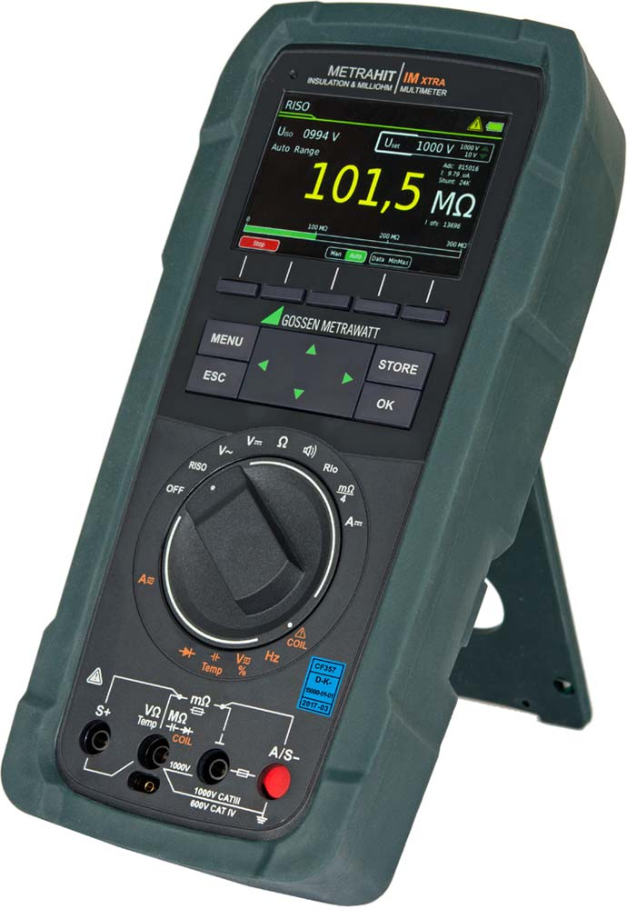
Illustration: The new METRAHIT IM XTRA range of mobile multimeters provides safe, reliable all-in-one devices with a class-leading scope of functions

Moreover, the all-in-one devices perform TRMS current and voltage measurements up to 10 or 100 kHz, precision temperature measurements with RTD and TC-K sensors, capacitance measurements, as well as measurements of the polarization and absorption index. To ensure protection from high short-circuit currents in electric vehicles, the multimeters now meet the demands of measurement categories CAT III 1000 V and CAT IV 600 V. The user-friendly design optimized for one-hand operation ensures easy handling of the devices. A 3.5" color graphics TFT screen neatly displays test sequences, measured values, and help texts. Test sequences and up to 300,000 readings can be saved in the unit and directly transmitted to the test software by means of a push/print function. Bluetooth and WiFi data communication interfaces are integrated. A USB connection is available with an optional power module. In mobile mode, the device runs on a quick-change lithium-ion battery. The battery can be recharged via micro USB. Gossen Metrawatt also supplies new generation METRAHIT IM XTRA multimeters with a special design for the automotive and electric car sector.

Illustrations: | metrahitimxtra_persp1 | Char.s: | 2,025
File name: | 201711030_pm_metrahit_en | Date: | 11-28-2017

About Gossen Metrawatt

GMC-I Messtechnik is one of the world's leading suppliers of measurement systems. Under the GOSSEN METRAWATT brand, the company develops and distributes a wide range of high-quality measuring and test devices for the electrical trade, industry, and the medical sector. The scope of products includes measuring and testing equipment for standardized testing of electrical systems and appliances, multimeters, calibrators, network analyzers, power supplies, as well as transducers and power meters for high-voltage and moving-coil measurement. GMC-I Messtechnik also provides a varied offering of training courses for customers and develops energy management concepts. The corporate group runs its own DakkS-certified calibration center that performs DakkS, ISO, and factory calibrations for virtually all electrical measured values. GMC-I Messtechnik is part of the GMC Instruments group, which also includes other specialized manufacturers for measurement and testing technology – notably, Camille Bauer Metrawatt, Dranetz, Prosys, Seaward and Rigel, and Kurth Electronic. The group's production sites in Germany, Switzerland, England, and the United States are complemented by a global sales network.

Contact:  GMC-I Messtechnik GmbH  Christian Widder  Leiter Marketingkommunikation  Südwestpark 15  90449 Nürnberg  Germany |  | gii die Presse-Agentur GmbH  Immanuelkirchstr. 12  10405 Berlin  Germany  Phone: +49 30 / 538 965 -0  Fax: +49 30 / 538 965 -29  Email: info@gii.de  Web: www.gii.de
Phone: +49 911 / 8602 - 572
Fax: +49 911 / 8602 - 4699
Email: christian.widder@gossenmetrawatt.com
Web: www.gossenmetrawatt.com

