Press Release

More than a century of measurement expertise
Gossen Metrawatt celebrates 111th anniversary

Nuremberg, Germany – Gossen Metrawatt, a leading measurement and testing technology specialist, is celebrating its 111th anniversary in 2017. The company was originally founded by physicist Siegfried Guggenheimer, as an enterprise for the development and production of electric measuring instruments in Nuremberg, Germany, in 1906. In addition to measuring and test equipment, GMC-I Messtechnik GmbH, its brand Gossen Metrawatt, and affiliated companies in the GMC Instruments group stand for intelligent solutions for detailed, standard-compliant energy management, monitoring and analysis of grid quality, and inspection of data and communication networks. "The safe use of electric power has been and remains at the core of our brand. We manufacture future-proof measuring and testing equipment that meets the needs of digitization and of the growing interconnection of power supply and communication systems," says CEO Dr. Hans-Peter Opitz. New generations of meters and measurement and system testing devices fulfill current standards as well as demanding requirements relating to safety, accuracy, data transfer, and documentation. The product portfolio includes high-end, individually tested energy meters for transparent consumption data acquisition in industrial, commercial, medical, and building technology, and in private households. The measurement specialist also supplies various lines for testing electrical safety up to the high voltage range. The GMC-I group operates an officially approved calibration laboratory and several DakkS-accredited calibration centers, which carry out DakkS, ISO, and factory calibrations for almost all electrical and optical parameters.

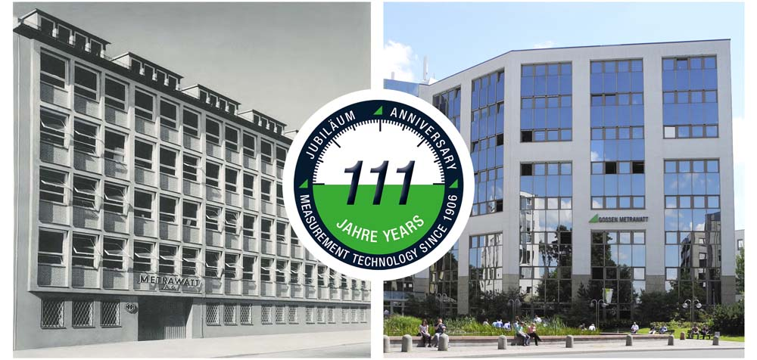
Illustration: In Nuremberg, state-of-the-art precision measurement instruments have been manufactured for 111 years

Illustrations: | 2017_111jahre-gebaeude | Char.s: | 1,663
File name: | 201711031_pm_111_yrs_gmc_en | Date: | 11-23-2017

About Gossen Metrawatt

GMC-I Messtechnik is one of the world's leading suppliers of measurement systems. Under the GOSSEN METRAWATT brand, the company develops and distributes a wide range of high-quality measuring and test devices for the electrical trade, industry, and the medical sector. The scope of products includes measuring and testing equipment for standardized testing of electrical systems and appliances, multimeters, calibrators, network analyzers, power supplies, as well as transducers and power meters for high-voltage and moving-coil measurement. GMC-I Messtechnik also provides a varied offering of training courses for customers and develops energy management concepts. The corporate group runs its own DakkS-certified calibration center that performs DakkS, ISO, and factory calibrations for virtually all electrical measured values. GMC-I Messtechnik is part of the GMC Instruments group, which also includes other specialized manufacturers for measurement and testing technology – notably, Camille Bauer Metrawatt, Dranetz, Prosys, Seaward and Rigel, and Kurth Electronic. The group's production sites in Germany, Switzerland, England, and the United States are complemented by a global sales network.

Contact:  GMC-I Messtechnik GmbH  Christian Widder  Leiter Marketingkommunikation  Südwestpark 15  90449 Nürnberg  Germany |  | gii die Presse-Agentur GmbH  Immanuelkirchstr. 12  10405 Berlin  Germany  Phone: +49 30 / 538 965 -0  Fax: +49 30 / 538 965 -29  Email: info@gii.de  Web: www.gii.de
Phone: +49 911 / 8602 - 572
Fax: +49 911 / 8602 - 4699
Email: christian.widder@gossenmetrawatt.com
Web: www.gossenmetrawatt.com

