Press Release

New test software from Gossen Metrawatt
Modern data management with intuitive user interface

Nuremberg, Germany – Measurement technology specialist Gossen Metrawatt launches IZYTRON.IQ, a completely new test software that enables visualization, management, and revision-proof documentation of all test events across various devices. For the first time, measurement and test data from different testers and multimeters can be collated in one inspection. An intuitive and stylish GUI provides quick access to all functions. Intelligent highlighting and hiding functions ensure that users are pointed to those tools and sections that are pertinent to their respective tasks. Usability is further enhanced through meaningful icons and tree views of complex database relations. Users can individually adjust the viewing options and switch between table, tree, and index card views in portrait or landscape formats. They can also switch between touch and mouse operation. Objects and places are assigned via drag and drop. Therefore, even complex procedures become very easy, for instance assigning datasets to other locations such as lots, buildings, levels, and rooms.

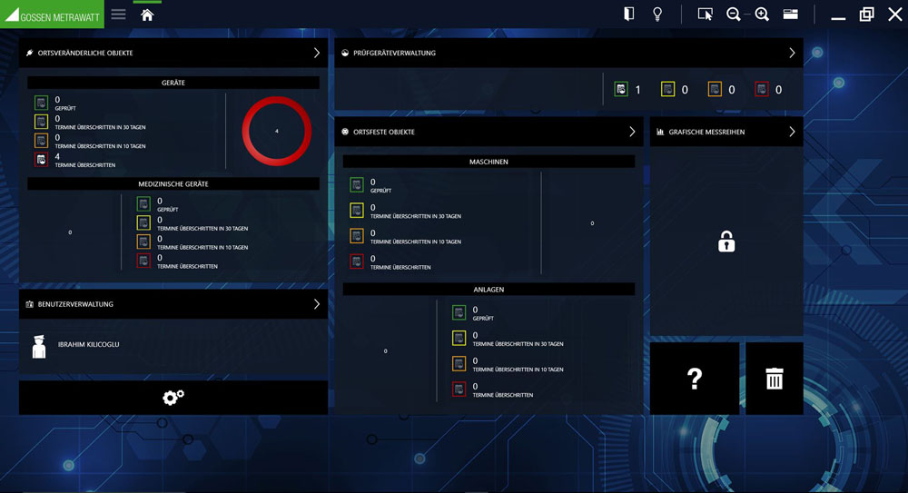
Illustration: The new multi-device test software from Gossen Metrawatt combines extensive functionality and a modern interface with intuitive control and viewing options

Control options also include such practical features as remote mode and a push/print function. These further simplify the transmission of measured values with all relevant characteristics. Flagged datasets with a GUID identifier ensure maximum data integrity. Gossen Metrawatt offers different, scalable software versions for trade, industry, and training purposes. Business-grade single-user licenses are available in three versions with a different scope of functions. Upgrades are possible at any time. All versions come with an integrated SQLite database. In addition, there are network-enabled Enterprise versions with floating licenses that use a Microsoft SQL database. Included functions for the latter comprise tiered access rights and data replication for online and offline applications, allowing for simultaneous use in testing teams.

Illustrations: | izy_dash_2000px | Char.s: | 1,896
File name: | 201711032_pm_test_software_izytron_en | Date: | 11-28-2017

About Gossen Metrawatt

GMC-I Messtechnik is one of the world's leading suppliers of measurement systems. Under the GOSSEN METRAWATT brand, the company develops and distributes a wide range of high-quality measuring and test devices for the electrical trade, industry, and the medical sector. The scope of products includes measuring and testing equipment for standardized testing of electrical systems and appliances, multimeters, calibrators, network analyzers, power supplies, as well as transducers and power meters for high-voltage and moving-coil measurement. GMC-I Messtechnik also provides a varied offering of training courses for customers and develops energy management concepts. The corporate group runs its own DakkS-certified calibration center that performs DakkS, ISO, and factory calibrations for virtually all electrical measured values. GMC-I Messtechnik is part of the GMC Instruments group, which also includes other specialized manufacturers for measurement and testing technology – notably, Camille Bauer Metrawatt, Dranetz, Prosys, Seaward and Rigel, and Kurth Electronic. The group's production sites in Germany, Switzerland, England, and the United States are complemented by a global sales network.

Contact:  GMC-I Messtechnik GmbH  Christian Widder  Leiter Marketingkommunikation  Südwestpark 15  90449 Nürnberg  Germany |  | gii die Presse-Agentur GmbH  Immanuelkirchstr. 12  10405 Berlin  Germany  Phone: +49 30 / 538 965 -0  Fax: +49 30 / 538 965 -29  Email: info@gii.de  Web: www.gii.de
Phone: +49 911 / 8602 - 572
Fax: +49 911 / 8602 - 4699
Email: christian.widder@gossenmetrawatt.com
Web: www.gossenmetrawatt.com

