Press Release

Polycarbonate control cabinets – low-maintenance and more robust than sheet steel

Highly robust and resilient, light-weight, and almost maintenance-free: in all of these respects, ARCA IEC series wall cabinets made by Fibox from glass fiber-reinforced polycarbonate are superior to standard sheet-metal housings. User will therefore often find them to be a higher-quality replacement – for instance, in harsh and demanding indoor and outdoor applications of various kinds, such as housing telecom equipment, power distribution components, or control systems e.g. in machine engineering. Moreover, while they may cost about the same, ARCA IEC enclosures are only half the weight of sheet-steel cabinets, making them considerably easier to handle. The plastic housings with foamed polyurethane gaskets tolerate long-term exposure to temperatures between -40 °C and +80 °C. The vandal-proof enclosures maintain their high degree of IP66/67 ingress protection thanks to their top-rated IK09 impact resistance: they can take deformations, dents or dings that would seriously compromise the sealing of steel cases. Scratches are not a cause for concern either: while they can easily damage anti-corrosion coatings on other enclosures, they are irrelevant for polycarbonate housings. Holes for cable entry can be easily drilled. In addition, ARCA IEC cabinets come with protective insulation. Hence, unlike sheet-steel cabinets, they require no dedicated earthing.

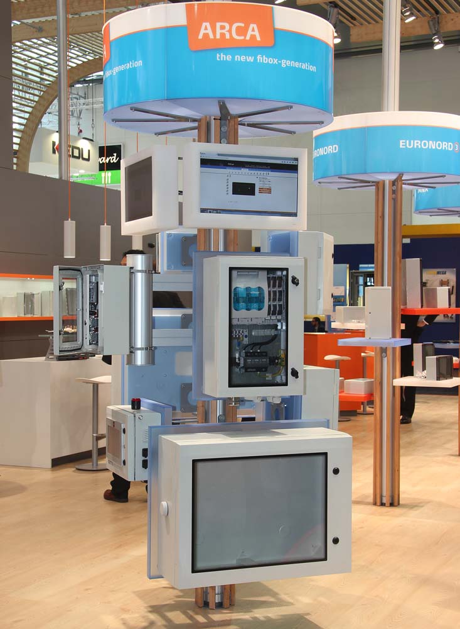
Illustration: Lightweight, durable polycarbonate enclosures facilitate machining for versatile switching and control applications

Illustrations: | arca_iec_messe | Char.s: | 1,375
File name: | 201711048_pm_arca_iec_en | Date: | 12-15-2017
About FIBOX
The Finnish company FIBOX Oy Ab is one of the leading international suppliers of plastic enclosures for electric and electronic components used in industrial automation as well as information, communication, and medical technology. At present, the FIBOX portfolio features more than 1,000 types of standard enclosures manufactured from polycarbonate, the copolymer ABS, glass fiber polyester, and aluminum that provide ingress protection ratings up to IP66/IP67. For several decades, FIBOX has been actively driving the market for enclosure products and the associated tool and production technologies with original designs. As early as 1966, the company introduced injection-molded polycarbonate enclosures, thus marking the start of a new era in control cabinet manufacturing. FIBOX offers a wide range of services, including customization and marking of individual boards or cabinets as well as the planning and delivery of complete automation systems. A broad range of accessories complements the enclosure solutions.

Contact:  FIBOX GmbH  Hans-Martin Reimler  Rehwinkel 30  32457 Porta Westfalica  Germany  Tel.: +49 . 5731 . 869 460  Fax: +49 . 5731 . 869 4650  Email: hans-martin.reimler@fibox.com  WWW: www.fibox.de |  | gii die Presse-Agentur GmbH  Immanuelkirchstr. 12  10405 Berlin  Germany  Tel.: +49 . 30 . 5389 650  Fax: +49 . 30 . 5389 6529  Email: info@gii.de  WWW: www.gii.de

