Press Release

Pushed, not screwed:
Universal cable entry system KES for maximum packing density

Hövelhof – The new KES series of gland plates from CONTA-CLIP enables the quick and safe introduction of cables and tubes without connectors into cabinets and machine housings. KES plates provide IP66 ingress protection with no need to specially fit and secure cables with screws.
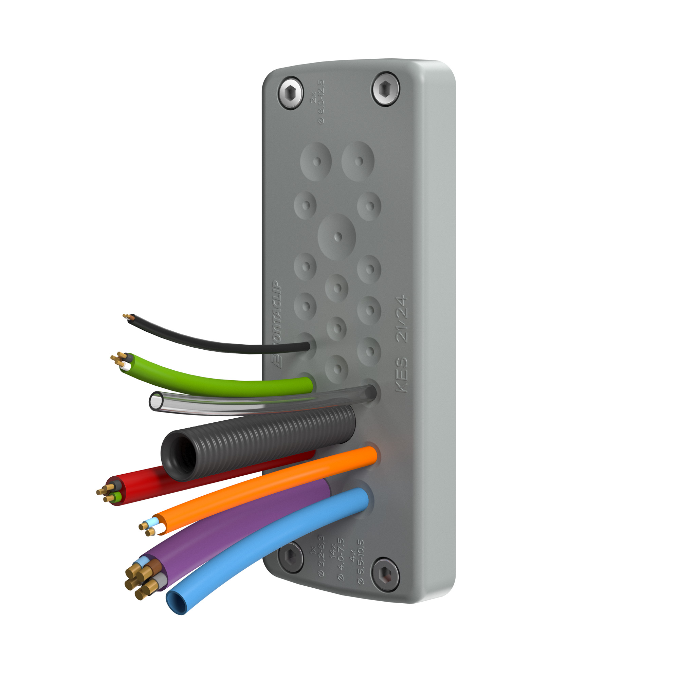
Illustration: The new cable entry system KES features a very high packing density and provides IP66 ingress protection.

The robust polyamide frames filled with elastomer are placed on the outside of the cabinet or housing wall and fixed with screws onto 36 mm x 112 mm openings. The plates feature a low profile height of only 14 mm. For a toolless installation, they can also be snapped-on. In this case, the screw holes remain completely sealed thanks to the layer of elastomer.
To insert cables, the outer membrane of the gland plate is pierced with a pointed tool at a designated entry point. The wires are then simply pushed through. Aside from the punctured membrane, the conical entry grommets on the back of the plate provide an extra double sealing of the cables with IP 66 ingress protection as well as reliable strain relief. This new concept accommodates up to 32 cables per plate, achieving a much higher packing density than conventional screw-fitted cable entry solutions.
CONTA-CLIP is launching the new KES plates in 24 variants designed for different maximum numbers of lines and cable diameters. The elastic cable guides are suitable for cables or pneumatic lines with diameters ranging from 3.2 mm to 20.5 mm. The cable entry system's advanced IP66 ingress protection enables use in harsh environments. KES also features smooth surfaces, rounded corners and ECOLAB certified resistance to industrial cleaning products, and therefore provides all necessary hygienic properties for use in the food industry or in pharmaceutical production.

Figures: | KES_0029 | Char.s: | 1,707
File name: | 201711061_pm_kes_en | Date: | 02-21-2018
About CONTA-CLIP
CONTA-CLIP is one of Europe’s leading manufacturers of electric terminal blocks. Based in Hövelhof, Germany, the medium-sized, family-run company has been producing electric and electronic connection systems for the process and automation industries for more than 40 years. CONTA-CLIP supplies all industry sectors, focusing on railroad industries, shipbuilding, building automation, conveyor technology, machine and plant engineering and construction, instrumentation and control technology, control panel manufacturing, transformer manufacturing, and environmental technology. The company consists of three specialized branches: CONTA-CONNECT for electric connection technology, CONTA-ELECTRONICS for electronics and CONTA-CON for PCB edge connectors. Additionally, CONTA-CLIP provides services such as customizing housings and mounting rails, labeling and supplying user-specific electronic components.

Contact:  CONTA-CLIP  Verbindungstechnik GmbH  Christian Quade  Otto-Hahn-Str. 7  33161 Hövelhof  Germany  tel.: +49 . 52 57 . 98 33 - 0  fax: +49 . 52 57 . 98 33 - 33  email: quade@conta-clip.de  WWW: www.conta-clip.com |  | gii die Presse-Agentur GmbH  Immanuelkirchstr. 12  10405 Berlin  Germany  tel.: +49 . 30 . 53 89 65 - 0  fax: +49 . 30 . 53 89 65 - 29  email: info@gii.de  WWW: www.gii.de

