Press Release

Flange plate KDS-FP – cable management at its best

With the KDS-FP flange plate, CONTA-CLIP take the tool-free click-and-push concept of their cable entry system KDSClick to a larger scale for control cabinet construction. With this system extension, the connection technology experts primarily address the needs of series machine and special purpose machinery manufacturers, who are dealing with wiring requirements for cabinet packing that keep changing all the time. KDS-FP is an extra-flexible solution for managing cables and pneumatic or hydraulic tubes: the number and diameters of the required openings can be seamlessly adapted at any time without drilling, sawing or other machining. At all times, the system reliably provides IP66 sealing. First, a cavity with standard dimensions in the cabinet wall is fully and tightly sealed by screwing on the flange plate. Then, up to three plate segments can be broken off at predetermined breaking points as needed without the use of tools. Each removed segment reveals a 40x110mm duct that can be further divided into up to ten frame openings by snapping frame inlays from the KDSClick series into place. The inlays are available as plain partitions, T-pieces or cross and double cross form to allow for the required custom dimensioning of the frame openings. CONTA-CLIP offer a continually expanding range of different sealing elements (currently numbering about 100) for sealing lines and tubes of various diameters as well as feeding multiple cables through one frame opening. The sealing elements, which feature a crinkle cut at the side, are simply placed around the wires and ensure not only a precise and tight seal but also provide the connections with a reliable strain relief. After the wires are sheathed, the elements are inserted from the inside of the cabinet and pushed to the outside through the frame openings defined by the inlays. Thanks to the conical tapering, the sealing elements are easily and effortlessly pushed into the frame opening/inlays and just as easily removed for new or additional wiring. Unused frame openings are safely closed off with sealing plugs. This ensures comfortable changes to the wiring, even for single cables, without having to disassemble the frame. Two flange plate types are initially available: KDS-FP-2x10/24 and KDS-FP-3 x 10/24 for up to 20 or up to 30 configurable frame openings, respectively. More form factors are already in development.
For users who want an additional strain relief of the cable towards the inside of the cabinet, a locking accessory for sealing elements provides a toolless solution that can be clicked into undercuts at the back of the flange plate.

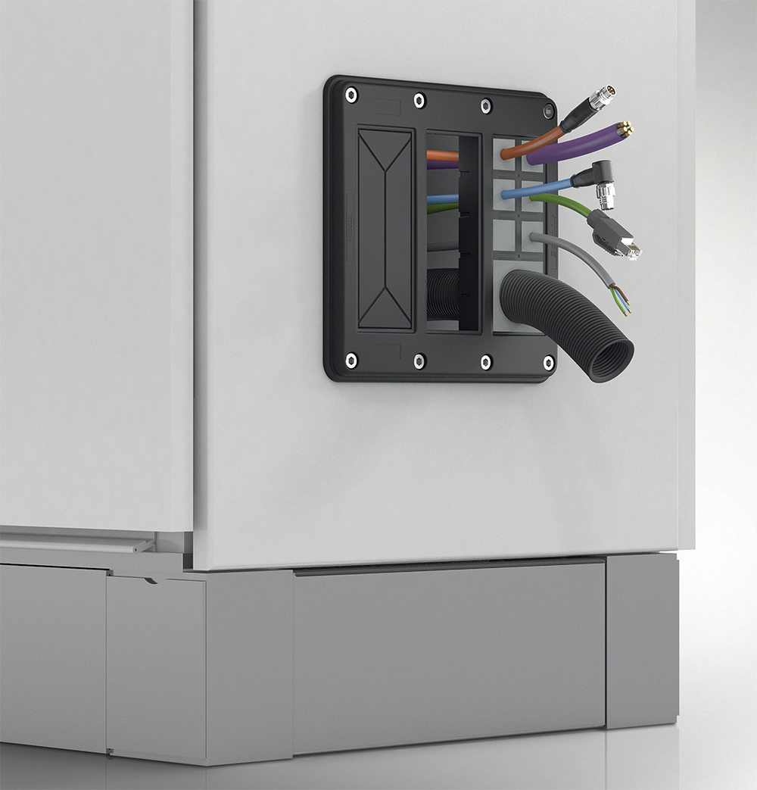
Illustration: The flange plate KDS-FP provides flexible cable management and IP66 ingress protection

Figures: | flanschplatte | Char.s: | 2,737
File name: | 201711062_pm_flanschplatte_kds_fp_en | Date: | 04-23-2018
About CONTA-CLIP
CONTA-CLIP is one of Europe’s leading manufacturers of electric terminal blocks. Based in Hövelhof, Germany, the medium-sized, family-run company has been producing electric and electronic connection systems for the process and automation industries for more than 40 years. CONTA-CLIP supplies all industry sectors, focusing on railroad industries, shipbuilding, building automation, conveyor technology, machine and plant engineering and construction, instrumentation and control technology, control panel manufacturing, transformer manufacturing, and environmental technology. The company consists of three specialized branches: CONTA-CONNECT for electric connection technology, CONTA-ELECTRONICS for electronics and CONTA-CON for PCB edge connectors. Additionally, CONTA-CLIP provides services such as customizing housings and mounting rails, labeling and supplying user-specific electronic components.

Contact:  CONTA-CLIP  Verbindungstechnik GmbH  Christian Quade  Otto-Hahn-Str. 7  33161 Hövelhof  Germany  tel.: +49 . 52 57 . 98 33 - 0  fax: +49 . 52 57 . 98 33 - 33  email: quade@conta-clip.de  WWW: www.conta-clip.com |  | gii die Presse-Agentur GmbH  Immanuelkirchstr. 12  10405 Berlin  Germany  tel.: +49 . 30 . 53 89 65 - 0  fax: +49 . 30 . 53 89 65 - 29  email: info@gii.de  WWW: www.gii.de

