Press Release

New German website for pyrometers and data loggers

Fluke Process Instruments has relaunched the German company website at www.flukeprocessinstruments.de. Following the relaunch of the .com domain of the same name, the temperature measurement specialists now also provide a single stop for all product lines for German-speaking customers. The redesign was due after the established brands Raytek, Ircon, and Datapaq had merged into one company. The new responsive web pages are easy to use with any device. Content is presented with an even stronger focus on areas of use, which facilitates product searches for any industry sector from metals to electronics and to coating. All kinds of applications are represented – each with one or more suitable temperature monitoring or temperature profiling systems. Data sheets and additional product information resources are listed on the same page and can be immediately downloaded. Of course, users can also navigate to products directly or by a search function. All the manufacturer's infrared thermometers, thermal imagers, and temperature profiling systems are documented clearly and comprehensively. Users quickly find their local distributor and can also request a callback.

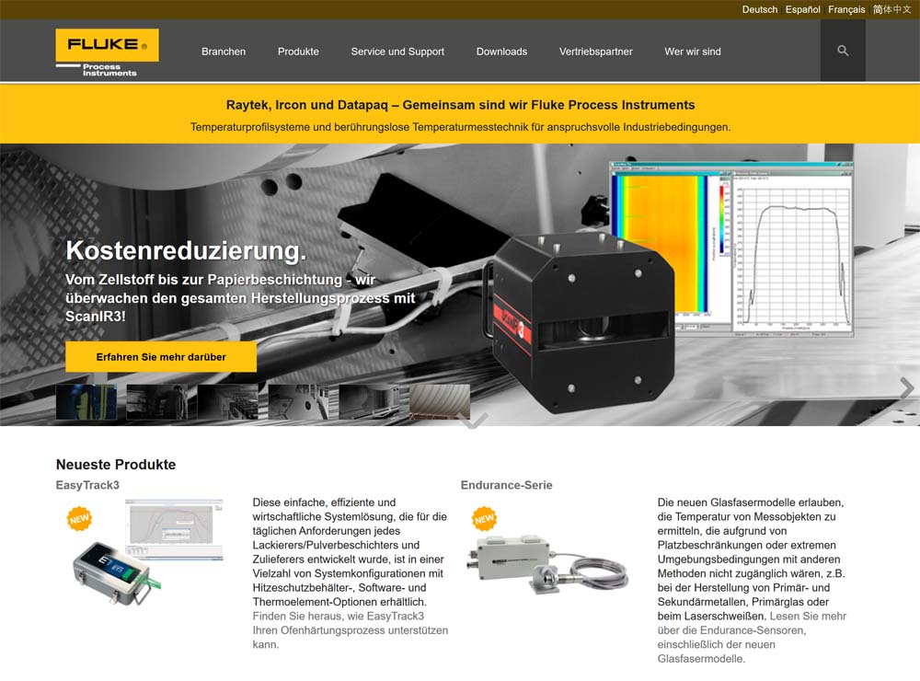
Illustration: The new website presents infrared sensors, thermal imaging systems, and temperature profilers for industrial process control and quality control

Illustrations: | flukeprocessinstruments_de_2018 | Char.s: | 1.172
File name: | 201801017_pm_wwwflukeprocessinstrumentsde_en | Date: | 01-17-2018
About Fluke Process Instruments
Fluke Process Instruments designs, manufactures, and markets a complete line of infrared temperature measurement and profiling solutions for industrial, maintenance, and quality control applications. Distributed worldwide under the Raytek, Ircon, and Datapaq brands, the products reflect the combined experience of over 125 years in manufacturing the world’s finest temperature measurement tools and devices.
About Fluke
Founded in 1948, Fluke Corporation is the world leader in compact, professional electronic test tools. Fluke customers are technicians, engineers, electricians, and metrologists who install, troubleshoot, and manage industrial, electrical, and electronic equipment and calibration processes.

Contact for Europe, Middle East, Africa:  Fluke Process Instruments GmbH  Stephan Wilke  Blankenburger Str. 135  13127 Berlin  Germany |  | gii die Presse-Agentur GmbH  Immanuelkirchstr. 12  10405 Berlin  Germany  Tel.: +49 . 30 . 538 965-0  Fax: +49 . 30 . 538 965-29  Email: info@gii.de  WWW: www.gii.de
Tel.: +49 . 30 . 478 008-0
Fax: +49 . 30 . 471 0251
Email: marcom2.emea@flukeprocessinstruments.de
Internet: www.flukeprocessinstruments.com

Contact for Americas and Australasia:
Arlene Lucas-Starrh
arlene.lucas-starrh@fluke.com

Contact for Asia (except China):
Clothilde Bugnard
clothilde.bugnard@fluke.com

