Press Release

Floor-rail weighbridge for payloads up to 45 tons

Weighing stations that can be installed flush with the factory floor are LOSYCO's latest addition to its innovative heavy-duty intra-logistics rail system. In one recent LOXrail installation in a German machine manufacturer's factory, the intra-logistics specialist has also integrated two specially developed heavy-duty scales. These weighing systems are perfectly level with the floor. At the very end of the assembly line, they are used to determine the exact freight weight before shipping. LOXrail rails and trolleys enable easy transport of machines and parts from one assembly station to the next. Once packaged, the products are simply pushed onto the 5000 mm x 2500 mm wide weighing station. Without time-consuming maneuvering, the customer saves costs, effort, and energy.

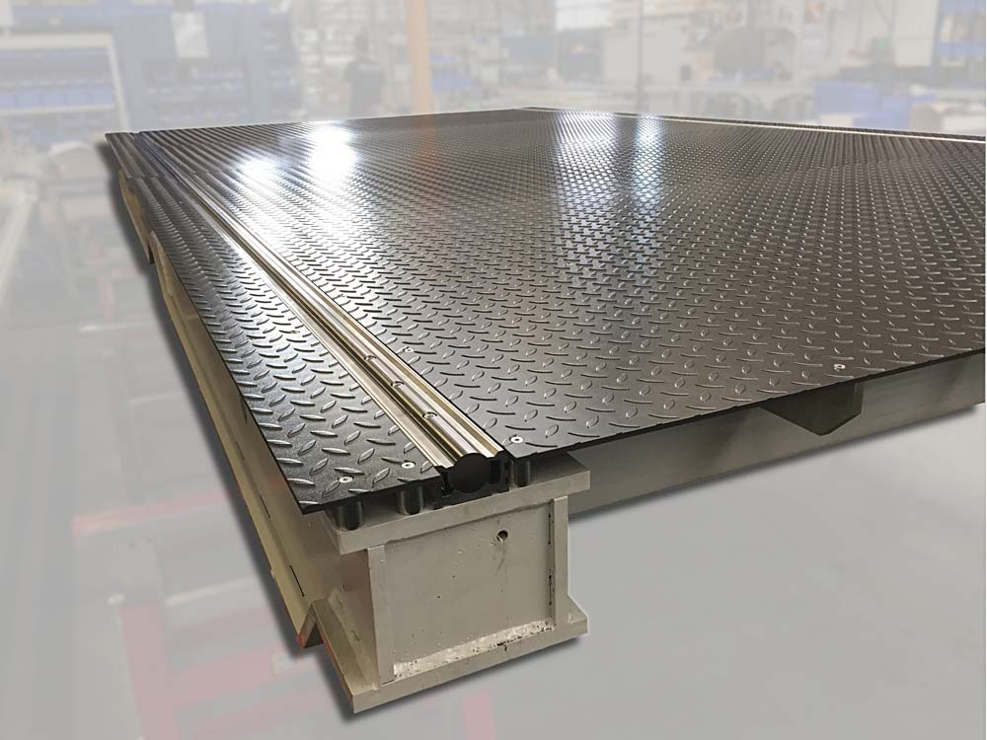
Illustration: New weighing stations for integration into the LOXrail system flush with the floor weigh loads up to 45 tons and facilitate intra-logistics and shipping processes

The new heavy-duty weighing stations with their six electronic load cells are designed for total payloads up to 45 tons. The electronic scales subtract the weight of the trolley to determine the cargo load, which they can also automatically transmit to the control system via WiFi (WLAN) to make the data immediately available for entry in the shipping documents and communication to logistics partners. A label printer connected to the scales enables direct marking of the freight load for shipping. The scales conform to SOLAS accuracy class III and meet the latest requirements for goods transport on container ships. According to the SOLAS VGM regulation, which took effect in over 160 countries in July 2016, container cargo must have a verified gross mass (VGM) to be loaded onto a vessel. The new LOSYCO weighing station facilitates the weighing and documentation of cargo loads and enables machinery and equipment manufacturers to streamline logistics and shipping processes.

Illustrations: | wiegestation | Char.s: | 1,765
File name: | 201801043_pm_loxrail_scales_en | Date: | 01-31-2018
About Losyco
Based in Bielefeld, Germany, Losyco designs, manufactures, and deploys intra-logistics systems for industrial customers. Founded by experienced engineers in 2016, the company's first core product is LOXrail®: with this novel round bar rail system, loads weighing several tons can be easily moved around, precisely to the desired spot. It can be operated manually or with auxiliary drives. Losyco also supplies conveying and handling equipment such as chain and roller conveyors, material management and storage systems, sound-proof cabins, and machine covers. In addition, Losyco offers support and guidance for customers wishing to transform their production processes to implement lean manufacturing and continuous flow production. Losyco is a member of the DRECKSHAGE Family.

Contact:  LOSYCO GmbH  Member of the DRECKSHAGE Family  Derek P. Clark  Walter-Werning-Str. 7  33699 Bielefeld  Germany  Tel.: +49 . 521 . 945 643-0  Fax: +49 . 521 . 945 643-399  Email: info@losyco.com  Internet: www.losyco.com |  | gii die Presse-Agentur GmbH  Immanuelkirchstr. 12  10405 Berlin  Germany  Tel.: +49 . 30 . 538 965-0  Fax: +49 . 30 . 538 965-29  Email: info@gii.de  Internet: www.gii.de

