Press Release

Modular summator with up to 64 channels

Gossen Metrawatt has launched the new, modular SU1604 summator for energy control systems (ECS). It can be expanded to up to 64 processing channels. Users can assign electrically isolated S0 counter inputs for processing pulse-shaped S0 input signals to individual channels. They can also choose to assign LON devices, with all the added benefits of this easy-to-wire, electrically isolated interface featuring polarity reversal protection. Energy or consumption data are collected in lockstep with the energy supplier's measurement cycle and added up over defined time periods and a programmable interval, and saved along with the corresponding maximum values. In addition to the interval-based data list, up to four recorders with up to 64 channels and different time bases starting from one second can be defined. Each channel can be parameterized for any measured data such as analog, power, and consumption values in the interval or for running totals.

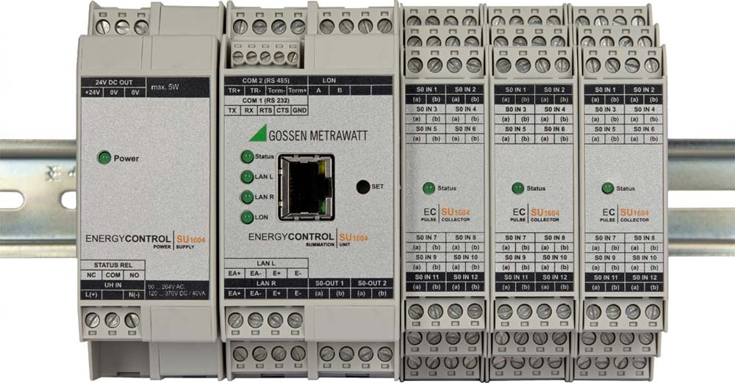
Illustration: The new, modular SU1604 summator – pictured with supplementary modules – can be extended to up to 64 data channels

Measured data comprise 32-bit float values or 64-bit double values saved to 100 MB of rolling storage space. This autonomous database for all electrical and non-electrical energy and consumption data enables visualization, consumption optimization, and cost-related billing. The summator features an RS485 and an RS232 interface as well as an Ethernet port for remote access to device data via TCP/IP. Four TCP/IP sockets with ECL access can be used simultaneously, and two of these sockets can be used for ECS-LAN networking. The U1604 summator is suitable for supplementing or replacing ECS summators from the U1600, U1601, U1602, and U1603 series. Thanks to intelligent evaluation electronics with the system's own programming language, the summator can also be used for customer-specific calculation, evaluation, monitoring, and optimization of energy values without integration into an ECS.

Illustrations: | su1604_summenstation | Char.s: | 1,852
File name: | 201802004_pm_su1604_summator_en | Date: | 02-27-2018

About Gossen Metrawatt

GMC-I Messtechnik is one of the world's leading suppliers of measurement systems. Under the GOSSEN METRAWATT brand, the company develops and distributes a wide range of high-quality measuring and test devices for the electrical trade, industry, and the medical sector. The scope of products includes measuring and testing equipment for standardized testing of electrical systems and appliances, multimeters, calibrators, network analyzers, power supplies, as well as transducers and power meters for high-voltage and moving-coil measurement. GMC-I Messtechnik also provides a varied offering of training courses for customers and develops energy management concepts. The corporate group runs its own DakkS-certified calibration center that performs DakkS, ISO, and factory calibrations for virtually all electrical measured values. GMC-I Messtechnik is part of the GMC Instruments group, which also includes other specialized manufacturers for measurement and testing technology – notably, Camille Bauer Metrawatt, Dranetz, Prosys, Seaward and Rigel, and Kurth Electronic. The group's production sites in Germany, Switzerland, England, and the United States are complemented by a global sales network.

Contact:  GMC-I Messtechnik GmbH  Christian Widder  Leiter Marketingkommunikation  Südwestpark 15  90449 Nürnberg  Germany |  | gii die Presse-Agentur GmbH  Immanuelkirchstr. 12  10405 Berlin  Germany  Phone: +49 30 / 538 965 -0  Fax: +49 30 / 538 965 -29  Email: info@gii.de  Web: www.gii.de
Phone: +49 911 / 8602 - 572
Fax: +49 911 / 8602 - 4699
Email: christian.widder@gossenmetrawatt.com
Web: www.gossenmetrawatt.com

