Press Release

Safe stop at the end of the production line

Intra-logistics expert LOSYCO now equips its LOXrail system with newly developed end stops. These modules are mounted at the end of a track to ensure trolleys will stop in a safe way without jamming up. Plastic buffers slow down the trolley wheels and also prevent derailment. An end plate prevents axial displacement of the rail shaft. Because of their particularly installation-friendly design, the new end fittings can be attached to the track in seconds. Stops and intra-logistics rails are installed level with the factory floor in one piece. They are precisely positioned and fixed with cast concrete. All this takes very little time since there is no need for drilling holes and affixing anchors or screws. Plastic buffers and plates can be easily replaced when they are worn out. Machine and equipment builders and other manufacturers will find LOXrail to be an economical and extremely sturdy solution for transporting heavy and bulky parts. The installation of this rail system generally requires no structural changes to a facility. That makes it highly suitable for streamlining processes and implementing one-piece flow production almost anywhere where heavy parts are involved, even if the number of manufactured units is small and individual assembly steps are labor-intensive and require a lot of material. The track layout can be flexibly adapted to the floor plan of a plant, since crossings and switches are part of the LOXrail program. The system design ensures that people, pallet jacks, rolling shelves, or cleaning machines are never tripped up.

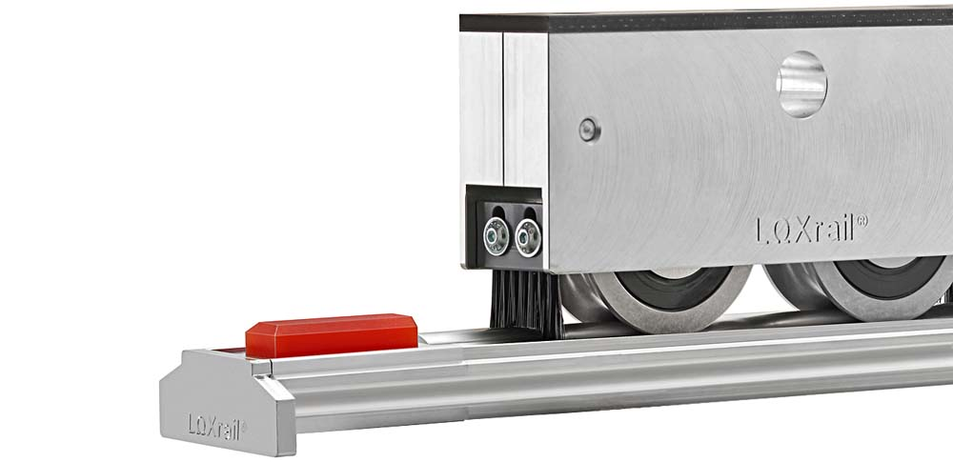
Illustration: The new LOXrail end fittings smoothly decelerate and stop trolleys. The intra-logistics rail system is flush with the hall floor and poses no obstacle.

Illustrations: | loxrail-endstopper | Char.s: | 1,568
File name: | 201802014_pm_loxrail_end_stops_en | Date: | 02-27-2018
About Losyco
Based in Bielefeld, Germany, Losyco designs, manufactures, and deploys intra-logistics systems for industrial customers. Founded by experienced engineers in 2016, the company's first core product is LOXrail®: with this novel round bar rail system, loads weighing several tons can be easily moved around, precisely to the desired spot. It can be operated manually or with auxiliary drives. Losyco also supplies conveying and handling equipment such as chain and roller conveyors, material management and storage systems, sound-proof cabins, and machine covers. In addition, Losyco offers support and guidance for customers wishing to transform their production processes to implement lean manufacturing and continuous flow production. Losyco is a member of the DRECKSHAGE Family.

Contact:  LOSYCO GmbH  Member of the DRECKSHAGE Family  Derek P. Clark  Walter-Werning-Str. 7  33699 Bielefeld  Germany  Tel.: +49 . 521 . 945 643-0  Fax: +49 . 521 . 945 643-399  Email: info@losyco.com  Internet: www.losyco.com |  | gii die Presse-Agentur GmbH  Immanuelkirchstr. 12  10405 Berlin  Germany  Tel.: +49 . 30 . 538 965-0  Fax: +49 . 30 . 538 965-29  Email: info@gii.de  Internet: www.gii.de

