Press Release

Wheelsets for all rail-bound intra-logistics systems

Based on its LOXrail system, LOSYCO develops, manufactures, and installs full-scale solutions for the transport of heavy machinery and components. In addition, smooth-running wheelsets from LOSYCO are also adapted to the specifications of other widely used systems based on round rail shafts. Single or double wheelsets are available for rails with 25 mm and 40 mm shaft diameters to accommodate payloads up to 100 kN. Mounting holes can be machined to suit transport trolleys and rolling platforms from different suppliers. Integrating the wheelsets in existing rail transport equipment is easy. A mounting frame for fixed or floating bearings and track setting enables precise installations.

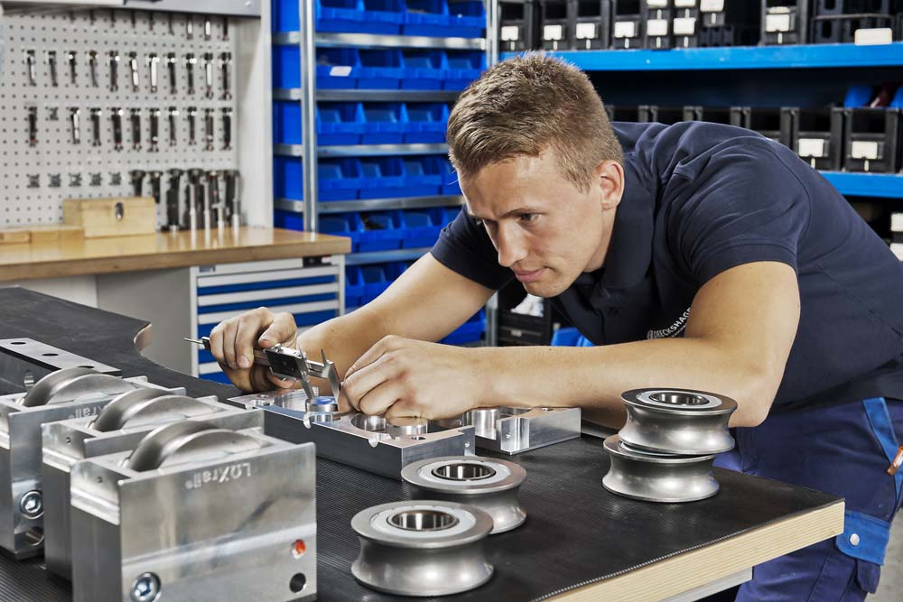
Illustration: LOSYCO's smooth-running wheelsets can be specified for all standard intra-logistics rail systems with rail shafts diameters of 25 mm and 40 mm

A special roller profile minimizes the touch points between wheel and rail to ensure smooth running, with a significantly reduced friction coefficient compared to conventional rolling elements designed with flanges. Even loads weighing several tons can therefore be easily, safely, and precisely moved by hand. The wheels are mounted in a sturdy aluminum casing and are designed for the transport of light and medium loads along straight tracks and rail crossings. LOSYCO offers double wheelsets for transporting heavy loads. The range is completed by single- and two-wheel versions for driven applications, which can be connected to PTO shafts via adapters. Wiper brushes or scraper blades, which are mounted on the wheelset casing and can be readjusted via slotted holes, keep dirt and foreign objects away.

Illustrations: | radsatz_mass | Char.s: | 1,502
File name: | 201803008_pm_loxrail_wheelsets_en | Date: | 03-22-2018
About Losyco
Based in Bielefeld, Germany, Losyco designs, manufactures, and deploys intra-logistics systems for industrial customers. Founded by experienced engineers in 2016, the company's first core product is LOXrail®: with this novel round bar rail system, loads weighing several tons can be easily moved around, precisely to the desired spot. It can be operated manually or with auxiliary drives. Losyco also supplies conveying and handling equipment such as chain and roller conveyors, material management and storage systems, sound-proof cabins, and machine covers. In addition, Losyco offers support and guidance for customers wishing to transform their production processes to implement lean manufacturing and continuous flow production. Losyco is a member of the DRECKSHAGE Family.

Contact:  LOSYCO GmbH  Member of the DRECKSHAGE Family  Derek P. Clark  Walter-Werning-Str. 7  33699 Bielefeld  Germany  Tel.: +49 . 521 . 945 643-0  Fax: +49 . 521 . 945 643-399  Email: info@losyco.com  Internet: www.losyco.com |  | gii die Presse-Agentur GmbH  Immanuelkirchstr. 12  10405 Berlin  Germany  Tel.: +49 . 30 . 538 965-0  Fax: +49 . 30 . 538 965-29  Email: info@gii.de  Internet: www.gii.de

