Press Release

ceramitec 2018 –
thermal profiling inside kilns

Fluke Process Instruments will present its temperature profilers for the unique challenges of heat treatment in the ceramic industry at the ceramitec exhibition in Munich, Germany. The DATAPAQ Kiln Tracker product family comprises thermal profiling systems for tunnel kilns, roller hearth kilns, and hydro kilns. These consist of heat-protected data loggers that record temperature profiles via up to 20 thermocouple channels, and user-friendly analysis software.

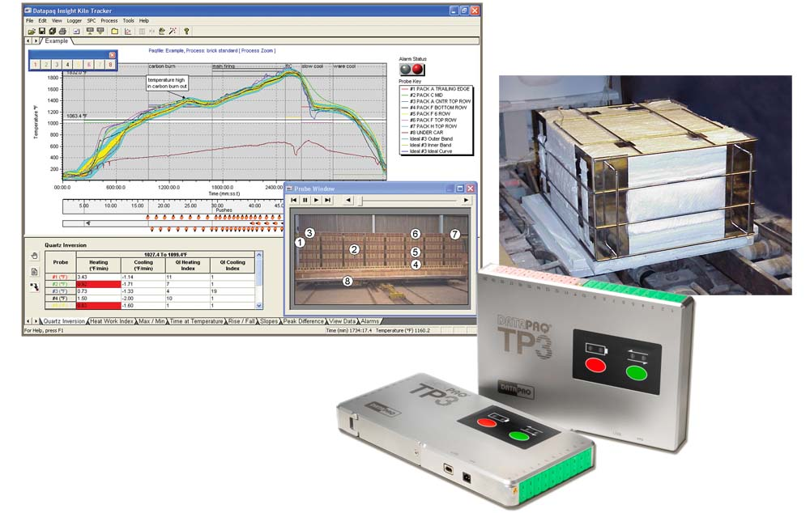
Illustration: DATAPAQ Kiln Trackers create complete temperature profiles as they travel through the kiln

The thermal barriers are engineered to protect the electronics so efficiently they can sustain firing cycles lasting several days and peak temperatures reaching up to 1,250 °C. Memory for storing 3.6 million data points also provides more than adequate capacity. Ceramics, bricks, technical ceramics, as well as the air temperature can be monitored during the burning process – with wireless data transmission and live evaluation options. Users can download all data after the end of the process, analyze and share profiles, and create certified reports. The software features sophisticated functions for speedy, optimal setup of kilns as well as quick diagnosis and correction of errors such as faulty burners and temperature imbalance. Dedicated TUS systems geared at manufacturers of ceramic molds for the aerospace industry ensure compliance with NADCAP specification AMS 2750E.

Fluke Process Instruments at the ceramitec exhibition
Munich, Germany, 10 – 13 April 2018
Hall B5, Stand 440

Illustrations: | datapaq_kiln_tracker_tp3 | Char.s: | 1.345
File name: | 201803028_pm_ceramitec_en | Date: | 03-22-2018
About Fluke Process Instruments
Fluke Process Instruments designs, manufactures, and markets a complete line of infrared temperature measurement and profiling solutions for industrial, maintenance, and quality control applications. Distributed worldwide under the Raytek, Ircon, and Datapaq brands, the products reflect the combined experience of over 125 years in manufacturing the world’s finest temperature measurement tools and devices.
About Fluke
Founded in 1948, Fluke Corporation is the world leader in compact, professional electronic test tools. Fluke customers are technicians, engineers, electricians, and metrologists who install, troubleshoot, and manage industrial, electrical, and electronic equipment and calibration processes.

Contact:  Fluke Process Instruments GmbH  Stephan Wilke  Blankenburger Str. 135  13127 Berlin  Germany |  | gii die Presse-Agentur GmbH  Immanuelkirchstr. 12  10405 Berlin  Germany  Tel.: +49 . 30 . 538 965-0  Fax: +49 . 30 . 538 965-29  Email: info@gii.de  WWW: www.gii.de
Tel.: +49 . 30 . 478 008-0
Fax: +49 . 30 . 471 0251
Email: marcom1.emea@flukeprocessinstruments.de
Internet: www.flukeprocessinstruments.com

Contact for Asia (except China):
Clothilde Bugnard
clothilde.bugnard@fluke.com

