Press Release

Ergonomic locking devices for trolleys

For its LOXrail floor transport system, intra-logistics expert LOSYCO offers new stoppers for locking trolleys in place. LOXrail is available in two sizes with heavy-duty, hardened, and polished rail shafts with a 25 or 40 mm diameter. The system portfolio comprises wheelsets for different payloads, standard and heavy-duty trolleys, and a range of drive concepts. The new stoppers can be easily mounted at the side or front end of transport trolleys. They are designed to provide additional support for handling particularly heavy and bulky components by firmly arresting these in a designated position. The spring-loaded modules fix the transport trolleys in place with a contact pressure of around 100 kg each and compensate for minor unevenness in the hall floor. Two ergonomic foot levers are used to easily lock and release the stoppers. These mechanisms allow for keeping large components, such as machines, safely in place at various different points along the rail track throughout the stages of assembly. Thus, the trolleys can be used as mobile assembly stations, enabling manufacturers to streamline the entire logistics processes in cycle production. LOXrail trolleys are designed for heavy payloads, with standard versions accommodating up to 40 tons. Due to their special profile, LOXrail wheels feature a very low rolling resistance, which is why even components weighing several tons can be moved manually and precisely positioned without the need for an auxiliary drive. Crossings and switches enable a flexible adaptation of the rail layout to local conditions and production lines.

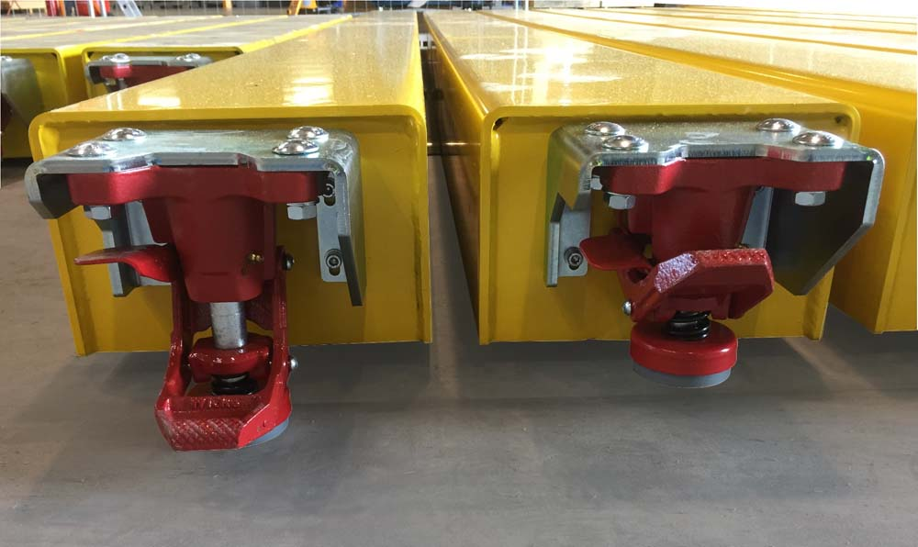
Illustration: LOXrail stoppers can keep heavy assemblies securely locked in place at various points on the production line

Illustrations: | loxrail-bodenstopper | Char.s: | 1,602
File name: | 201803034_pm_loxrail_stoppers_en | Date: | 04-18-2018
About Losyco
Based in Bielefeld, Germany, Losyco designs, manufactures, and deploys intra-logistics systems for industrial customers. Founded by experienced engineers in 2016, the company's first core product is LOXrail®: with this novel round bar rail system, loads weighing several tons can be easily moved around, precisely to the desired spot. It can be operated manually or with auxiliary drives. Losyco also supplies conveying and handling equipment such as chain and roller conveyors, material management and storage systems, sound-proof cabins, and machine covers. In addition, Losyco offers support and guidance for customers wishing to transform their production processes to implement lean manufacturing and continuous flow production. Losyco is a member of the DRECKSHAGE Family.

Contact:  LOSYCO GmbH  Member of the DRECKSHAGE Family  Derek P. Clark  Walter-Werning-Str. 7  33699 Bielefeld  Germany  Tel.: +49 . 521 . 945 643-0  Fax: +49 . 521 . 945 643-399  Email: info@losyco.com  Internet: www.losyco.com |  | gii die Presse-Agentur GmbH  Immanuelkirchstr. 12  10405 Berlin  Germany  Tel.: +49 . 30 . 538 965-0  Fax: +49 . 30 . 538 965-29  Email: info@gii.de  Internet: www.gii.de

