Press Release

SMT Hybrid Packaging with a new global launch:
Temperature profiling in SMD lines

At the SMT Hybrid Packaging trade show in Nuremberg, Germany, Fluke Process Instruments will launch a new range of temperature profiling systems for quality control and optimization of soldering processes. The all-new family of DATAPAQ DP5 data loggers is augmented by the Insight Reflow Tracker professional software which quickly transforms the raw data into actionable information. Reflow soldering process optimization using the Easy Oven Setup recipe calculator is included as standard, as are SPC and trending analysis. These functions enable the operator to get the best out of every SMT production line. The launch furthermore includes two sensor holding frames that save setup time and ensure repeatability: an improved 12-thermocouple pallet for monitoring wave soldering process stability and a new, easy-to-use DATAPAQ Surveyor for reflow processes. The manufacturer will also showcase the world's smallest temperature profiler for selective mini-wave soldering: no more than 20 mm high and 40 mm wide including the thermal shield, DATAPAQ SelectivePaq enables reliable measurements even in very tight spaces.
Fluke Process Instruments at SMT Hybrid Packaging
05 – 07 June 2018, Nuremberg, Germany
Hall 4, Stand 437

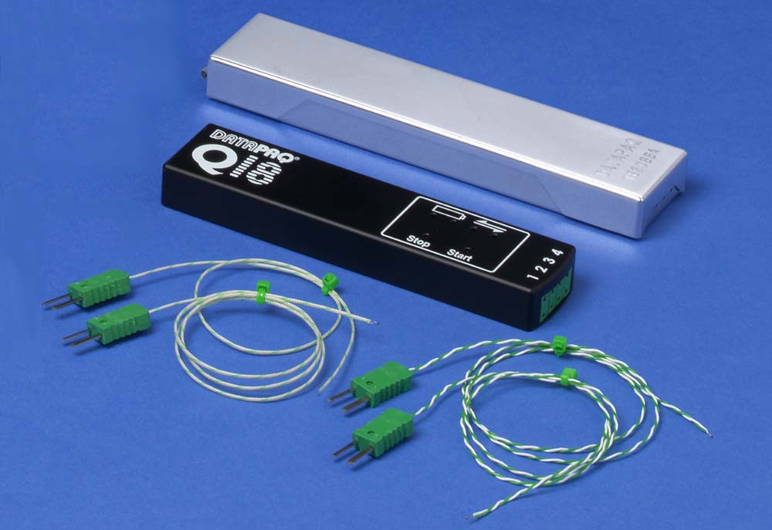
Illustration: Fluke Process Instruments offers ultra-compact temperature profilers for all kinds of solder machines or reflow ovens (pictured: DATAPAQ SelectivePaq)

Illustrations: | datapaq_selectivepaq_w_tb | Char.s: | 1,121
File name: | 201803055_pm_smt_hybrid_packaging_en | Date: | 05-02-2018
About Fluke Process Instruments
Fluke Process Instruments designs, manufactures, and markets a complete line of infrared temperature measurement and profiling solutions for industrial, maintenance, and quality control applications. Distributed worldwide under the Raytek, Ircon, and Datapaq brands, the products reflect the combined experience of over 125 years in manufacturing the world’s finest temperature measurement tools and devices.
About Fluke
Founded in 1948, Fluke Corporation is the world leader in compact, professional electronic test tools. Fluke customers are technicians, engineers, electricians, and metrologists who install, troubleshoot, and manage industrial, electrical, and electronic equipment and calibration processes.

Contact:  Fluke Process Instruments GmbH  Stephan Wilke  Blankenburger Str. 135  13127 Berlin  Germany |  | gii die Presse-Agentur GmbH  Immanuelkirchstr. 12  10405 Berlin  Germany  Tel.: +49 . 30 . 538 965-0  Fax: +49 . 30 . 538 965-29  Email: info@gii.de  WWW: www.gii.de
Tel.: +49 . 30 . 478 008-0
Fax: +49 . 30 . 471 0251
Email: marcom1.emea@flukeprocessinstruments.de
Internet: www.flukeprocessinstruments.com

Contact for Asia (except China):
Clothilde Bugnard
clothilde.bugnard@fluke.com

