Press Release

EMC rail for KDSClick cable entry system

Accompanying the KDSClick cable entry system, CONTA-CLIP supplies easy-to-install, galvanized EMC rails for safe and secure shield termination of cables. KDS-EMV-SAB type rails are attached to the KDSClick mounting screws inside control cabinets and secured with a nut. The manufacturer's SAB program also includes spring-loaded and screw-connection clips for all cable diameters. These ensure large-surface grounding. In addition to shunting electromagnetic interference, the shield-connection clips provide strain relief.

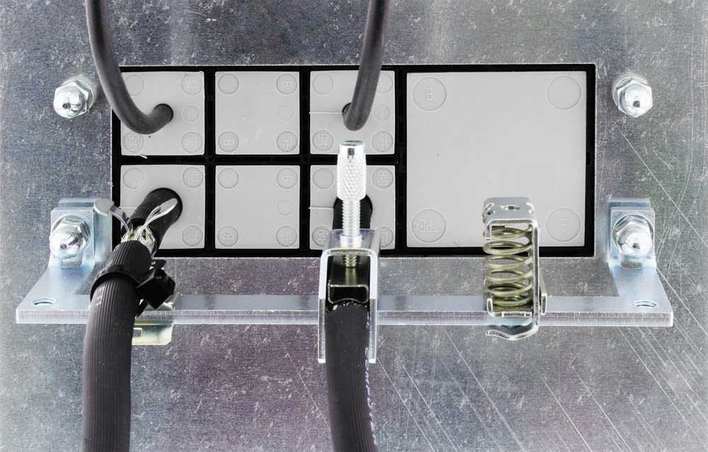
Illustration: EMC rails for the KDSClick cable entry system enable safe and secure shield connection

Illustrations: | Anwendung_KDS_EMV | Char.s: | 523
File name: | 201804005_pm_kdsclick_emc_rail_en | Date: | 05-29-2018
About CONTA-CLIP
CONTA-CLIP is one of Europe’s leading manufacturers of electric terminal blocks. Based in Hövelhof, Germany, the medium-sized, family-run company has been producing electric and electronic connection systems for the process and automation industries for more than 40 years. CONTA-CLIP supplies all industry sectors, focusing on railroad industries, shipbuilding, building automation, conveyor technology, machine and plant engineering and construction, instrumentation and control technology, control panel manufacturing, transformer manufacturing, and environmental technology. The company consists of three specialized branches: CONTA-CONNECT for electric connection technology, CONTA-ELECTRONICS for electronics and CONTA-CON for PCB edge connectors. Additionally, CONTA-CLIP provides services such as customizing housings and mounting rails, labeling and supplying user-specific electronic components.

Contact:  CONTA-CLIP  Verbindungstechnik GmbH  Christian Quade  Otto-Hahn-Str. 7  33161 Hövelhof  Germany  Tel.: +49 . 5257 . 9833 - 0  Fax: +49 . 5257 . 9833 - 33  Email: christian.quade@conta-clip.de  WWW: www.conta-clip.com |  | gii die Presse-Agentur GmbH  Immanuelkirchstr. 12  10405 Berlin  Germany  Tel.: +49 30 / 538 965 - 0  Fax: +49 30 / 538 965 - 29  Email: info@gii.de  WWW: www.gii.de

