Press Release

New GSM-PRO2E I/O communication modules replace GSM-PRO

I/O communication modules from CONTA-CLIP's GSM-PRO series provide easy-to-use and economic solutions for remote monitoring, control, and maintenance of distributed applications via mobile networks. Now, the connection technology specialist replaces the first generation with the new, same-size versions GSM-PRO2E and GSM-PRO2E-GPS. The new I/O modules also have four relay outputs. But instead of eight, they feature 10 inputs. The I/Os can be configured for digital (24V DC) or analog (0...10V and 0[4]...20mA) signals, as required. If users need more inputs and outputs, they can simply add them themselves by inserting E/A extension modules. The new communication modules moreover feature a counter input with a counting speed of up to 1000 pulses per second.

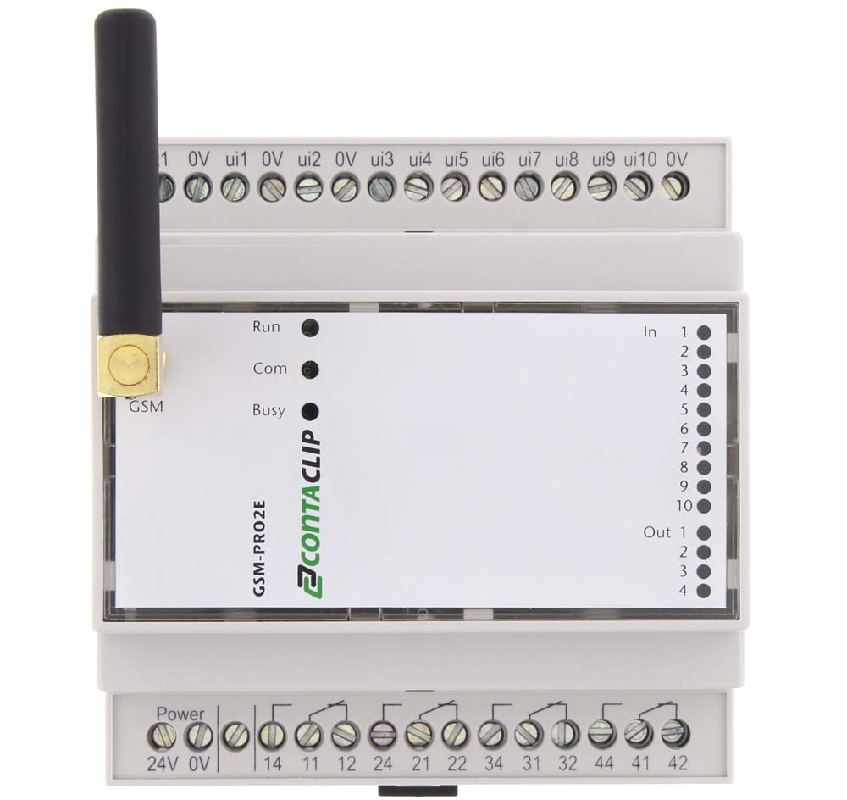
Illustration: Featuring identical exterior dimensions, the new GSM-PRO2E communication module is now available to replace the previous GSM-PRO I/O

In cases of input values exceeding or falling below defined thresholds, GSM-PRO2E can automatically notify up to 10 persons per input via text or email. Contacts for individual or group alerts can be selected from an integrated address book. Conversely, control-room staff or service technicians can switch digital relay outputs by text message or phone call. GSM-PRO2E provides various logging functions for keeping track of communication events, process values from analog inputs, and the activation of inputs and outputs over time. Users can read out log files via USB or have them sent via email. The accompanying software enables easy parameterization without programming skills. Even after installing and commissioning the modules, firmware updates and online configuration changes can be easily carried out at any time via the GSM network. Users can simply export complete configurations to other modules to minimize the effort for implementing serial applications. An app for iPhone and Android devices enables fast and easy monitoring and control of the communication module and allows for a quick overview of the status of all inputs and outputs of several GSM-PRO2 modules at once.

Illustrations: | GSM-PRO2E | Char.s: | 1,955
File name: | 201804007_pm_gsm-proe_en | Date: | 04-23-2018
About CONTA-CLIP
CONTA-CLIP is one of Europe’s leading manufacturers of electric terminal blocks. Based in Hövelhof, Germany, the medium-sized, family-run company has been producing electric and electronic connection systems for the process and automation industries for more than 40 years. CONTA-CLIP supplies all industry sectors, focusing on railroad industries, shipbuilding, building automation, conveyor technology, machine and plant engineering and construction, instrumentation and control technology, control panel manufacturing, transformer manufacturing, and environmental technology. The company consists of three specialized branches: CONTA-CONNECT for electric connection technology, CONTA-ELECTRONICS for electronics and CONTA-CON for PCB edge connectors. Additionally, CONTA-CLIP provides services such as customizing housings and mounting rails, labeling and supplying user-specific electronic components.

Contact:  CONTA-CLIP  Verbindungstechnik GmbH  Christian Quade  Otto-Hahn-Str. 7  33161 Hövelhof  Germany  Tel.: +49 . 5257 . 9833 - 0  Fax: +49 . 5257 . 9833 - 33  Email: christian.quade@conta-clip.de  WWW: www.conta-clip.com |  | gii die Presse-Agentur GmbH  Immanuelkirchstr. 12  10405 Berlin  Germany  Tel.: +49 30 / 538 965 - 0  Fax: +49 30 / 538 965 - 29  Email: info@gii.de  WWW: www.gii.de

