Press Release

New IP66 ribbon cable entry system

Introducing the new KDS-FB cable entry system for flat ribbon cables, CONTA-CLIP expands its KDSClick program of cable management solutions. As is typical for this product range, the system consists of only a few modular components that are easy to assemble without tools.

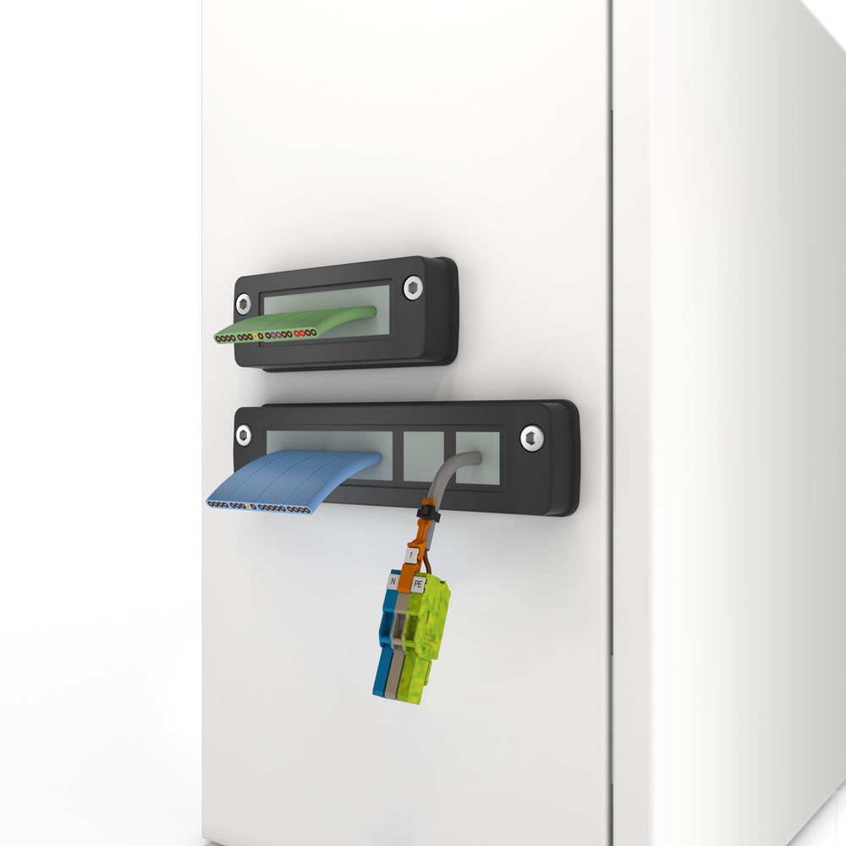
Illustration: The new KDS-FB-type, IP66-rated system enables easy entry of ribbon cables

First, the one-piece frame is screwed on the opening from outside the enclosure or distribution cabinet. Next, the cables are pushed through the cable openings of the sealing elements, which are then inserted in the frame slots from the inside. TPE gaskets are molded directly into the frames to ensure high, IP66-rated ingress protection. Sealing elements with gills outside and in the cable openings ensure an absolutely tight fit and reliable ingress protection. CONTA-CLIP provides KDS-FB in four frame widths and with different divisions for flat and round cables. Sealing elements are available for all common industrial cable sizes. The manufacturer has implemented a particularly user-friendly innovation: the sealing element for the smallest cable size is sealed by a membrane. It can therefore also be used as a blanking plug. KDS-FB allows manufacturers to pre-configure machine housings or cabinets for later wiring with no need for advance detailed knowledge of specific end-user requirements. Due to the easy, tool-less exchange of sealing elements, the wiring can be changed at any time.

Illustrations: | KDS-FB | Char.s: | 1,374
File name: | 201804029_pm_kds-fb_cable_entry_en | Date: | 07-04-2018
About CONTA-CLIP
CONTA-CLIP is one of Europe’s leading manufacturers of electric terminal blocks. Based in Hövelhof, Germany, the medium-sized, family-run company has been producing electric and electronic connection systems for the process and automation industries for more than 40 years. CONTA-CLIP supplies all industry sectors, focusing on railroad industries, shipbuilding, building automation, conveyor technology, machine and plant engineering and construction, instrumentation and control technology, control panel manufacturing, transformer manufacturing, and environmental technology. The company consists of three specialized branches: CONTA-CONNECT for electric connection technology, CONTA-ELECTRONICS for electronics and CONTA-CON for PCB edge connectors. Additionally, CONTA-CLIP provides services such as customizing housings and mounting rails, labeling and supplying user-specific electronic components.

Contact:  CONTA-CLIP  Verbindungstechnik GmbH  Christian Quade  Otto-Hahn-Str. 7  33161 Hövelhof  Germany  Tel.: +49 . 5257 . 9833 - 0  Fax: +49 . 5257 . 9833 - 33  Email: christian.quade@conta-clip.de  WWW: www.conta-clip.com |  | gii die Presse-Agentur GmbH  Immanuelkirchstr. 12  10405 Berlin  Germany  Tel.: +49 30 / 538 965 - 0  Fax: +49 30 / 538 965 - 29  Email: info@gii.de  WWW: www.gii.de

