Press Release

Die Klemme: state-of-the-art Push-in terminal series with improved design

Hövelhof – CONTA-CLIP presents the new Push-in terminal series PRK. The comprehensive range provides users with a number of design improvements on conventional Push-in terminals and satisfies even very demanding requirements regarding ease of use and mechanical stability. The Push-in connection ensures a safe, tool-free insertion of rigid wires or wires with end sleeves and significantly reduces the time spent on wiring.

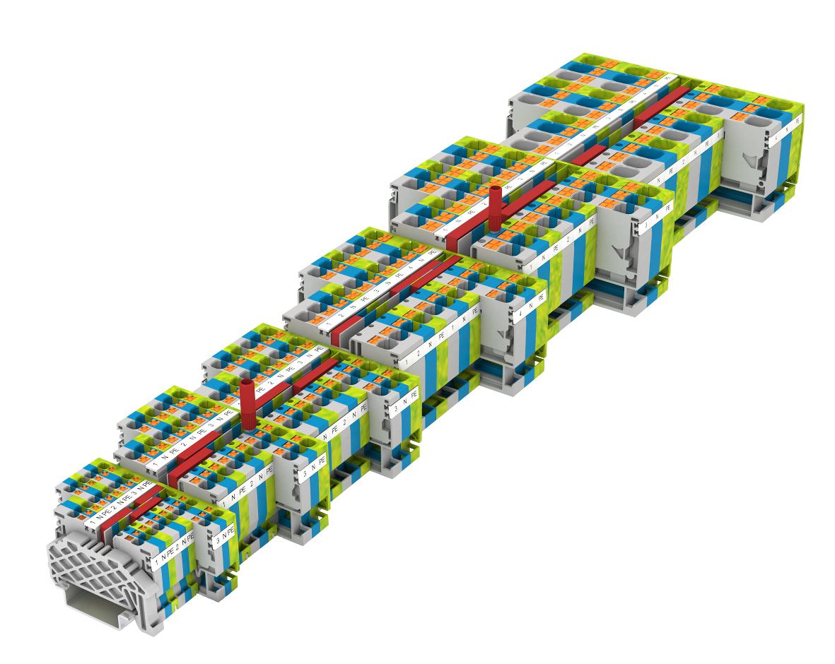
Figure: The new Push-in terminal range PRK from CONTA-CLIP

For a quick release of inserted wires, the terminals are equipped with a pusher that requires only slight pressure and no special tools, although the Push-in-springs provide high contact force for the wire connections. Improving on conventional Push-in terminals, accidental incorrect insertions of wires are made impossible due to the physical separation of the insertion channel and pusher. The completely new internal layout with large contact surfaces and fixed metal parts ensures a high current-carrying capacity with low heat build-up, mechanical toughness and an absolutely secure hold of the compact terminals. All potentials have a test point for easy measurement. PRK range feed-through and PE terminals are available for six nominal cross-sections from 1.5 mm² to 16 mm² in versions with two, three and four-wire connectors suitable for wire cross section from 0.34 mm² to 25 mm². The protective-conductor terminals are equipped with a foot contact on both sides to ensure maximum electrical and mechanical reliability. In addition, CONTA-CLIP offers the plug-in cross-connection system PQI for quick and convenient potential distribution. Standard terminals with rated cross-sections from 1.5 mm² to 10 mm² can route two potentials within the two cross-connection channels. All insulating materials used in the PRK series are free of harmful substances and meet the V-0 self-extinguishing fire classification according to UL 94.

Figures: | prk_leiste | Char.s: | 1,853
File name: | 201605006_pm_prk_en | Date: | 04-23-2018
About CONTA-CLIP
CONTA-CLIP is one of Europe’s leading manufacturers of electric terminal blocks. Based in Hövelhof, Germany, the medium-sized, family-run company has been producing electric and electronic connection systems for the process and automation industries for more than 30 years. CONTA-CLIP supplies all industry sectors, focusing on railroad industries, shipbuilding, building automation, conveyor technology, machine and plant engineering and construction, instrumentation and control technology, control panel manufacturing, transformer manufacturing, and environmental technology. The company consists of three specialized branches: CONTA-CONNECT for electric connection technology, CONTA-ELECTRONICS for electronics and CONTA-CON for PCB edge connectors. Additionally, CONTA-CLIP provides services such as customizing housings and mounting rails, labeling and supplying user-specific electronic components.

Contact:  CONTA-CLIP  Verbindungstechnik GmbH  Christian Quade  Otto-Hahn-Str. 7  33161 Hövelhof  Germany  tel.: +49 . 52 57 . 98 33 - 0  fax: +49 . 52 57 . 98 33 - 33  email: quade@conta-clip.de  WWW: www.conta-clip.com |  | gii die Presse-Agentur GmbH  Immanuelkirchstr. 12  10405 Berlin  Germany  tel.: +49 . 30 . 53 89 65 - 0  fax: +49 . 30 . 53 89 65 - 29  email: info@gii.de  WWW: www.gii.de

