Press Release

New Datapaq DP5 temperature loggers for all soldering and coating cure processes

Fluke Process Instruments launches a new range of data loggers for temperature profiling in short and medium-duration processes in the electronics and paint & powder-coating industries. The Datapaq DP5 series is optimized for ovens with a low clearance and reflow solder applications. A machined-from-solid aluminum case ensures maximum protection for the electronics when used in an industrial environment. Users can pick from various profiler formats for the best match to process restrictions. The loggers are available in six and 12 thermocouple input versions. They provide a ±0.5 °C accuracy and a ±0.1 °C resolution over the full measuring and operating temperature ranges. Measurements can be started and stopped manually, via two color-coded buttons, or triggered by time or temperature. The loggers combine ease of use with excellent availability and minimal running costs: they feature a user-replaceable NimH battery pack, which can be recharged from any USB outlet or port. One 90-minute charge allows for more than 40 hours of profiling. The sampling intervals can be set between 20 milliseconds and 10 minutes.

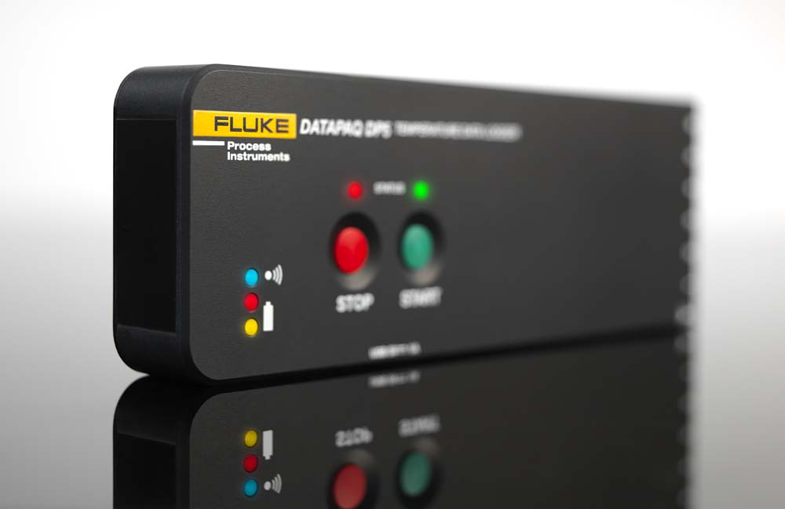
Illustration: The temperature profilers are used to set up and monitor reflow and paint cure processes

One logger can survey up to 10 ovens in succession, storing individual profiles with up to 600k data points in total. Downloads via the USB or Bluetooth connections can therefore be scheduled more efficiently. An integrated radio transmitter optionally provides real-time data from within the process. All process and system data can be communicated to factory-monitoring systems via the OPC interface. The standard Datapaq Insight software quickly transforms the raw data into actionable information. It now includes the Easy Oven Setup recipe calculator, SPC, and trending analysis. The new Datapaq Insight Professional software includes the Surveyor profiling tool that measures process performance at the critical board level and reduces the need for expensive Golden Boards. Furthermore, the portfolio includes a complete range of thermal barriers for all industry needs. All Datapaq DP5 loggers are supported with a full one-year warranty. Complementing the warranty, the manufacturer offers a yearly service and recalibration contract, which includes free software updates and loan equipment for guaranteed peace of mind.

Illustrations: | datapaq_dp5 | Char.s: | 2,253
File name: | 201805021_pm_datapaq_dp5_en | Date: | 07-04-2018
About Fluke Process Instruments
Fluke Process Instruments designs, manufactures, and markets a complete line of infrared temperature measurement and profiling solutions for industrial, maintenance, and quality control applications. Distributed worldwide under the Raytek, Ircon, and Datapaq brands, the products reflect the combined experience of over 125 years in manufacturing the world’s finest temperature measurement tools and devices.
About Fluke
Founded in 1948, Fluke Corporation is the world leader in compact, professional electronic test tools. Fluke customers are technicians, engineers, electricians, and metrologists who install, troubleshoot, and manage industrial, electrical, and electronic equipment and calibration processes.

Contact:  Fluke Process Instruments GmbH  Stephan Wilke  Blankenburger Str. 135  13127 Berlin  Germany |  | gii die Presse-Agentur GmbH  Immanuelkirchstr. 12  10405 Berlin  Germany  Tel.: +49 . 30 . 538 965-0  Email: info@gii.de  WWW: www.gii.de
Tel.: +49 . 30 . 478 008-0
Email: marcom1.emea@flukeprocessinstruments.de
Internet: www.flukeprocessinstruments.com
Contact for Americas and Australasia:
Lindsay Schutter
lindsay.schutter@fluke.com
Contact for Asia (except China):
Clothilde Bugnard
clothilde.bugnard@fluke.com
Contact for China:
Grace Cheng
chen.cheng@fluke.com

