Press Release

ALUMINIUM 2018:
20-channel temperature profiler for aluminum processing

At the ALUMINIUM 2018 exhibition in Düsseldorf, Germany, Fluke Process Instruments will present its latest temperature profiling innovations for the aluminum processing industry. The thermal profilers enable furnace surveys and in-process product temperature monitoring with up to 20 thermocouple channels. The Datapaq Insight analysis software includes comprehensive reporting functions. Users can easily customize reports and generate CQI-9, AMS 2750E, and ISO9000-compliant reports. Dedicated system solutions are available for temperature uniformity surveys (TUS) and for product temperature profiling during controlled atmosphere brazing, vacuum brazing, age hardening, solution treatment, aluminum log homogenizing, quenching, and ingot reheating.

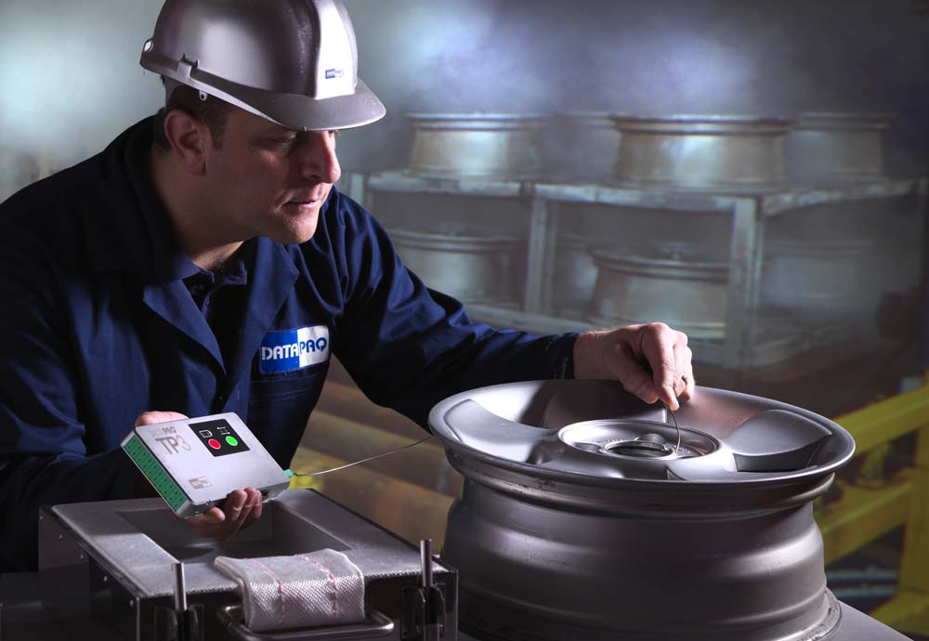
Illustration: Fluke Process Instruments provides application-specific thermal profilers consisting of a data logger, thermal barrier, thermocouples, and Datapaq Insight analysis software

The Datapaq TP3 data loggers store up to 3.6 million data points. The measured temperature range is -100 °C to 1370 °C with a ±0.3 °C accuracy. Operating costs are minimal due to flexible charging with any of three user-interchangeable battery types: Lithium, Alkaline, or rechargeable NiMH batteries. Each logger is supplied with an onboard digital calibration certificate allowing automatic measurement correction functions which eliminate risk of human error and save time on reporting. Application-specific thermal barriers protect the electronics throughout the length of the process. The line-up for the aluminum industry includes, among others, special barriers for vacuum brazing furnaces with minimized out-gassing and low-height quench systems. Featuring automatic temperature triggers, the programmable loggers can automatically choose a faster sampling interval once immersed in the quench tank, enabling users to collect more data during this critical phase of the process. The barriers cool down quickly and can be re-used immediately after a measurement run. The data loggers, too, enable time-saving serial measurements: they can execute up to ten consecutive profiling runs before download via Bluetooth or USB. The manufacturer also provides suitable thermocouples as well as a surveyor jig for brazing, which enables repeatable measurements and furnace trending analysis without having to rig up a product.
Fluke Process Instruments at ALUMINIUM 2018
Düsseldorf, Germany, 9 – 11 October 2018
Hall 10, Stand H65

Illustrations: | datapaq_tp3_1496 | Char.s: | 2178
File name: | 201807042_pm_aluminium_exhibition_en | Date: | 08-02-2018
About Fluke Process Instruments
Fluke Process Instruments designs, manufactures, and markets a complete line of infrared temperature measurement and profiling solutions for industrial, maintenance, and quality control applications. Distributed worldwide under the Raytek, Ircon, and Datapaq brands, the products reflect the combined experience of over 125 years in manufacturing the world’s finest temperature measurement tools and devices.
About Fluke
Founded in 1948, Fluke Corporation is the world leader in compact, professional electronic test tools. Fluke customers are technicians, engineers, electricians, and metrologists who install, troubleshoot, and manage industrial, electrical, and electronic equipment and calibration processes.

Contact:  Fluke Process Instruments GmbH  Stephan Wilke  Blankenburger Str. 135  13127 Berlin  Germany |  | gii die Presse-Agentur GmbH  Immanuelkirchstr. 12  10405 Berlin  Germany  Tel.: +49 . 30 . 538 965-0  Email: info@gii.de  WWW: www.gii.de
Tel.: +49 . 30 . 478 008-0
Email: marcom1.emea@flukeprocessinstruments.de
Internet: www.flukeprocessinstruments.com
Contact for Americas and Australasia:
Lindsay Schutter
lindsay.schutter@fluke.com
Contact for Asia (except China):
Clothilde Bugnard
clothilde.bugnard@fluke.com
Contact for China:
Grace Cheng
chen.cheng@fluke.com

