Press Release

glasstec exhibition:
Process control and QA in the glass industry

Fluke Process Instruments will showcase solutions for temperature measurement and quality control with data loggers and infrared technology at the glasstec exhibition in Düsseldorf, Germany. The new Thermalert 4.0 spot pyrometers enable noncontact, automatic monitoring of glass surfaces. The series includes a sensor with a 5 µm wavelength for measuring temperatures from 250 °C to 2250 °C, which is suitable for applications such as glass bending. A 7.9 µm model from the Thermalert series with a 300 °C to 900 °C range measures ultra-thin drawn glass that is used for screens in many mobile devices. The infrared thermometers have the largest ambient temperature range in their class: -20 °C to 85 °C. Therefore, many measuring points can be set up without cooling accessories, saving costs. Moreover, the sensors can be read out, configured, calibrated, and fitted with firmware updates remotely via the internet. This minimizes service costs per measuring point.

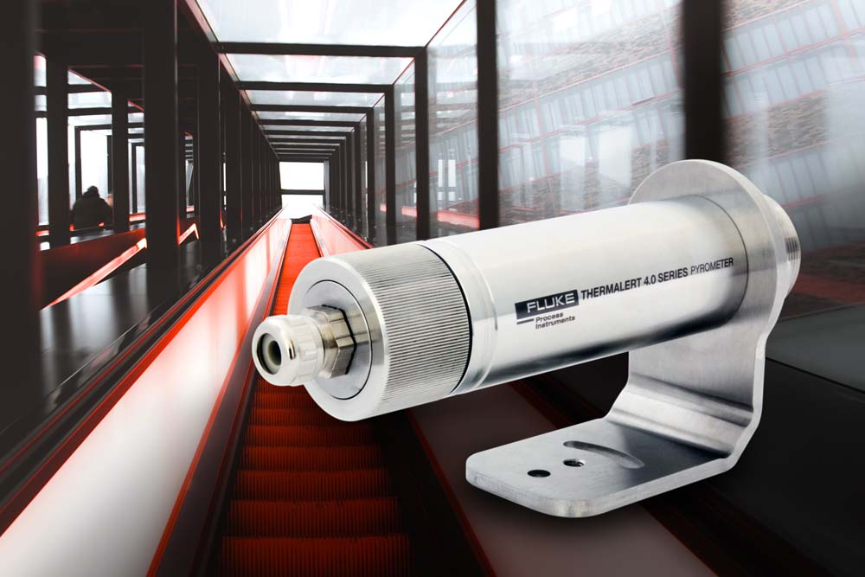
Illustration: Application-specific infrared thermometers for various manufacturing processes feature superior optical resolution and save service costs

In addition, the manufacturer will also present a system solution for glass tempering that allows plant operators to optimize their processes, especially in the production of high-value products such as architectural glass. A Datapaq Furnace Tracker measuring mere 29 mm in height passes through the tempering furnace and air quench along with the glass. Taking readings from ten thermocouples that are attached to the glass pane, it generates a temperature profile of the entire process. Such profiling runs are used for process setup and troubleshooting primarily. Complementing the profiling solution, noncontact infrared measurement technology ensures 100% production control and traceability: an IR linescanner generates full thermal images at the furnace exit, which are used to monitor temperature uniformity. The Raytek MP150 linescanner offers a superior resolution of up to 1024 measurement points per line, revealing even minimal deviations.
Fluke Process Instruments at the glasstec exhibition
Düsseldorf, Germany, 23 – 26 October 2018
Hall 14, Stand G48

Illustrations: | thermalert_40_glass | Char.s: | 1919
File name: | 201808003_pm_glasstec_en | Date: | 10-23-2018
About Fluke Process Instruments
Fluke Process Instruments designs, manufactures, and markets a complete line of infrared temperature measurement and profiling solutions for industrial, maintenance, and quality control applications. Distributed worldwide under the Raytek, Ircon, and Datapaq brands, the products reflect the combined experience of over 125 years in manufacturing the world’s finest temperature measurement tools and devices.
About Fluke
Founded in 1948, Fluke Corporation is the world leader in compact, professional electronic test tools. Fluke customers are technicians, engineers, electricians, and metrologists who install, troubleshoot, and manage industrial, electrical, and electronic equipment and calibration processes.

Contact:  Fluke Process Instruments GmbH  Stephan Wilke  Blankenburger Str. 135  13127 Berlin  Germany |  | gii die Presse-Agentur GmbH  Immanuelkirchstr. 12  10405 Berlin  Germany  Tel.: +49 . 30 . 538 965-0  Email: info@gii.de  WWW: www.gii.de
Tel.: +49 . 30 . 478 008-0
Email: marcom2.emea@flukeprocessinstruments.de
Internet: www.flukeprocessinstruments.com
Contact for Americas and Australasia:
Lindsay Schutter
lindsay.schutter@fluke.com
Contact for Asia (except China):
Clothilde Bugnard
clothilde.bugnard@fluke.com
Contact for China:
Grace Cheng
chen.cheng@fluke.com

