Press Release

Thermal imaging and furnace surveys in the steel and metals industry

Fluke Process Instruments offers a comprehensive range of temperature monitoring solutions for primary and secondary metals manufacturing. The company has just introduced ThermoView TV40 thermal imagers with an integrated visible-light camera. Designed for fixed installation, this new series is ideal for iron foundries where the imagers check temperatures of molten metal and monitor ladles to ensure that the refractory lining is intact. Users can define various areas of interest with distinct alarm conditions. The analysis software enables easy traceability for each melt. Fluke Process Instruments furthermore offers temperature profiling solutions for downstream steel and metals processing. The Datapaq Furnace Tracker based on the Datapaq TP3 data logger with up to 20 measurement channels enables furnace surveys according to NADCAP AMS 2750E and CQI-9. The systems include analysis and reporting software, thermocouples, and thermal barriers for maximum protection at high temperatures up to 1200 °C. They are also used for in-process product temperature profiling.
These and more products and applications will be presented at the 2018 HeatTreatmentCongress in Cologne, Germany.
Fluke Process Instruments at HeatTreatmentCongress
Koelnmesse, Cologne, Germany, 16 – 18 October 2018
Hall 4.1, Stand A-060, B-061

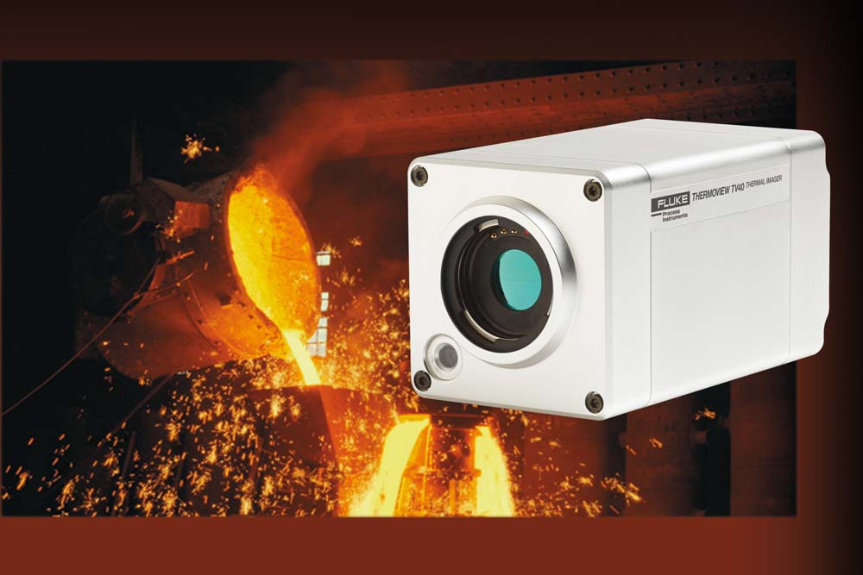
Illustration: The new, fixed-installation thermal camera enables continuous monitoring of heat treatment processes

Illustrations: | thermoview_tv40_iron_foundry_ladle | Char.s: | 1077
File name: | 201808049_pm_metals_heat_treatment_en | Date: | 09-12-2018
About Fluke Process Instruments
Fluke Process Instruments designs, manufactures, and markets a complete line of infrared temperature measurement and profiling solutions for industrial, maintenance, and quality control applications. Distributed worldwide under the Raytek, Ircon, and Datapaq brands, the products reflect the combined experience of over 125 years in manufacturing the world’s finest temperature measurement tools and devices.
About Fluke
Founded in 1948, Fluke Corporation is the world leader in compact, professional electronic test tools. Fluke customers are technicians, engineers, electricians, and metrologists who install, troubleshoot, and manage industrial, electrical, and electronic equipment and calibration processes.

Contact:  Fluke Process Instruments GmbH  Stephan Wilke  Blankenburger Str. 135  13127 Berlin  Germany |  | gii die Presse-Agentur GmbH  Immanuelkirchstr. 12  10405 Berlin  Germany  Tel.: +49 . 30 . 538 965-0  Email: info@gii.de  WWW: www.gii.de
Tel.: +49 . 30 . 478 008-0
Email: marcom2.emea@flukeprocessinstruments.de
Internet: www.flukeprocessinstruments.com
Contact for Americas and Australasia:
Lindsay Schutter
lindsay.schutter@fluke.com
Contact for Asia (except China):
Clothilde Bugnard
clothilde.bugnard@fluke.com
Contact for China:
Grace Cheng
chen.cheng@fluke.com

