Press Release

Profiling aluminum vacuum brazing furnaces

Fluke Process Instruments provides a dedicated temperature profiler for aluminum vacuum brazing furnaces. The Datapaq Furnace Tracker system automatically generates CQI-9 and AMS 2750E reports. It is designed for frequent use, even during normal production. The data logger traces product temperature profiles via ten thermocouples throughout all process phases. Thermal protection is provided by a phase-change heat sink and a thermal barrier consisting of nine stainless-steel and aluminum reflective plates with a ceramic outer coating. The all-metal construction eliminates the need for micro-porous insulation and therefore minimizes outgassing along with its related problems of oxidation and unnecessary rejects. The Datapaq VB1150 vacuum barrier protects the logger for 3.5 hours at 600 °C. The maximum operating temperature in vacuum processes is 700 °C. After only 45 minutes of cooling down, the system is ready to be reused. The innovative application-specific design and superior manufacturing quality ensure a solution that will perform reliably for many years. The system software enables trending analysis and facilitates logger diagnostics. It allows users to identify hot and cold spots and optimize product load and furnace parameters such as brazing times, max/min temperatures, and temperature slopes to ensure that all products meet thermal specifications. An optional radio module enables real-time process control, allowing users to adjust furnace settings and ramp-up to the next zone at the right time. Fluke Process Instruments will present all its latest temperature profiling innovations for the aluminum processing industry at the ALUMINIUM 2018 exhibition in Düsseldorf, Germany, in Hall 10, at Stand H65.
Fluke Process Instruments at ALUMINIUM 2018
Düsseldorf, Germany, 9 – 11 October 2018
Hall 10, Stand H65

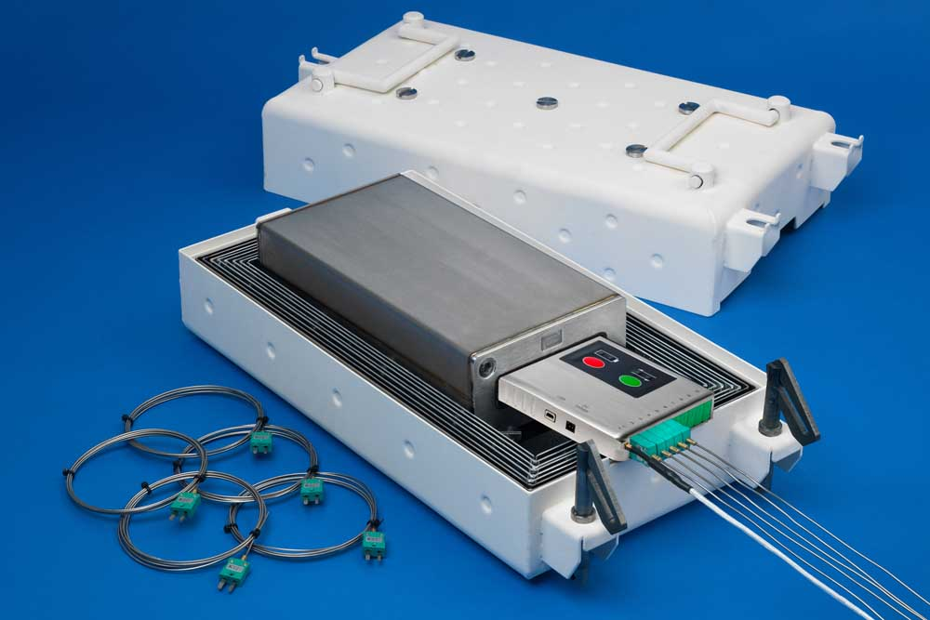
Illustration: The quick-cool-down, no-outgassing system enables frequent profiling of product temperatures even during normal production

Illustrations: | datapaq_vb1150_tp3_alu_vacuum_brazing | Char.s: | 1736
File name: | 201809020_pm_aluminum_vacuum_brazing_en | Date: | 09-19-2018
About Fluke Process Instruments
Fluke Process Instruments designs, manufactures, and markets a complete line of infrared temperature measurement and profiling solutions for industrial, maintenance, and quality control applications. Distributed worldwide under the Raytek, Ircon, and Datapaq brands, the products reflect the combined experience of over 125 years in manufacturing the world’s finest temperature measurement tools and devices.
About Fluke
Founded in 1948, Fluke Corporation is the world leader in compact, professional electronic test tools. Fluke customers are technicians, engineers, electricians, and metrologists who install, troubleshoot, and manage industrial, electrical, and electronic equipment and calibration processes.

Contact:  Fluke Process Instruments GmbH  Stephan Wilke  Blankenburger Str. 135  13127 Berlin  Germany |  | gii die Presse-Agentur GmbH  Immanuelkirchstr. 12  10405 Berlin  Germany  Tel.: +49 . 30 . 538 965-0  Email: info@gii.de  WWW: www.gii.de
Tel.: +49 . 30 . 478 008-0
Email: marcom1.emea@flukeprocessinstruments.de
Internet: www.flukeprocessinstruments.com
Contact for Americas and Australasia:
Lindsay Schutter
lindsay.schutter@fluke.com
Contact for Asia (except China):
Clothilde Bugnard
clothilde.bugnard@fluke.com
Contact for China:
Grace Cheng
chen.cheng@fluke.com

