Press Release

Two know more than one

Combining two devices using two different temperature measurement technologies, Fluke Process Instruments provides the glass industry with more information on high-value applications like float glass manufacturing, glass tempering, and windshield forming and laminating. Temperature profiling runs with a data logger enable operators to quickly optimize furnace settings for new products and to identify problems with burners or airflow. They are complemented by a thermal imager installed at the furnace exit for 100 % production monitoring and traceability. Datapaq Furnace Tracker profiling systems travel through heat-treatment and quench processes. They record the product temperature curves via up to 20 thermocouples cemented to the glass pane. These industry-specific profiling systems consist of a data logger, a thermal barrier, and software with advanced analysis, reporting, and archiving functions. The manufacturer offers the largest range of thermal barriers in the market and will advise customers on which system setup to use for their applications. The other measuring device, a Raytek MP150 infrared linescanner, scans each glass pane when it exits the furnace. It generates a thermal image and immediately shows up hot and cold spots. The series comprises various different spectral models, allowing even low-emissivity glass to be monitored. In contrast to thermal cameras, the linescanner needs only a very narrow field of view. It is therefore ideal for manufacturing lines with furnace and quench installed in close proximity.

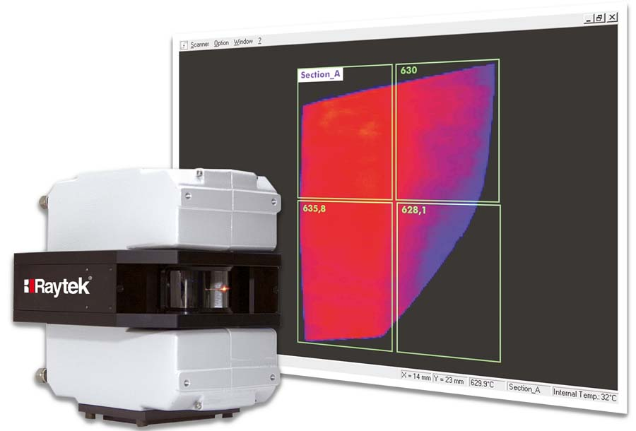
Illustration: Fluke Process Instruments provides comprehensive temperature profiling and imaging solutions for high-value glasses, including low-E glass

Illustrations: | raytek_mp150_carglass | Char.s: | 1550
File name: | 201810003_pm_profiling_and_ir_for_glass_en | Date: | 10-23-2018
About Fluke Process Instruments
Fluke Process Instruments designs, manufactures, and markets a complete line of infrared temperature measurement and profiling solutions for industrial, maintenance, and quality control applications. Distributed worldwide under the Raytek, Ircon, and Datapaq brands, the products reflect the combined experience of over 125 years in manufacturing the world’s finest temperature measurement tools and devices.
About Fluke
Founded in 1948, Fluke Corporation is the world leader in compact, professional electronic test tools. Fluke customers are technicians, engineers, electricians, and metrologists who install, troubleshoot, and manage industrial, electrical, and electronic equipment and calibration processes.

Contact:  Fluke Process Instruments GmbH  Stephan Wilke  Blankenburger Str. 135  13127 Berlin  Germany |  | gii die Presse-Agentur GmbH  Immanuelkirchstr. 12  10405 Berlin  Germany  Tel.: +49 . 30 . 538 965-0  Email: info@gii.de  WWW: www.gii.de
Tel.: +49 . 30 . 478 008-0
Email: marcom2.emea@flukeprocessinstruments.de
Internet: www.flukeprocessinstruments.com
Contact for Americas and Australasia:
Lindsay Schutter
lindsay.schutter@fluke.com
Contact for Asia (except China):
Clothilde Bugnard
clothilde.bugnard@fluke.com
Contact for China:
Grace Cheng
chen.cheng@fluke.com

