Press Release

Electrical testing instruments get software upgrade

Gossen Metrawatt now provides PROFITEST MASTER instruments with the new IZYTRONIQ testing software. The upgrade enables visualization, data management, and audit-proof documentation of all test events across devices. For the first time, measurement and test data from different testers and multimeters can be collated in one inspection. Objects and places are assigned via drag and drop. Therefore, even complex procedures become very easy, for instance assigning datasets to other locations such as lots, buildings, levels, and rooms. Individual test structures can be directly uploaded to the test instrument. Control options also include practical features such as a push/print function to further simplify the transmission of measured values with all relevant characteristics. The Business Starter version installed by default in all PROFITEST MASTER instruments can be upgraded be at any time as needed. Additional Business versions are available, as well as network-enabled Enterprise versions. This expands the capabilities of the CAT IV devices.

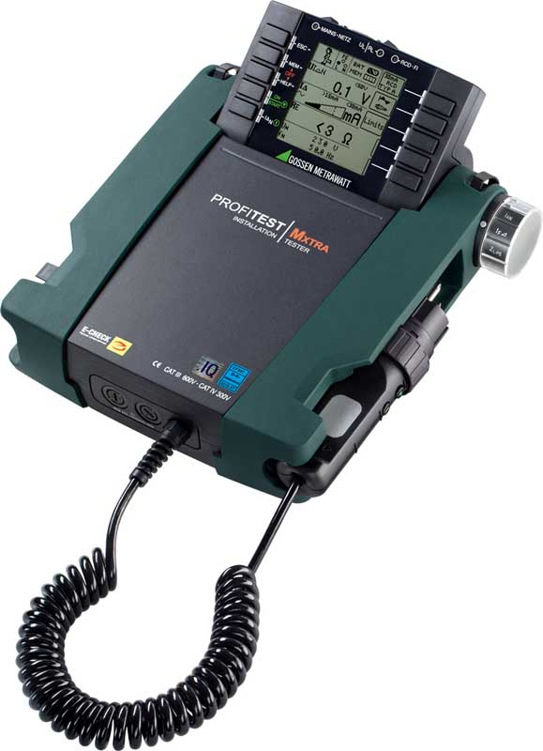
Illustration: Gossen Metrawatt now provides PROFITEST MASTER instruments with the new IZYTRONIQ software for comprehensive test data management

The series is designed for testing and measuring tasks in all AC and three-phase networks with voltages from 65 V to 500 V and frequencies from 15.4 Hz to 420 Hz. The systems support all tests according to DIN VDE 0100-600 / DIN VDE 0105-100 to check the effectiveness of protection measures in electrical installations in private homes, commercial buildings, and industrial facilities. On top of basic standard tests, PROFITEST MASTER offers numerous additional measuring functions and meets the requirements for acceptance tests and periodic inspections in fixed electrical installations. The devices' ergonomic design and user-friendly operation simplify the selection and setup of test sequences. The current measuring method and values are always clearly shown on the integrated illuminated display.

Illustrations: | profitestmxtra-iq | Char.s: | 1857
File name: | 201810031_pm_profitest_master_izytroniq_en | Date: | 02-06-2019

About Gossen Metrawatt

GMC-I Messtechnik is one of the world's leading suppliers of measurement systems. Under the GOSSEN METRAWATT brand, the company develops and distributes a wide range of high-quality measuring and test devices for the electrical trade, industry, and the medical sector. The scope of products includes measuring and testing equipment for standardized testing of electrical systems and appliances, multimeters, calibrators, network analyzers, power supplies, as well as transducers and power meters for high-voltage and moving-coil measurement. GMC-I Messtechnik also provides a varied offering of training courses for customers and develops energy management concepts. The corporate group runs its own DakkS-certified calibration center that performs DakkS, ISO, and factory calibrations for virtually all electrical measured values. GMC-I Messtechnik is part of the GMC Instruments group, which also includes other specialized manufacturers for measurement and testing technology – notably, Camille Bauer Metrawatt, Dranetz, Prosys, Seaward and Rigel, and Kurth Electronic. The group's production sites in Germany, Switzerland, England, and the United States are complemented by a global sales network.

Contact:  GMC-I Messtechnik GmbH  Christian Widder  Leiter Marketingkommunikation  Südwestpark 15  90449 Nürnberg  Germany |  | gii die Presse-Agentur GmbH  Immanuelkirchstr. 12  10405 Berlin  Germany  Phone: +49 30 / 538 965 -0  Fax: +49 30 / 538 965 -29  Email: info@gii.de  Web: www.gii.de
Phone: +49 911 / 8602 - 572
Fax: +49 911 / 8602 - 4699
Email: christian.widder@gossenmetrawatt.com
Web: www.gossenmetrawatt.com

