Press Release

Safety test instruments with new software

For SECUTEST instruments from Gossen Metrawatt, the manufacturer's new IZYTRONIQ software is now included in supply. The SECUTEST series comprises various models for testing the electrical safety of electrical devices and welding units up to 400 V. Special variants are available for type testing of medical devices during production as well as for periodic inspections according to IEC/EN 62353 and IEC/EN 60601: SECULIFE ST BASE, ST BASE25, and ST PRO. The instruments feature pre-programmed test sequences with automatic evaluation per VDE 0701-0702, IEC/EN 62353 (VDE 0751), and IEC/EN 60974-4 (VDE 0544-4). In addition, users can define their own test sequences to meet specific standards such as IEC 60601, 61010, 60335, 60204. The software upgrade expands the scope of measuring, testing, and integral metering capabilities, since IZYTRONIQ adds new device functions and methods of measurement. In addition to an exceptional function range, the software features intuitive operation and a contemporary design for up-to-date standards-compliant data management.

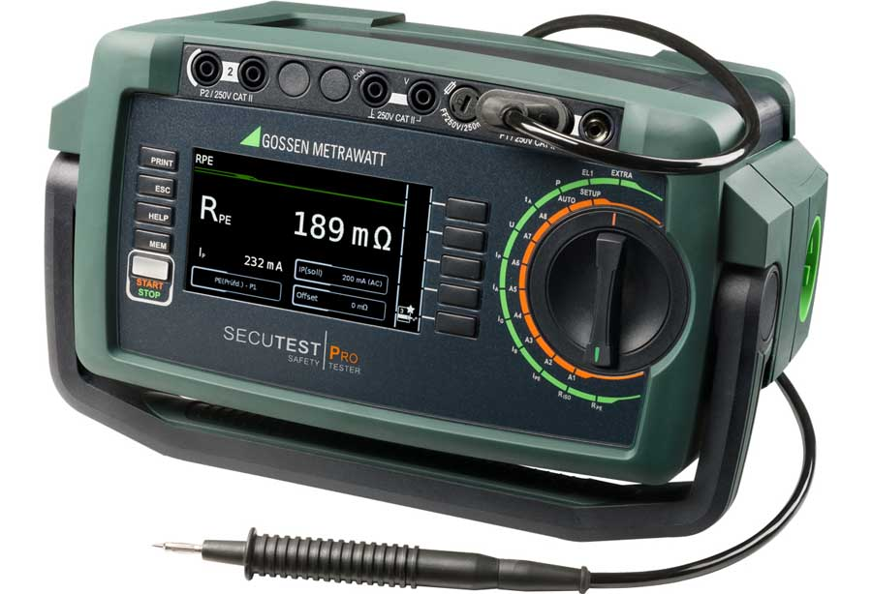
Illustration: Running the IZYTRONIQ software, SECUTEST instruments now offer a greater range of testing capabilities with simplified data acquisition and documentation

Users can simply drag and drop test objects and locations. Even complex operations such as assigning existing objects to other sites, buildings, levels, or rooms are easy to accomplish. Users can freely switch between table, tree, and index card views in portrait or landscape formats as well as between touch and mouse operation. Smart features for highlighting or hiding specific tools and workspaces make it easy to select the right function in everyday operation. User-friendly control options also include the practical remote mode and a push/print function, which simplify the transmission of measured values with all relevant characteristics. Furthermore, the software now enables the collation of measurement and test data from different testers and multimeters in one inspection as well as their audit-proof documentation. The default Business Starter version installed in all SECUTEST instruments can be upgraded at any time as needed. Users can choose from additional Business versions or network-enabled Enterprise versions. All existing data is simply carried over.

Illustrations: | secutestpro-iq | Char.s: | 2145
File name: | 201810032_pm_secutest_izytroniq_en | Date: | 01-07-2019

About Gossen Metrawatt

GMC-I Messtechnik is one of the world's leading suppliers of measurement systems. Under the GOSSEN METRAWATT brand, the company develops and distributes a wide range of high-quality measuring and test devices for the electrical trade, industry, and the medical sector. The scope of products includes measuring and testing equipment for standardized testing of electrical systems and appliances, multimeters, calibrators, network analyzers, power supplies, as well as transducers and power meters for high-voltage and moving-coil measurement. GMC-I Messtechnik also provides a varied offering of training courses for customers and develops energy management concepts. The corporate group runs its own DakkS-certified calibration center that performs DakkS, ISO, and factory calibrations for virtually all electrical measured values. GMC-I Messtechnik is part of the GMC Instruments group, which also includes other specialized manufacturers for measurement and testing technology – notably, Camille Bauer Metrawatt, Dranetz, Prosys, Seaward and Rigel, and Kurth Electronic. The group's production sites in Germany, Switzerland, England, and the United States are complemented by a global sales network.

Contact:  GMC-I Messtechnik GmbH  Christian Widder  Leiter Marketingkommunikation  Südwestpark 15  90449 Nürnberg  Germany |  | gii die Presse-Agentur GmbH  Immanuelkirchstr. 12  10405 Berlin  Germany  Phone: +49 30 / 538 965 -0  Fax: +49 30 / 538 965 -29  Email: info@gii.de  Web: www.gii.de
Phone: +49 911 / 8602 - 572
Fax: +49 911 / 8602 - 4699
Email: christian.widder@gossenmetrawatt.com
Web: www.gossenmetrawatt.com

