Press Release

Managing electrical test data in the cloud

The GMC-Instruments group and its Gossen Metrawatt brand have launched a new cloud platform for secure inspection data management that holds up to legal scrutiny. The GMC-Instruments cloud offers a suite of applications and services for structured, comprehensive test and measurement data acquisition, archiving, and documentation. It greatly facilitates standards-compliant electrical safety inspections. Incorporating the IZYTRONIQ, ELEXONIQ, and VIZIONIQ modules, the cloud platform covers all current requirements of a modern, future-proof, upgradeable testing regime. Measured values and test data from various devices can be easily combined into one inspection. Users can view these schemes remotely at any time. Tiered access rights can be set up. Connection to this cloud saves costly investments in IT infrastructure and storage capacity.

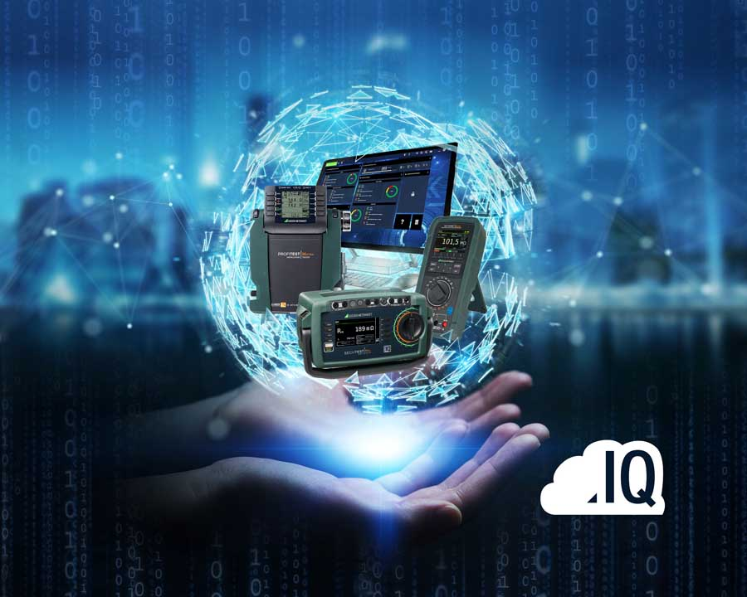
Illustration: The new cloud platform from GMC-Instruments provides direct access to the latest software tools for flexible, comprehensive test data management
(image source: Adobe Stock/GMC-I)

It ensures maximum data availability and secure communications through SSL-encrypted data transfer. The solution is based on the new cloud version of the IZYTRONIQ test software, which enables multiple users to easily access all inspection data, facilities, and documentation materials. Team access, shared execution of test sequences, and rights management tailored to employees' qualifications make the entire testing process more flexible. In addition, the ELEXONIQ app enables taking rapid inventories of customers, sites, and objects using smartphones, tablets, or notebooks. App users can directly synchronize data with the cloud without the IZYTRONIQ inspection software. They can also scan bar codes and take photos and assign them to objects. As a third module, GMC-I has integrated the web-based VIZIONIQ customer portal. This tool enables users to share all kinds of data with customers in a clearly structured form without time-consuming configuration: test results, reports, documentation, and attachments. Test technicians and electricians can now subscribe to the new GMC-I cloud service for a monthly fee.

Illustrations: | cloud-computing | Char.s: | 1968
File name: | 201811038_pm_cloud_platform_en | Date: | 12-05-2018

About Gossen Metrawatt

GMC-I Messtechnik is one of the world's leading suppliers of measurement systems. Under the GOSSEN METRAWATT brand, the company develops and distributes a wide range of high-quality measuring and test devices for the electrical trade, industry, and the medical sector. The scope of products includes measuring and testing equipment for standardized testing of electrical systems and appliances, multimeters, calibrators, network analyzers, power supplies, as well as transducers and power meters for high-voltage and moving-coil measurement. GMC-I Messtechnik also provides a varied offering of training courses for customers and develops energy management concepts. The corporate group runs its own DakkS-certified calibration center that performs DakkS, ISO, and factory calibrations for virtually all electrical measured values. GMC-I Messtechnik is part of the GMC Instruments group, which also includes other specialized manufacturers for measurement and testing technology – notably, Camille Bauer Metrawatt, Dranetz, Prosys, Seaward and Rigel, and Kurth Electronic. The group's production sites in Germany, Switzerland, England, and the United States are complemented by a global sales network.

Contact:  GMC-I Messtechnik GmbH  Christian Widder  Leiter Marketingkommunikation  Suedwestpark 15  90449 Nürnberg  Germany |  | gii die Presse-Agentur GmbH  Immanuelkirchstr. 12  10405 Berlin  Germany  Phone: +49 . 30 . 538 965-0  Fax: +49 . 30 . 538 965-29  Email: info@gii.de  Web: www.gii.de
Phone: +49 . 911 . 8602-572
Fax: +49 . 911 . 8602-4699
Email: christian.widder@gossenmetrawatt.com
Web: www.gmc-instruments.com

