Press Release

Underfloor intra-logistics system

Based on the LOXrail system, the LOSYCO team of intra-logistics specialists creates handling solutions that help machine and plant engineering companies streamline production processes. The rails designed for payloads of several tons, the choice of drive technology, and the line layout are adapted to the requirements of the particular operation. Optionally, the entire system can be installed in the hall floor to implement mobile assembly lines for one-piece flow. Working for a machine tool builder, LOSYCO recently developed a drive concept with an especially low installation height to realize just such a solution. An underfloor pull-bar system that spans the entire assembly line is powered by a chain conveyor installed at the end of the line. A tow conveyor pulls the bulky assembly platforms from station to station. After each move, the system is retracted to the original position and again coupled to the platforms. This enables seamless flow production throughout all stages and allows assembly teams to move freely, unobstructed by the underfloor intra-logistics system. "This special in-floor solution illustrates the high degree of variability of our LOXrail system," says LOSYCO sales director Manuel Granz. The system comes with 25 mm or 40 mm rail diameters and includes intersections and turntables for a flexible adaption of the line to any shop-floor layout. The transport platforms run on smooth wheel sets with single or double rollers to accommodate payloads from 16 kN to 100 kN per wheel set. Due to the particularly low-friction wheel profile, machine tools and other very heavy goods are safely transported and accurately positioned. In applications requiring more power, LOSYCO equips the LOXrail system with electric or pneumatic movers, batteries, cable reels, or inductive drive technology.

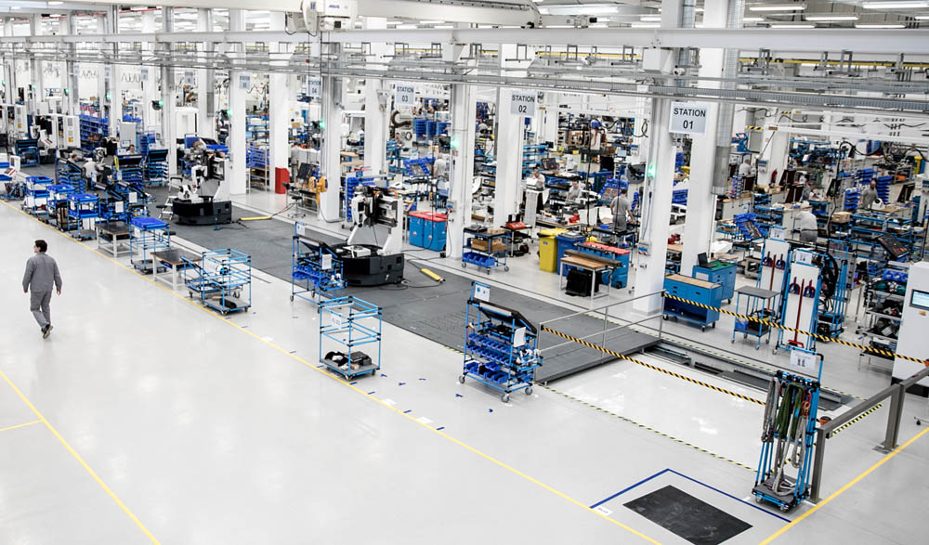

Illustration: LOSYCO has developed an underfloor pull-bar system for LOXrail one-piece flow assembly lines

Illustrations: | fliessmontage_pm_2000px | Char.s: | 1825
File name: | 201811046_pm_loxrail_underfloor_drive_en | Date: | 02-19-2019
About Losyco
Based in Bielefeld, Germany, Losyco designs, manufactures, and deploys intra-logistics systems for industrial customers. Founded by experienced engineers in 2016, the company's first core product is LOXrail®: with this novel round bar rail system, loads weighing several tons can be easily moved around, precisely to the desired spot. It can be operated manually or with auxiliary drives. Losyco also supplies conveying and handling equipment such as chain and roller conveyors, material management and storage systems, sound-proof cabins, and machine covers. In addition, Losyco offers support and guidance for customers wishing to transform their production processes to implement lean manufacturing and continuous flow production. Losyco is a member of the DRECKSHAGE Family.

Contact:  LOSYCO GmbH  Member of the DRECKSHAGE Family  Derek P. Clark  Walter-Werning-Str. 7  33699 Bielefeld  Germany  Tel.: +49 . 521 . 945 643-0  Fax: +49 . 521 . 945 643-399  Email: info@losyco.com  Internet: www.losyco.com |  | gii die Presse-Agentur GmbH  Immanuelkirchstr. 12  10405 Berlin  Germany  Tel.: +49 . 30 . 538 965-0  Fax: +49 . 30 . 538 965-29  Email: info@gii.de  Internet: www.gii.de

