Press Release

New FNT 16 neutral disconnect terminal for 2.5 – 25 mm²

CONTA-CLIP expands its range of single-level push-in installation terminals, adding the FNT 16 neutral disconnect terminal for wire cross sections between 2.5 mm² and 25 mm² (up to 16 mm² with wire-end ferrules). The push-in connection system allows for safe connection of wires without tools. When a solid wire or ferrule is inserted, the pressure spring opens automatically and establishes a secure contact. Standard screwdrivers can be used to connect and disconnect flexible wires without ferrules. The disconnect terminal integrates a receptacle for the 10x3-mm neutral busbar. There is no need for an additional fixing plate. The neutral busbar is securely connected via a screw-less slider. Like FRKI feed-through terminals and FSLI PE terminals, the neutral disconnect terminals can be used alongside FDLIS three-level installation terminals, because the position of the neutral busbar is identical in both versions.

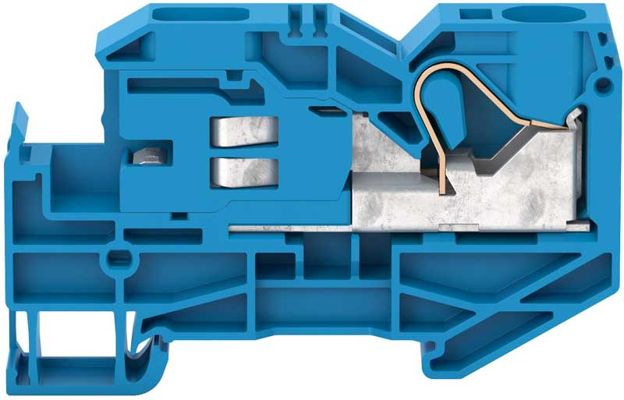
Illustration: The new FNT 16 neutral disconnect terminal has a contact wire range of 2.5 mm² to 25 mm²

Illustrations: | FNT16 | Char.s: | 924
File name: | 201812010_pm_fnt_16_neutral_disconnect_en | Date: | 02-06-2019
About CONTA-CLIP
CONTA-CLIP is one of Europe’s leading manufacturers of electrical and electronic connection elements and cable management solutions. Based in Hövelhof, Germany, the medium-sized, family-run company has been producing electric and electronic connection systems for the process and automation industries for 40 years. CONTA-CLIP supplies all industry sectors, focusing on railroad industries, shipbuilding, building automation, conveyor technology, machine and plant engineering and construction, instrumentation and control technology, control panel manufacturing, transformer manufacturing, and environmental technology. The company consists of three specialized branches: CONTA-CONNECT for electric connection technology, CONTA-ELECTRONICS for electronics and CONTA-CON for PCB edge connectors. Additionally, CONTA-CLIP provides services such as customizing housings and mounting rails, labeling and supplying user-specific electronic components.

Contact:  CONTA-CLIP  Verbindungstechnik GmbH  Christian Quade  Otto-Hahn-Str. 7  33161 Hövelhof  Germany  Tel.: +49 . 5257 . 9833 - 0  Fax: +49 . 5257 . 9833 - 33  Email: christian.quade@conta-clip.de  WWW: www.conta-clip.com |  | gii die Presse-Agentur GmbH  Immanuelkirchstr. 12  10405 Berlin  Germany  Tel.: +49 30 / 538 965 - 0  Fax: +49 30 / 538 965 - 29  Email: info@gii.de  WWW: www.gii.de

