Press Release

TKS transformer terminal for wire cross-sections up to 16 mm²

CONTA-CLIP adds a transformer terminal for wire cross-sections up to 16 mm² to its TKS series. The terminals are used to adapt coil ends to screw connections to implement power supply of specific devices or machinery in a larger system. Their hinged cover elements open wide and can be fixed in place when opened to enable comfortable, time-saving soldering of the coil ends. The new, two-pole TKS 16 terminal like all terminals from this series can be mounted directly on a core with integrated receptacles or on aluminum 10 x 2 mm DIN rails. The proven clamping yoke system accomplishes a secure, vibration-resistant connection. The closed housing design ensures touch safety in compliance with DGUV provision 3. The terminals are available in orange or gray polyamide PA 6.6 UL94 V-0. The PMC SB 7,5 and PC-SB 7,5 quick marking systems are available for labeling the terminals.

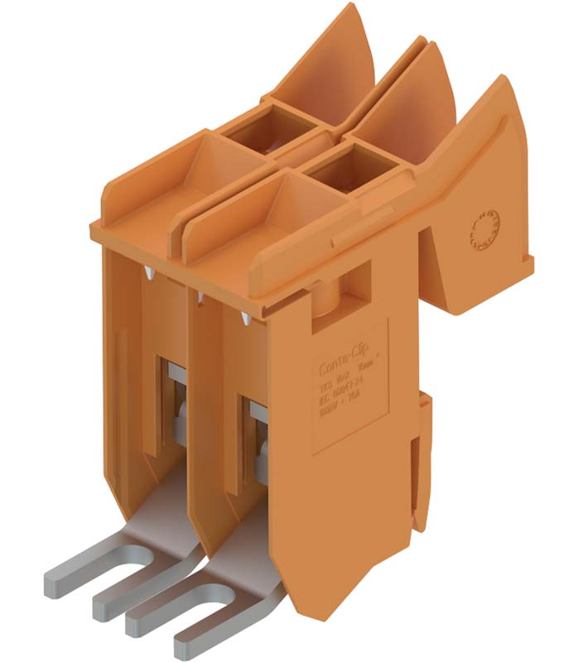
Illustration: The TKS 16 transformer terminal for wire cross-sections up to 16 mm² feature a cover that opens wide for easy access

Illustrations: | TKS_16_offen_eingerastet | Char.s: | 880
File name: | 201812011_pm_tks_16_transformer_terminal_en | Date: | 02-27-2019
About CONTA-CLIP
CONTA-CLIP is one of Europe’s leading manufacturers of electrical and electronic connection elements and cable management solutions. Based in Hövelhof, Germany, the medium-sized, family-run company has been producing electric and electronic connection systems for the process and automation industries for 40 years. CONTA-CLIP supplies all industry sectors, focusing on railroad industries, shipbuilding, building automation, conveyor technology, machine and plant engineering and construction, instrumentation and control technology, control panel manufacturing, transformer manufacturing, and environmental technology. The company consists of three specialized branches: CONTA-CONNECT for electric connection technology, CONTA-ELECTRONICS for electronics and CONTA-CON for PCB edge connectors. Additionally, CONTA-CLIP provides services such as customizing housings and mounting rails, labeling and supplying user-specific electronic components.

Contact:  CONTA-CLIP  Verbindungstechnik GmbH  Christian Quade  Otto-Hahn-Str. 7  33161 Hövelhof  Germany  Tel.: +49 . 5257 . 9833 - 0  Fax: +49 . 5257 . 9833 - 33  Email: christian.quade@conta-clip.de  WWW: www.conta-clip.com |  | gii die Presse-Agentur GmbH  Immanuelkirchstr. 12  10405 Berlin  Germany  Tel.: +49 30 / 538 965 - 0  Fax: +49 30 / 538 965 - 29  Email: info@gii.de  WWW: www.gii.de

