Press Release

New KDS-FB cable entry for five round-cable sealing elements

CONTA-CLIP continuously expands the KDS-FB flat ribbon cable entry system. The portfolio currently comprises a total of 13 cable entries with four frame widths and various divisions for flat and round cables. The latest addition is a pre-configured cable entry with five sealing elements to accommodate round cables. The new variant has a 39 mm x 120 mm frame size. Like all KDSClick cable management solutions, the KDS-FB line is based on a few basic components designed for tool-less assembly and tool-less placement into a frame. Once the one-piece frame is screwed on the opening from outside the enclosure or distribution cabinet, flat or round cables fitted with suitable sealing elements can simply be pushed in from the inside for a snug insertion into the frame slots. TPE gaskets are molded directly into the frames to ensure high, IP66-rated ingress protection. Sealing elements with gills all around ensure an absolutely tight fit and reliable ingress protection. The gaskets for flat cable entries additionally feature gills in the cable openings. Sealing elements are available for all common industrial cable sizes. KDS-FB thus allows manufacturers to pre-configure machine housings or cabinets for later wiring with no need for advance detailed knowledge of specific end-user requirements. The sealing elements for different cable diameters all have uniform sizes. Due to the easy, tool-less exchange of the sealing elements, the cabling can therefore be changed at any time.

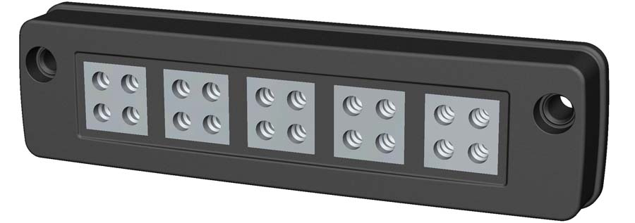
Illustration: The new KDS-FB variant accommodates five round-cable sealing elements

Illustrations: | KDS-SR-FB4-5-DE | Char.s: | 1491
File name: | 201812012_pm_kds-fb_for_round_cables_en | Date: | 01-16-2019
About CONTA-CLIP
CONTA-CLIP is one of Europe’s leading manufacturers of electric terminal blocks. Based in Hövelhof, Germany, the medium-sized, family-run company has been producing electric and electronic connection systems for the process and automation industries for 40 years. CONTA-CLIP supplies all industry sectors, focusing on railroad industries, shipbuilding, building automation, conveyor technology, machine and plant engineering and construction, instrumentation and control technology, control panel manufacturing, transformer manufacturing, and environmental technology. The company consists of three specialized branches: CONTA-CONNECT for electric connection technology, CONTA-ELECTRONICS for electronics and CONTA-CON for PCB edge connectors. Additionally, CONTA-CLIP provides services such as customizing housings and mounting rails, labeling and supplying user-specific electronic components.

Contact:  CONTA-CLIP  Verbindungstechnik GmbH  Christian Quade  Otto-Hahn-Str. 7  33161 Hövelhof  Germany  Tel.: +49 . 5257 . 9833 - 0  Fax: +49 . 5257 . 9833 - 33  Email: christian.quade@conta-clip.de  WWW: www.conta-clip.com |  | gii die Presse-Agentur GmbH  Immanuelkirchstr. 12  10405 Berlin  Germany  Tel.: +49 30 / 538 965 - 0  Fax: +49 30 / 538 965 - 29  Email: info@gii.de  WWW: www.gii.de

